|  |
| --- |
| **Our theme this half term is**  **Winter Celebrations**  C:\Program Files (x86)\Microsoft Office\MEDIA\CAGCAT10\j0299587.wmf  **We will be investigating all things wintery including seasonal changes, snow and ice and different winter festivals.**  C:\Program Files (x86)\Microsoft Office\MEDIA\CAGCAT10\j0299587.wmf |

|  |
| --- |
| Our whole school focus this year is **reading**. We will be holding a workshop in the Spring term to help parents support their children’s reading in the best way possible. Please also see the front of your child’s reading record to get some useful tips. We have also uploaded some reading lists on our website to help you choose books to read that both you and your children will enjoy.  gruff.jpg. |

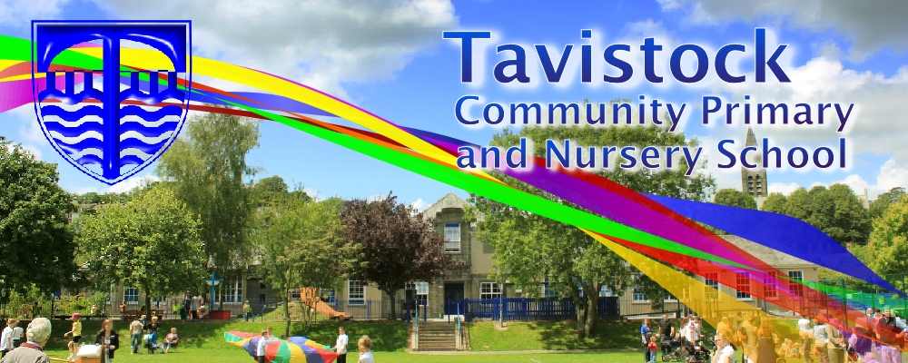

|  |
| --- |
| **This half term we plan to have a focus on the following areas:**  **Prime Areas of Learning**  **Personal, social and emotional development**  Children play co-operatively, taking turns with others. Children can describe self in positive terms and talk about abilities. Children understand that own actions affect other people, for example, becomes upset or tries to comfort another child when they realise they have upset them. We will use circle time activities to provide children with the opportunities to develop and show these skills  **Communication and Language**  Children maintain attention, concentrate and sit quietly during appropriate activity. Children are able to follow a story without pictures or props. Children use language to imagine and recreate roles and experiences in play situations. We will use roleplay and musical stories to develop these skills.  **Physical Development**  Children travel with confidence and skill around, under, over and through balancing and climbing equipment. Children show increasing control over an object in pushing, patting, throwing, catching or kicking it. We will use our PE lessons and activities in Free Learning time to develop these skills.  **Specific Areas**  **Literacy**  Children can hear and say the initial sound in words. Children can segment the sounds in simple words and blend them together and know which letters represent some of them. Children can links sounds to letters, naming and sounding the letters of the alphabet. We will cover this in daily Phonics lessons, guided reading activities and in Free Learning time.  **Mathematics**  Children can count actions or objects which cannot be moved. Children select the correct numeral to represent 1 to 5, then 1 to 10 objects then 1 – 20 objects. Children say the number that is one more than a given number. Children find one more or one less from a group of up to five objects, then ten objects. We will learn number songs, play number games and have activities in Free Learning as well as having maths lessons to develop and teach these skills.  **Understanding the World**  Children look closely at similarities, differences, patterns and change and enjoy joining in with family customs and routines. We will investigate how and why Diwali. Firework night and Christmas is celebrated and explore seasonal changes.  **Expressive Arts and Design**  Children begin to build a repertoire of songs and use simple tools and techniques competently and appropriately. Children will sing, dance and have opportunities to do topic related art activities. |

|  |
| --- |
| **We plan to change reading books every Monday. Each child will get a school reading scheme book and a picture book. You may find that you want to change your child’s book more frequently and you are very welcome to change the books yourself. Please ask a member of staff who will show you where the books are kept.**  C:\Users\00CSmith\AppData\Local\Microsoft\Windows\Temporary Internet Files\Content.IE5\LZZGY5N4\free-clip-art-children-reading-books[1].jpg |

|  |
| --- |
| **Dates for your diary:**  **C:\Users\00CSmith\AppData\Local\Microsoft\Windows\Temporary Internet Files\Content.IE5\R8KXY8XF\111538691[1].jpgC:\Users\00CSmith\AppData\Local\Microsoft\Windows\Temporary Internet Files\Content.IE5\R8KXY8XF\111538691[1].jpgC:\Users\00CSmith\AppData\Local\Microsoft\Windows\Temporary Internet Files\Content.IE5\R8KXY8XF\111538691[1].jpgC:\Users\00CSmith\AppData\Local\Microsoft\Windows\Temporary Internet Files\Content.IE5\R8KXY8XF\111538691[1].jpg**  **Christmas**   **Dinner 7/12**  **Nativity: 8/12 2.00pm**  **9/12 10.00 am**  **15/12 Christmas Celebration**  **Parent Workshops:**  **Literacy – 10th Jan**  **Maths – 19th Jan** |

**Each half term, we talk to the children about what skills they need to be a good learner. Our skill this half term is SELF BELIEF**

|  |
| --- |
| **Please remember; if you have any worries or concerns about your child, come and talk to your child’s teacher – we are always available in the morning and at the end of the day.** |