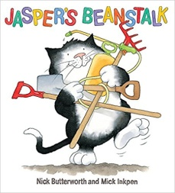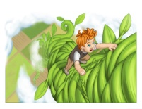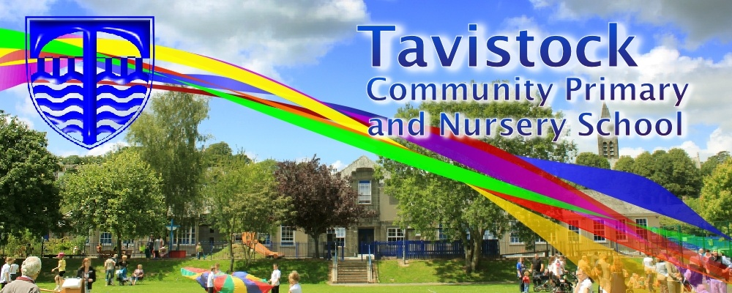

**Dates for your Diary;**

**16/4/18 Tavistock Library**

**23/4/16 Tavistock Library**

**30/4/18 Tavistock Library**

**14/5/18 Tavistock Library**

**21/5/18 Tavistock Library**

**24/5/18 Tavistock Library**

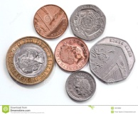

**OUR THEME THIS TERM:**

**Plant growth**

**MATHS**: We will be learning about:

* Addition and subtraction
* Doubling and halving and sharing
* Counting on or back to find the answer
* Exploring money and coins
* Exploring size and weight.



**LITERACY/COMMUNICATION AND LANGUAGE**

We will be reading, writing and talking about growth using fiction and non-fiction books. Some of the stories we will use are –**Jack and the Beanstalk, Jasper’s Beanstalk, Titch, The Tiny Seed, Oliver’s Vegetables and Ten Seeds.**

We will be practising our phase 2 and 3 sounds and tricky words and starting to look at CVCC words (tent, mend).

Please check Phase 4 tricky words in the front of your child’s reading diary.



***HOW CAN YOU HELP YOUR CHILD?***

* ***Read to your child daily and talk about what has happened in the story***
* ***Talk about the meaning of words***
* ***Play number games, concentrating on numbers to 20***
* ***Use real coins to make totals***
* ***Talk about weighing and weight***

**Personal, Social and Emotional Development**

We will be learning to work as part of a group/class and understanding and following rules.

**Physical Development**

We will be looking at how we can stay healthy and safe.

We will be learning football skills with Mr. Wickett.

**Understanding the World**

* Talking about plants - looking at what they need to grow and how they change
* Finding out about life-cycles

**Expressive Arts and Design**

* Drawing, painting and model making based on our topic
* Learning how to explore a variety of materials, tools and techniques
* Listening to and making our own music
* Making up our own stories with others

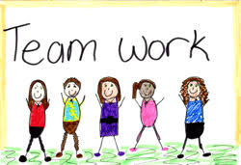

Our **Skill for Success** this half term is

**Co-operation**

**Let’s work together**

**HOMEWORK:**

* 10-15 minutes of daily reading, including tricky words and letter sounds labelled ‘Phase2 & 3’ in the front of our reading diaries.
* Make real and alien words with the letter cards, now using 4 letters in a word eg. went, damp, clom.
* Practise forming cursive letters