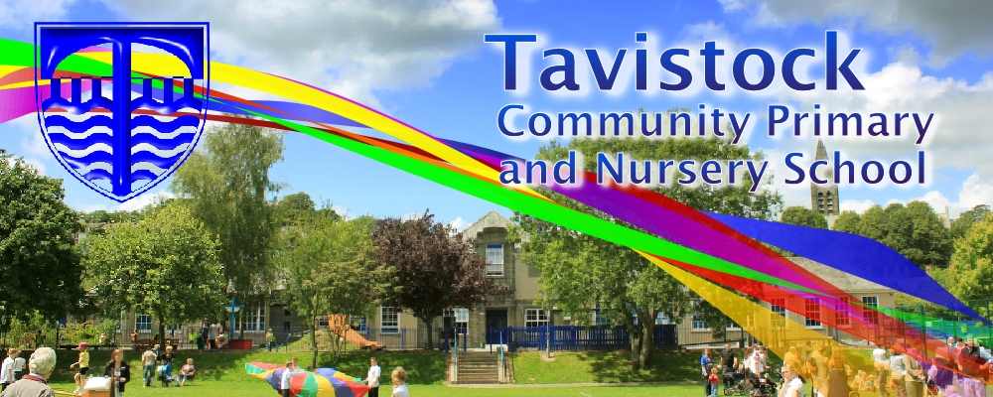 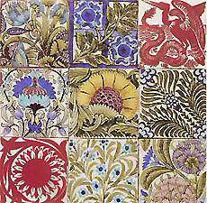

**DATES FOR YOUR DIARY**

Friday 9th June – Trip to Morwellham Quay

Friday 23rd June – Assembly

Tuesday 4th July – Join us in class

Wednesday 5th July pm – KS1 Sports Day

**Literacy**

**Our English work will include:**

* Writing character descriptions
* Writing informal letters
* Exploring use of language
* Learning poetry 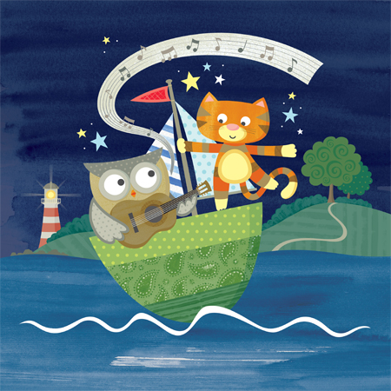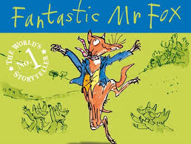 



**This term we are exploring:**

**Art/DT:** Prints in the style of William Morris

**History/Geography**: How was life different for children in Victorian times compared to now

**Music:** Improvising with voices and instruments, singing

**PSHE:** Being healthy

**PE:** Throwing and catching, balance, team games, athletics

**ICT:** We are Zoologists

**MATHS**

**This term, we will be learning:**

* Solving 2 step problems involving X ÷ - and +
* Division with remainders
* To quickly recall 2x, 3x, 5x and 10x table and the associated division facts
* Reasoning about mathematics

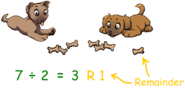

***SCIENCE***

* Living, non- living and dead
* Interdependency of habitats
* Microhabitats
* Food chains

Every half term new copies of recently published books will be available for your children to borrow from the library. The children visit the library regularly. Tell your children to look out for the following new books...

***Edgar & The Sausage Inspector***

***Message in a bottle***

***Mrs Mole, I’m home***

* The importance of food in religion
* Symbols in places of worship
* Church visit

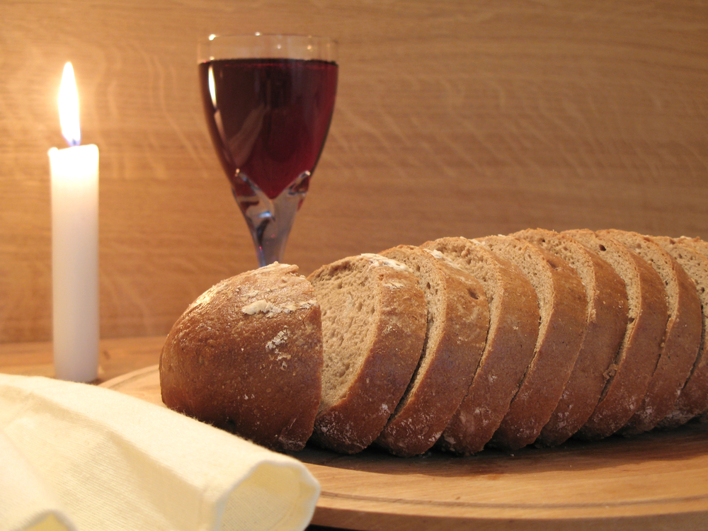

**Please make sure all clothing including PE kit is clearly labelled with your child’s name. With summer here, it is important your child brings a water bottle to school every day. A hat for playtimes is also a good idea.**

**RE**

Our **Skill for Success** this half term is

**Risk Taking – Always have a go, even if you’re not sure**

**LEARNING AT HOME**

**SET ON FRIDAY: IN ON WEDNESDAY**

**SPELLING TEST ON FRIDAY**

**DAILY READING FOR AT LEAST 10 MINUTES**