

[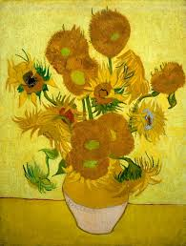](http://www.google.co.uk/url?sa=i&rct=j&q=van+gogh&source=images&cd=&cad=rja&uact=8&ved=&url=https%3A%2F%2Fwww.facebook.com%2FVanGoghMuseum%2Finfo&ei=dY8RVbbaIsvkaLvKgIgK&psig=AFQjCNGTRCa3zWmKBCU3RSI4BGc7kYCvzg&ust=1427300597954199)

Dates:

13th May – Family assembly and curriculum sharing.

19th May – Class 4 library trip

26th May – Class 5 library trip

**LITERACY**

**Our literacy work will be based**

**on plants:**

* Jack and the Beanstalk
* Jim and the Beanstalk by Raymond Briggs
* Non-fiction plant texts

***HOW CAN YOU HELP YOUR CHILD?***

* READ THEIR READING BOOKS WITH THEM EVERY DAY
* READ TOGETHER DAILY AND TALK ABOUT STORIES
* ASSIST WITH HOMEWORK ACTIVITIES

**Plants IS OUR**

**THEME THIS HALF TERM:**

**Science**: Plants

**Art/DT:** Van Gogh’s Sunflowers

Fruit and vegetable pictures in the style of Archinboldi.

**History/Geography**: Where shall I buy my field?

**Music:** ‘Round and round’– singing and instrumental work.

[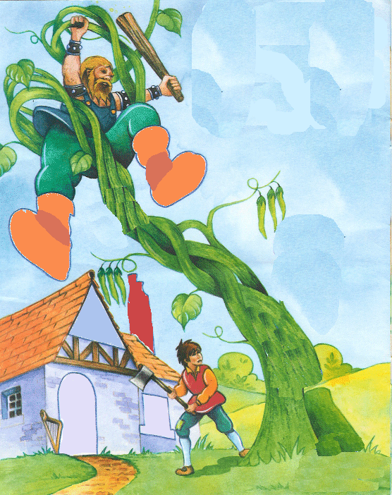](http://www.google.co.uk/url?sa=i&rct=j&q=jack+and+the+beanstalk&source=images&cd=&cad=rja&uact=8&ved=0CAcQjRw&url=http%3A%2F%2Fwww.absolute1.net%2Fjack-%26-the-beanstalk.html&ei=-o8RVYa9H5Dd7QbZiYHQBQ&psig=AFQjCNEThrEJhsAtTgzvBz3kQfOjwhpUmQ&ust=1427300721420549)

**READING**

* Children should **read for a**

**minimum of 15 mins** at home every

night – children should change their

books whenever they need to, on entry or at the end of the day.

**PE**

* **Co-ordination with equipment.**
* **Agility**

**KIT SHOULD STAY IN SCHOOL ALL WEEK: BLACK SHORTS, WHITE TEE SHIRT & TRAINERS/PLIMSOLLS.**



**RE & PSHE**

* Relationships
* Special people
* Growing and changing

**ICT**

We are storytellers



**MATHS**: In this year group the minimum

expectation is for your child to be able to:

* Read and write numbers from 1 to 100 in

numerals and to 20 in words as well

* Read, write and interpret mathematical statements involving addition (+), subtraction (-) and equals (=) signs
* Solve simple problems, with support, involving multiplication and division using objects or pictures

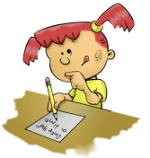

Our whole school focus is on **Communication**

Our **Skill for Success** this term is

**Co-operation**

**HOMEWORK:**

**SET ON FRIDAYS**

**IN ON WEDNESDAYS**