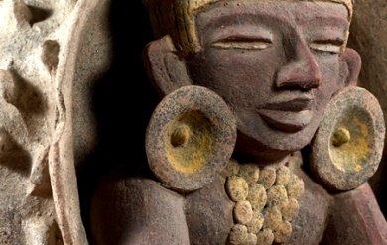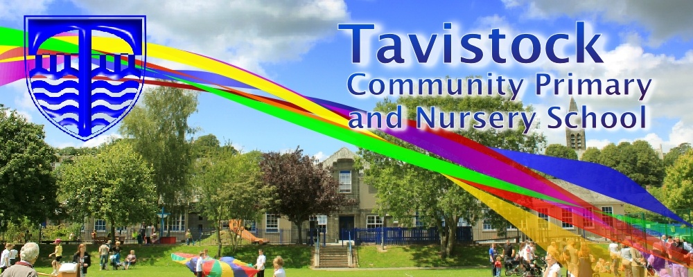

***HOW CAN YOU HELP YOUR CHILD?***

* READ with them EVERY night and TALK about the book – thoughts and understanding.
* SUPPORT them with their Maths homework by letting them SHOW YOU methods they have learnt at school.
* PRACTICE spellings daily, putting them into sentences to check understanding.
* **Talk, play and involve them with what you do. Always come and talk if you have any concerns.**

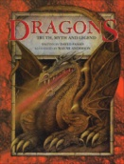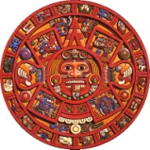

**THE MAYANS IS OUR THEME THIS TERM:**

**Science**:

Sound, exploring by doing a sound walk. Experimenting with pitch, volume and vibrations.

**Art/DT:**

Designing and creating a ceramic dragon bowl.

**History**:

**How did life change for the people on Dartmoor between the Stone age and Iron age?** Exploring the differences between the stone and iron age with links to evidence on Dartmoor.

**LITERACY**

* **Imaginative writing:** Dragons Truth,  
   Myths and Legend - To create own   
  story, information and poem about   
  a dragon to include in a class book
* **Non-fiction texts:** Paint me a poem - To write poetry about art work.

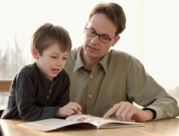

**READING & SPELLING**

* Children should **read for a**

**minimum of 15 mins** at home every

night – children should change their

books whenever they need to and record their reading in the Home School Diary.

PLEASE DISCUSS WITH YOUR CHILDREN WHAT THEY HAVE READ – ENCOURAGING THEM TO EXPAND ON THEIR THOUGHTS.

* **Spellings** sent home on **Fridays, spelling** **quiz** on **following Friday.** These are linked to our spelling, grammar and handwriting lessons. (Reading books & home/school diaries should come in every day).

**Children will have P.E. twice per week**

**KIT SHOULD STAY IN SCHOOL ALL WEEK: BLACK SHORTS, WHITE T SHIRT & TRAINERS.**

**Outdoor and indoor PE: Orienteering. Children will be developing movement skills and their ability to read maps, to understand that a map is an image.**



**PSHE/RE**

* Skills for success – Responsibility
* Life is like a jigsaw, all about me, where do I live?
* RE – Judaism.

**ICT**

We are meteorologists, we will be exploring the weather and methods of recording data.



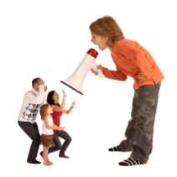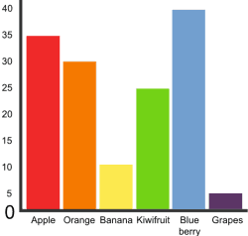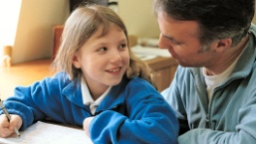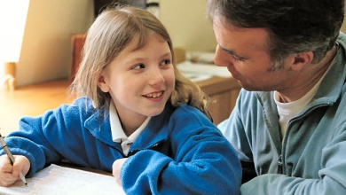

**HOMEWORK**Set on Friday and needs returning by the following Wednesday. Phonics/spelling relationships will be practised in class and consolidated through homework. Reading homework will alternate with literacy homework. There is also a times table /multiplicationchallenge every Friday.

**MATHS:**

* Learning to make appropriate decisions   
  about when to use their understanding of   
  counting (including counting below zero),  
  place value and rounding for solving problems
* Additive reasoning - choosing and using number facts, understanding of place value and counting mental and written methods
* Pupils can represent and explain the multiplicative nature of the number system including how it extends into decimal numbers.

Our whole school focus is on **literacy!**

Our **Skill for Success** this term is

Responsibility.