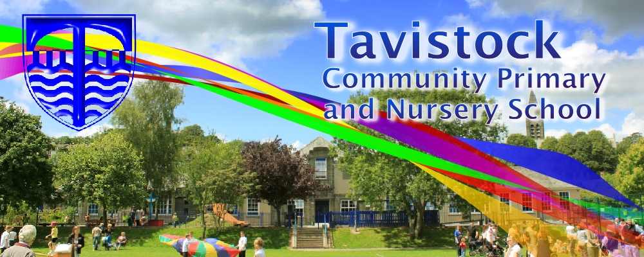

Dates for your Dairy:

16th June Y5 Family Assembly & ‘join us in class’

20th June KS2 Sports Day

23rd June Summer Fayre

29th June Art Enrichment

3rd July “Moving Up Day”

15th July Carnival

**LITERACY**

**The Piano:**

We will use this emotive film to create our own stories involving a flashback to the past.

.

**OUR THEME THIS TERM:**

**What is it like to live in Barcelona compared to London?**

**Science**: Survival Unit

**Geog**: What is it like to live in Barcelona compared to London?

**PE:** Striking & Fielding/ Fundamental Movement Skills / Gymnastics

**MFL:** French

**RE**: Islam

**MATHS**: In maths we are covering:

Co ordinates and reflection and translation of 2D shapes. Solve multi-step problems. Add and subtract fractions. Statistics, graphs and tables.

Multiply fractions and mixed numbers by

whole numbers

MC900233964[1]

***HOW CAN YOU HELP YOUR CHILD?***

***Listen to your children read on a regular basis and discuss what has been read.***

***Encourage a wide variety of texts.***

***Practise times tables and spellings.***

**READING**

Every half-term, new copies of recently published books will be available for your children to borrow from the School Library. This half-term, the new books will be as follows. Tell your children to look out for these in the School Library!

* Superdad's day off
* Spirit of the jungle by Bear Grylls
* Evie's ghost



**Art/DT:**

**Sketching the human form in action**

**ICT**

Researching and documenting London and Barcelona



**KIT SHOULD STAY IN SCHOOL ALL WEEK: BLACK SHORTS, WHITE T-SHIRT & TRAINERS/PLIMSOLLS.**

Our whole school focus is literacy.

Our **Skill for Success** this term is

**Risk-taking**

**HOMEWORK:**

**SET ON FRIDAYS**

**IN ON WEDNESDAYS**