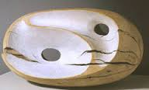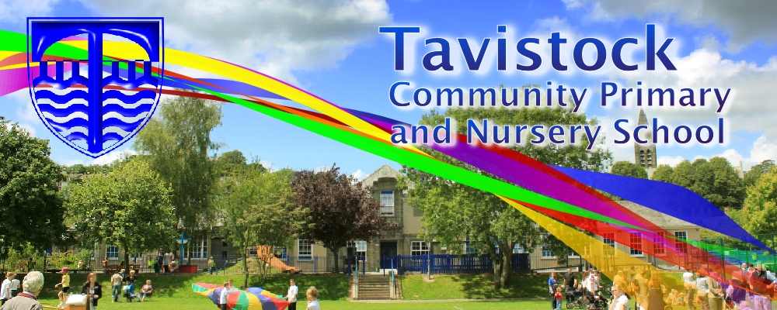

**LITERACY**

**Our literacy work will be partially based on on our habitat theme:**

* **information texts:** to write in a formal language style, using technical and precise vocabulary. To write complex sentences with appropriate conjunctions.
* **News paper reports:** to write in the correct tense and punctuate speech correctly.

***HOW CAN YOU HELP YOUR CHILD?***

* READ **WITH** them EVERY night and TALK about the book – thoughts and understanding.
* SUPPORT them with their Maths homework by letting them SHOW you methods they have learnt at school.
* PRACTISE spellings daily putting them into sentences to check understanding.

**Talk, play and involve them with what you do.**

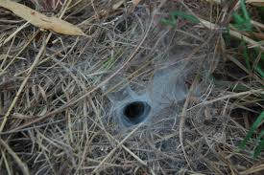

**Habitats IS OUR THEME**

**THIS TERM:**

**Science**: Habitats – learning about different habitats, classifications of animals and insects, understanding food chains within a specific habitat and how changes in the environment affect living things.

**Art:** sculpture linked to holes and habitats. Working with mixed mediums.

**History**: who were the Romans and how did they change life in Britain?

**Music:** Lean On Me By Bill Withers – vocal improvisation and instrumental accompaniment.



**READING & SPELLING**

* Children should **read for a**

**minimum of 15 mins** at home every

night – children should change their

books whenever they need to and record their reading in the Home School Diary.

PLEASE DISCUSS WITH YOUR CHILDREN WHAT THEY HAVE READ – ENCOURAGING THEM TO EXPAND ON THEIR THOUGHTS.

* **Spellings** sent home on **Fridays** will link to the phonics work your child is doing. There will be a  **spelling** **quiz** on **following Friday** (reading books & home/school diaries should come in every day).

**Children will have P.E. twice per week**

**KIT SHOULD STAY IN SCHOOL ALL WEEK: BLACK SHORTS, WHITE T SHIRT & TRAINERS/PLIMSOLLS.**

**Swimming: this continues this term and builds on skills developed in Autumn term.**

**Outdoor PE – we are very lucky to have an outside instructor visiting and working with year 4 students in cricket.**



**PSHE**

* Skills for success – Co-operation
* Healthy eating, living and exercise.

**ICT**

Use Isle of Tunes to create, compose, edit and record own music.



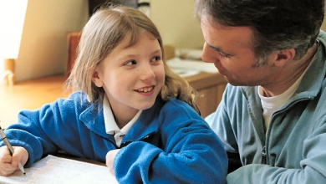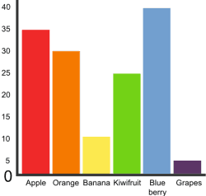

**HOMEWORK  
Set on Friday and needs returning by the following Wednesday. Spellings are tested on Friday so please retain a copy of the spellings. There is also a times table challenge every Friday.**

Our whole school focus is on **talk, talk, talk!**

Our **Skill for Success** this term is

CO-OPERATION

**MATHS**:

* Quick recall of multiplication facts for all

tables 1 – 12 and related division facts.

* Solve problems involving multiplying and adding.
* To make appropriate decisions about when to use knowledge of counting, place value and rounding for solving problems.
* Solve problems involving converting from hours to minutes; minutes to seconds; 12 and 24 hour clocks.
* To identify and plot coordinates and movement.