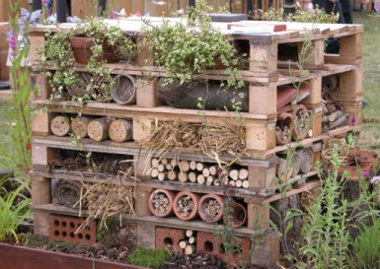

**LITERACY**

* **Stories from other Cultures:** To write complex sentences with appropriate conjunctions. Consider impact of sentence length on the reader. Word choices.
* **Persuasive writing:** to write with a point of view. To use connectives associated with reasoning: because, then, so, this causes, in order to, when etc.

***HOW CAN YOU HELP YOUR CHILD?***

* READ **WITH** them **EVERY** night and **TALK** about the book – thoughts and understanding.
* SUPPORT them with their Maths homework by letting them SHOW you methods they have learnt at school.
* PRACTISE spellings daily putting them into sentences to check understanding.

**Talk, play and involve them with what you do.**

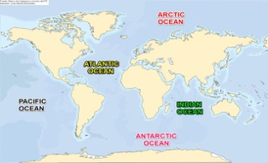

**Habitats IS OUR THEME**

**THIS TERM:**

**Science**: Habitats – learning about different habitats, classifications of animals and insects, understanding food chains within a specific habitat and how changes in the environment affect living things.

**DT:** designing and creating bug houses

**Geography**: What does the captain of a ship need to be able to navigate safely at sea? **Music:** reflect, rewind and replay. Looking at skills learnt and composing own music/songs.

m



**READING & SPELLING**

* Children should **read for a**

**minimum of 15 mins** at home every

night – children should change their

books whenever they need to and record their reading in the Home School Diary.

PLEASE DISCUSS WITH YOUR CHILDREN WHAT THEY HAVE READ – ENCOURAGING THEM TO EXPAND ON THEIR THOUGHTS.

* **Spellings** sent home on **Fridays** will link to the statutory spelling list. There will be a **spelling** **quiz** on **following Friday** (reading books & home/school diaries MUST come in every day).

**Children will have P.E. twice per week**

**KIT SHOULD STAY IN SCHOOL ALL WEEK: BLACK SHORTS, WHITE T SHIRT & TRAINERS/PLIMSOLLS.**

**Swimming: this continues this term and builds on skills developed in Autumn term.**

**Outdoor PE – we shall be developing the skills learnt in cricket last term and applying them to the game of ‘Dartmoor 3 balls’.**



**PSHE**

* Skills for success – Risk taking
* People who inspire us and preparation for next year!

**ICT**

We are introducing children to blogging and continuing with Wiki pages.



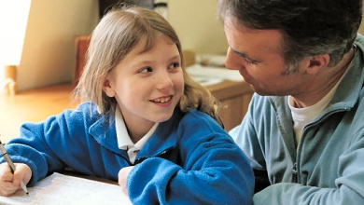

**HOMEWORK  
Set on Friday and needs returning by the following Wednesday. Spellings are tested on Friday so please retain a copy of the spellings. There is also a times table challenge every Friday.**

Our whole school focus is on **talk, talk, talk!**

Our **Skill for Success** this term is

RISK TAKING.

**MATHS**: 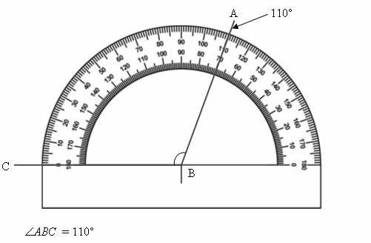

* Quick recall of multiplication facts for all

tables 1 – 12 and related division facts.

* Fractions and decimals to 2 decimal places.
* Analogue and digital time problems and measure.
* Angles and shape – measuring angles
* Symmetry, perimeter and area.