[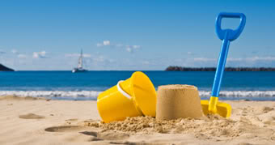](http://www.google.co.uk/url?sa=i&rct=j&q=&esrc=s&source=images&cd=&cad=rja&uact=8&ved=0ahUKEwjIzemhxavUAhUDtBQKHVSeCxgQjRwIBw&url=http%3A%2F%2Fwww.ebay.co.uk%2Fitm%2FSOUNDS-OF-THE-SEASIDE-CD-NATURAL-SOUNDS-CHILDHOOD-MEMORIES-THE-BEACH-%2F230796820635&psig=AFQjCNFgJwHxuykYOLBk9aWrYcF37Uz-Kg&ust=1496918269690139)

***HOW CAN YOU HELP YOUR CHILD?***

* READ THEIR READING BOOKS WITH THEM EVERY DAY
* READ TOGETHER DAILY AND TALK ABOUT STORIES
* ASSIST WITH HOMEWORK ACTIVITIES AND SUPPORT THEIR LEARNING OF PHONICS SOUNDS.

**The Seaside IS OUR**

**THEME THIS TERM:**

**Science**: Exploring the weather and shadows.

**Art/DT:** Seaside sculptures; driftwood boats and rock pool pictures.

**History/Geography**: The history of the seaside; finding clues and comparing past and present.

**Music:** Exploring boomwhackers!

**LITERACY**

**Our literacy work will be based on our seaside**

* **Sally and the Limpet by Simon James**
* **The Sand Horse by Anne Turnbull**
* **Writing postcards about a trip to the beach.**

[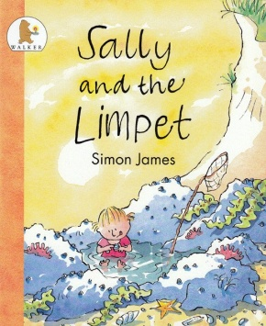](https://www.google.co.uk/url?sa=i&rct=j&q=&esrc=s&source=images&cd=&cad=rja&uact=8&ved=0ahUKEwiq54-dw6vUAhWFbxQKHdfQAY0QjRwIBw&url=https%3A%2F%2Fwww.hamiltoneducation.org.uk%2Fcollections%2Fbooks-for-children%2Fproducts%2Fsally-and-the-limpet&psig=AFQjCNGbrH4tBIEtzW1GRfgHRQQN0x8B7g&ust=1496917724475785)

**READING & SPELLING**

* Children should **read for a**

**minimum of 15 mins** at home every

night – children should change their

books whenever they need to, on entry or at

the end of the day.

* Reading books and home/school diaries should come into school every day.



**RE & PSHE**

* Celebrations
* Growing and changing
* Looking after ourselves

**ICT**

We are celebrating by making a celebratory card using learn pads.

* Practising for sports’ day and team games

**KIT SHOULD STAY IN SCHOOL ALL WEEK: BLACK SHORTS, WHITE TEE SHIRT & TRAINERS/PLIMSOLLS.**



[](http://www.google.co.uk/url?sa=i&rct=j&q=cartoom+image+counting&source=images&cd=&cad=rja&docid=P5LnG7W1G413sM&tbnid=ElJIdtDFu5cwdM:&ved=0CAUQjRw&url=http%3A%2F%2Fwww.clipartreview.com%2Fpages%2F110824-235560-163009.html&ei=lBKvUpeqKOLA7Ab3s4AY&psig=AFQjCNFWo-dPPyBIaveit4Xqj-O7knGEzQ&ust=1387291653202545)

**MATHS**: In this year group the minimum

expectation is for your child to be able to:

* Read and write numbers from 1 to 100 in

numerals and to 20 in words as well

* Read, write and interpret mathematical statements involving addition (+), subtraction (-) and equals (=) signs
* Solve simple problems, with support, involving multiplication and division using objects or pictures





Our whole school focus is on **Literacy**

Our Skill for Success this term is

**Risk Taking**

**HOMEWORK:**

**SET ON FRIDAYS**

**IN ON WEDNESDAYS**