[](http://www.google.co.uk/url?sa=i&rct=j&q=spring+flowers&source=images&cd=&cad=rja&docid=fo69P3zuMW-PMM&tbnid=VcI0P-SEN9CzqM:&ved=0CAUQjRw&url=http://www.hdwallpapers.in/spring_flower_arrangement-wallpapers.html&ei=kgevUoXzFOjC7AaWjoCoDw&psig=AFQjCNHEMBgQ6kbLMyUYKiyVAa5XMGeMMA&ust=1387288831655475)

**Please note...** In Nursery, your child’s “Key Person” is now their teacher. Mrs Dreher – Monday, Tuesday and Wednesday and Mrs Pierce – Thursday and Friday.

**Next Steps...**Replacing previous systems – From now on, all children’s current learning focus will be displayed on the wall in Nursery please check this regularly to support at home. You will also be informed of next steps at our termly parents’ evenings .Thank you.

**OUR THEMES THIS TERM:**

**Toys and Toy Shops, Spring Celebrations and Festivals**

**As examples we will be:**

* **Watching the changes in our Nursery garden as Spring arrives (flowers, birds, tree blossom)**
* **Making, hanging up and watching bird feeders in our garden**
* **Weeding and digging in the flowerpots and making mud pies**
* **Setting up a role-play toy shop**
* **Using the toy shop to develop our mark making, talk skills, counting and calculation etc**
* **Learning about how toys work**
* **Comparing old and new toys**
* **Learning about Easter – making cards, decorations, the meaning behind the celebration**

**Nursery “Blog”: Please go to <http://www.tavistock-pri.devon.sch.uk/website/nursery/46362> to see a weekly update of our learning in Nursery (All of these ideas are subject to change as we follow the children’s needs and interests at Nursery as they may wish to take their learning in a different direction.)**

[](http://www.google.co.uk/url?sa=i&rct=j&q=CARTOON+IMAGE+OF+CHILD+READING&source=images&cd=&cad=rja&docid=GDIKGDhxjnSlLM&tbnid=28mnPTmCZ2AjFM:&ved=0CAUQjRw&url=http://www.dreamstime.com/stock-image-family-reading-cartoon-image14049521&ei=CmZeUvbNLY6whAfrw4G4Cg&psig=AFQjCNF24QcVcYTwEw65CeNPxQ38MYm6Pw&ust=1382004602345694)

We will be sharing lots of picture books in Nursery this half term. Please continue to share books at home with your child and talk about the story with them.

Your child may like to help you with the shopping, perhaps making their own ‘list’ to take with them.

Letters and Sounds Every day in Nursery, our children learn “Letters and Sounds”. Our learning is based upon providing children with the experiences they need to have had in order to learn reading and writing more formally in Reception. **This half term our learning will focus on “Voice Sounds”.** You can support us by encouraging your child to make the sound effects in stories you read together (whoosh, squelch, splash etc). Describe new textures together (frothy, bubbly, lumpy etc).

**[](http://www.google.co.uk/url?sa=i&rct=j&q=children+talking&source=images&cd=&cad=rja&docid=h3kdfqQAyFz3WM&tbnid=IYgYuX_JgPzHBM:&ved=0CAUQjRw&url=http://www.ulsterscotsagency.com/weans/teachers/allaboutme.html&ei=5ROvUrKqHqyg7Aagj4FY&psig=AFQjCNEsO_H1RAFmsvpEr1BE3-Q0C_rCdQ&ust=1387291995573042)**

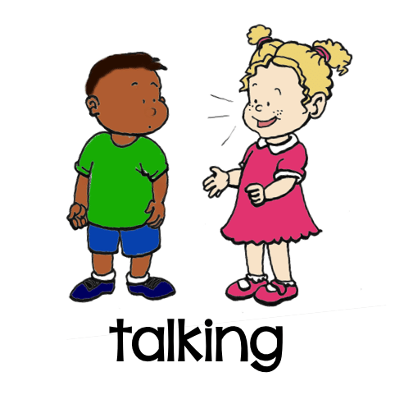

**Mathematics** – Some key nursery targets are:

* I can count a few things and say the number as I count them.

* I can match a numeral with a number of objects.

* I can spot simple shapes and patterns in pictures and all around me

Our whole school focus is on **Communication**

Our **Skill for Success** this term is

**Understanding Yourself**

**Don’t forget! Nursery is a very active place. Children are involved in Arts and Crafts, Messy Play and Movement activity inside and out. Please ensure that your child wears wellies and brings slippers or wears socks indoors at Nursery. PLEASE ENSURE CHILDREN ALWAYS BRING A COAT.**

**Date for your diary...Friday 4th March – Nursery and Foundation Afternoon Tea – 2-3pm. Enjoy some of our home made treats!**