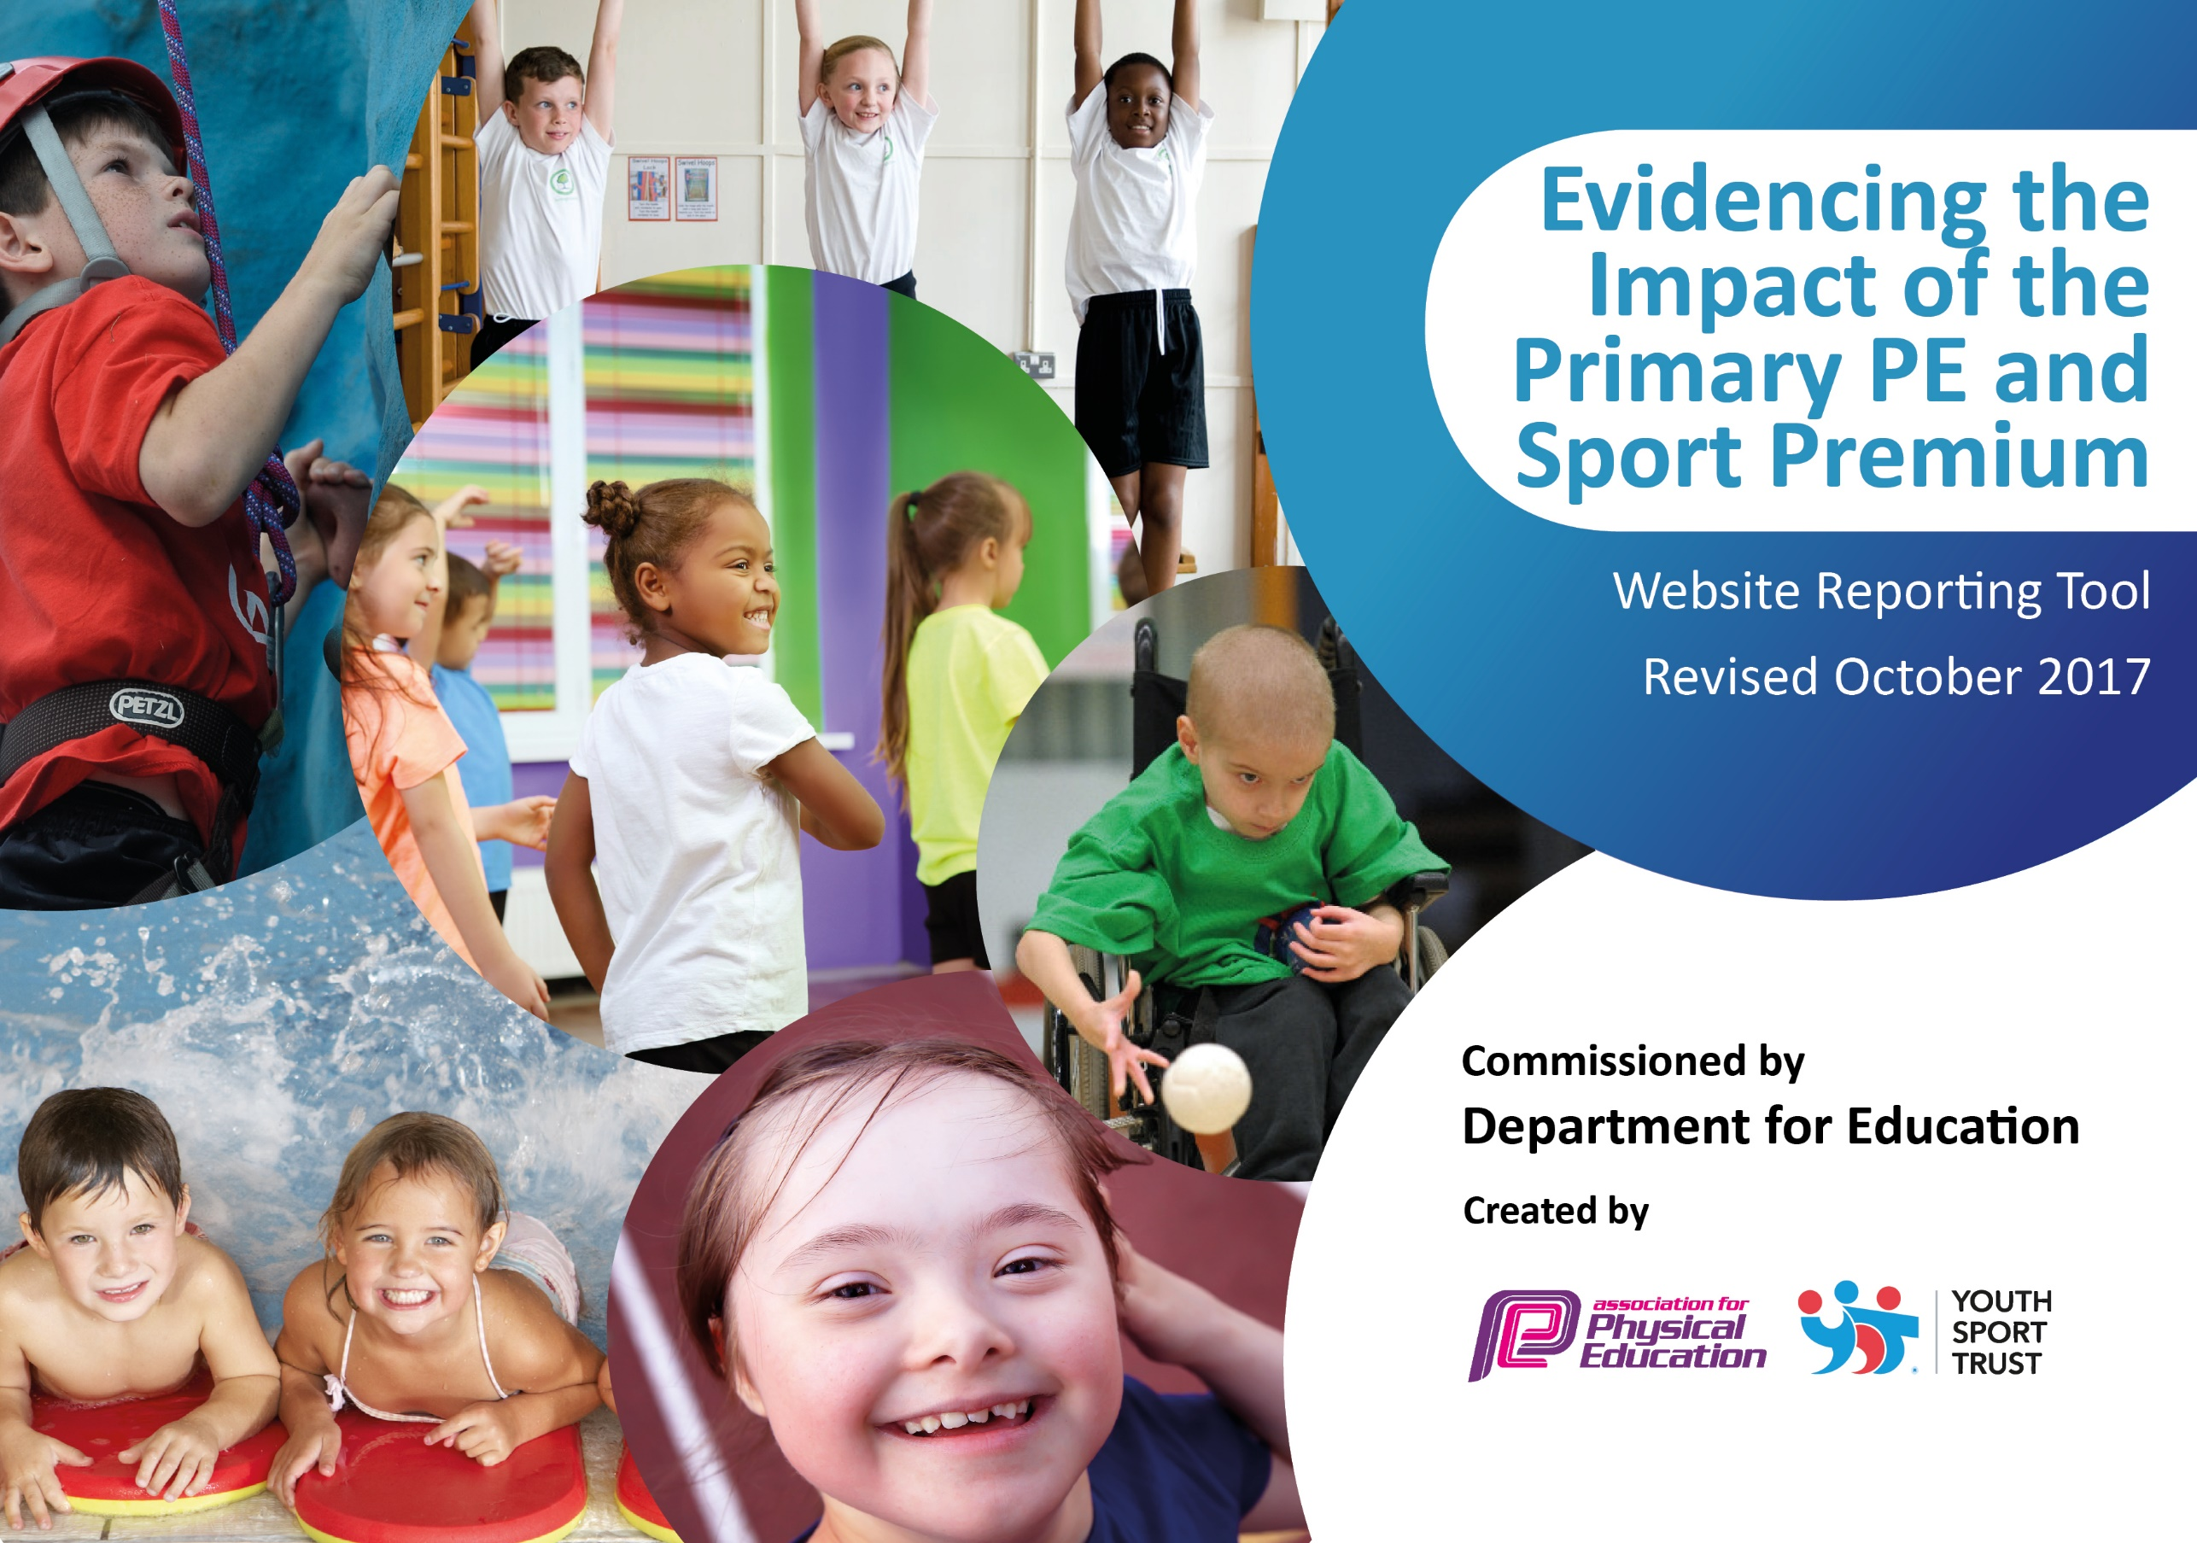

Schools must use the funding to make additional and sustainable improvements to the quality of PE and sport they offer. This means that you should use the Primary PE and Sport Premium to:

- develop or add to the PE and sport activities that your school already offers
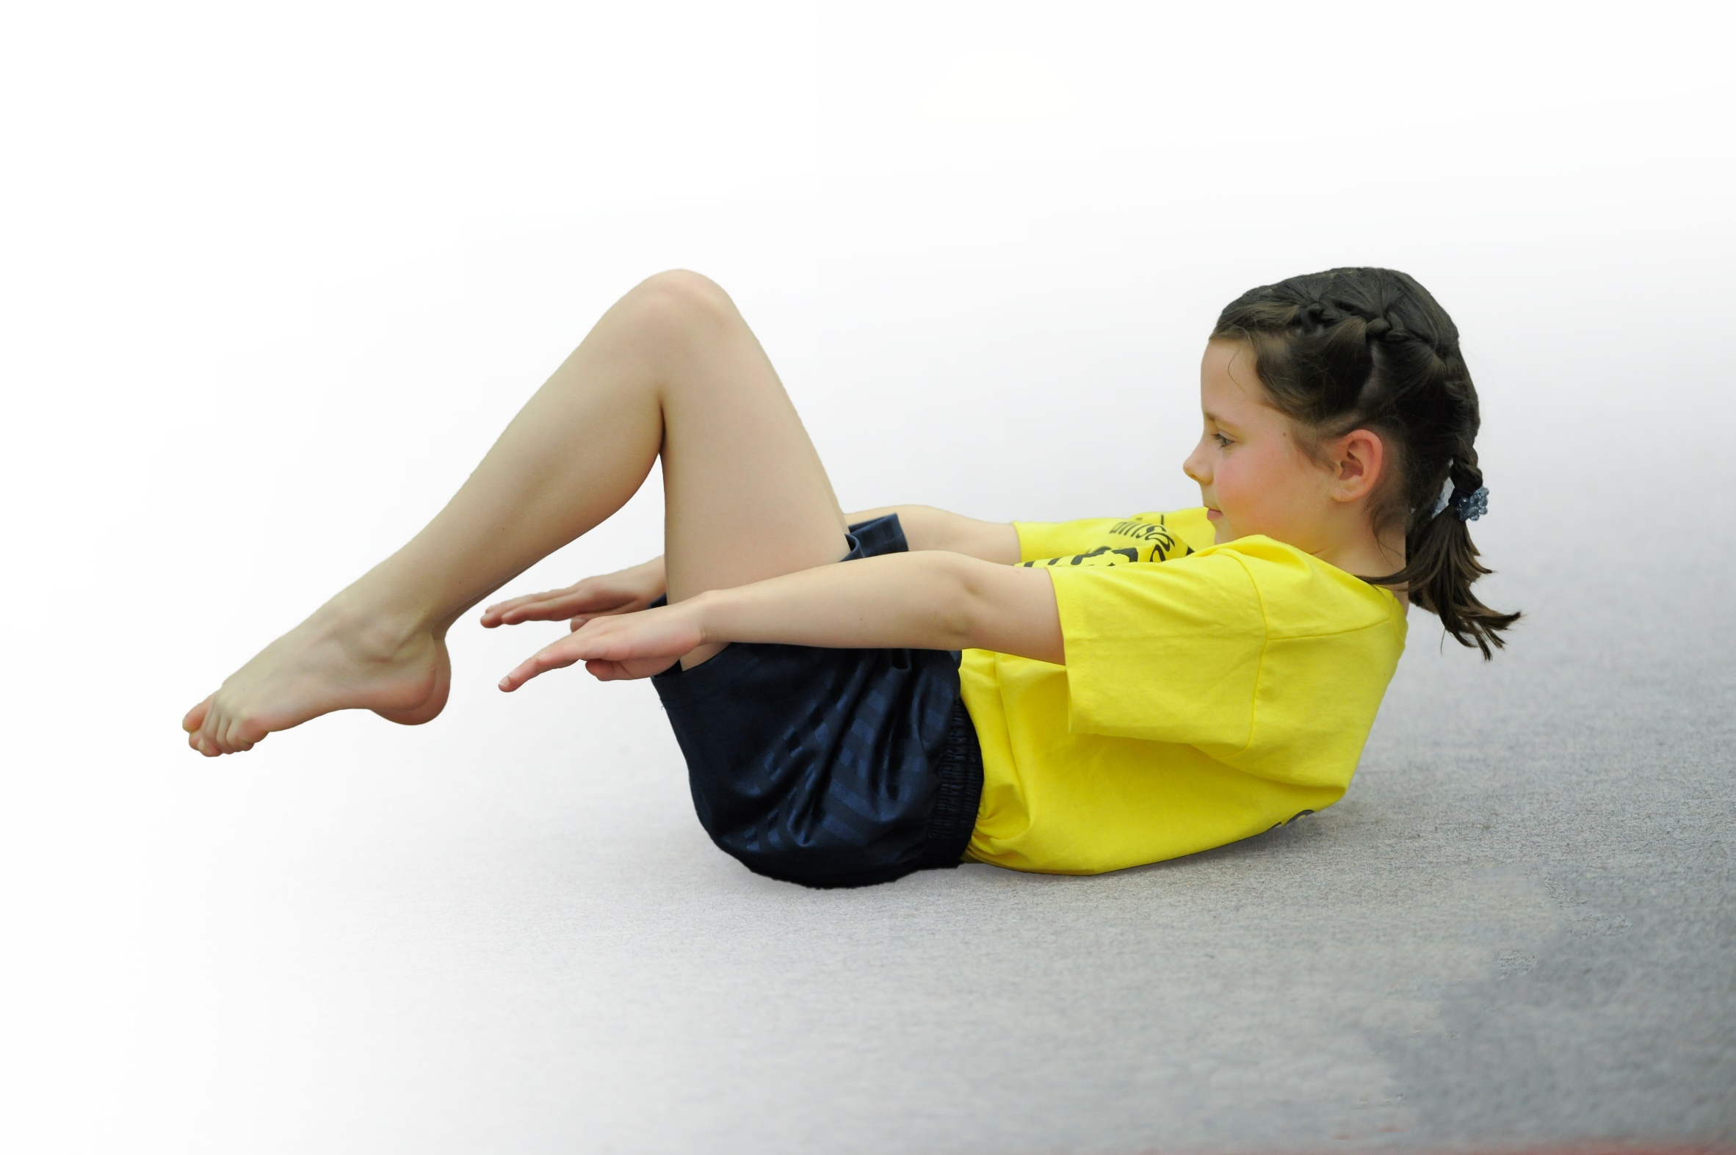
- build capacity and capability within the school to ensure that improvements made now will benefit pupils joining the school in future years

Please visit gov.uk for the revised DfE guidance including the 5 key indicators across which schools should demonstrate an improvement. This document will help you to review your provision and to report your spend. DfE encourages schools to use this template as an effective way of meeting the reporting requirements of the Primary PE and Sport Premium.

We recommend you start by reflecting on the impact of current provision and reviewing the previous spend.
Under the Ofsted Schools Inspection Framework, inspectors will assess how effectively leaders use
the Primary PE and Sport Premium and measure its impact on outcomes for pupils, and how effectively governors hold them to account
for this.

Schools are required to publish details of how they spend this funding as well as on the impact it has on pupils’ PE
and sport participation and attainment.
We recommend regularly updating the table and
publishing it on your website as evidence
of your ongoing review into how you are using the money
to secure maximum, sustainable impact. To see an example of how to complete the table please click HERE.
Support for review and reflection - considering the 5 key indicators from DfE, what development needs are a priority for your setting and your students now and why? Use the space below to reflect on previous spend, identify current need and priorities for the future.

Key achievements to date: | Areas for further improvement and baseline evidence of need:
- Increasing pupils’ engagement in regular physical activity by:  - Providing a broad range of active OSH clubs  - Engaging in as many competitive sporting opportunities and sporting festivals as possible, using funding for transport.  - Competing in a wide range of intra-school competitions  - Encourage and facilitate active break times through provision of engaging equipment.  - Promote importance of a healthy diet and lifestyle.  - Purchase of diet and exercise material for display around school  - Raise the profile of PE and sport across the school by:  - Developing additional squad focus, to ensure we compete to the best of our ability.  - Cups, badges and certificates presented in assemblies  - Increase confidence, knowledge and skills of all staff in teaching PE and sport.  - High quality sports provider to work alongside teachers, delivering fundamental movement skill sessions  - REAL PE material and training for staff to deliver high quality sessions, developing fundamental movement skills  - Training made available to all staff to develop provision of high quality PE and Games.  - Offer a broader experience of a range of sports and activities to pupils:  - Engaging in as many new competitive sporting opportunities and sporting festivals as possible, using funding for transport.  - Using OCRA to source and run a range of sporting competitions. | - Raise the profile of PE and sport across the school by:  - Inviting high-achieving participants, from a range of sports, to speak in assemblies and promote an active lifestyle.  - Offer a broader experience of a range of sports and activities to pupils:  - Providers of a range of sports, not already provided in school, to  deliver sessions, exposing children to new activities.

Meeting national curriculum requirements for swimming and water safety | Please complete all of the below:
What percentage of your Year 6 pupils could swim competently, confidently and proficiently over a distance of at least 25 metres when they left your primary school at the end of last academic year? | 58%
What percentage of your Year 6 pupils could use a range of strokes effectively [for example, front crawl, backstroke and breaststroke] when they left your primary school at the end of last academic year? | 52%
What percentage of your Year 6 pupils could perform safe self-rescue in different water-based situations when they left your primary school at the end of last academic year? | 46%
Schools can choose to use the Primary PE and Sport Premium to provide additional provision for swimming but this must be for activity over and above the national curriculum requirements. Have you used it in this way? | Yes

Action Plan and Budget Tracking
Capture your intended annual spend against the 5 key indicators. Clarify the success criteria and evidence of impact that you intend to measure to evaluate for students today and for the future.

Academic Year: 2017/18 | Total fund allocated: £19,610 | Date Updated: January 2018
Key indicator 1: The engagement of all pupils in regular physical activity – Chief Medical Officer guidelines recommend that primary school children undertake at least 30 minutes of physical activity a day in school |  |  |  | Percentage of total allocation:
 |  |  |  | %
School focus with clarity on intended impact on pupils: | Actions to achieve: | Funding allocated: | Evidence and impact: | Sustainability and suggested next steps:
Increase opportunities for pupils to participate in activities across the school day. | All teachers to introduce the ‘Daily Mile’ into their curriculum time. All pupils to be involved in this project, building stamina and running ability across the academic year.  Employment of training ‘Huff & Puff’ leader and selection and training of pupil ‘Huff & Puff’ helpers.  Purchase ‘Huff & Puff’ resources  Provide a wide range of sporting after-school extra-curricular clubs | £0.00  £2,340.00  £750.00  £0.00 | All classes have engaged in regular weekly runs for 15 minutes. Records demonstrate a consistent increase in cumulative distances run.  OCRA-delivered training over half a day for Sports Leaders and MTA staff.  Range of equipment purchased and made available over terms.  12 different active clubs offered | Successful as is. To continue.  Allocated staff helpers ensure quality long-term provision.  High turn-over of some resources. Plans to purchase further permanent outdoor equipment  Staff-run clubs at optimum. Possible scope to extend by using external providers
Key indicator 2: The profile of PE and sport being raised across the school as a tool for whole school improvement |  |  |  | Percentage of total allocation:
 |  |  |  | %
School focus with clarity on intended impact on pupils: | Actions to achieve: | Funding allocated: | Evidence and impact: | Sustainability and suggested next steps:
Recognise sporting achievements of pupils and staff. Promote staff participation in sport to encourage pupils understanding of lifestyle choice. | Celebration of pupils sporting achievements within and outside of school environment. Individual and team achievements to be recognised within weekly assemblies.  Provide elite staff with one day’s paid leave to attend national and international competitions.  Provide opportunities to extend coaching for talented pupils to help increase intra school achievements  . i.e swimming squad training  Provide pupils with certificates and badges to support and celebrate achievement | £0.00  £320  £1,400.00  £250.00 | Children bring awards from external events on a weekly basis. All competitive events celebrated in assemblies.  Great Britain aquathlon and triathlon events attended  Additional sessions for swimming led to improved team performance; winning the swimming gala. Cross Country position maintained.  Weekly practice. Certificates, cups and medals awarded. | Successful practice to continue  Successful practice to continue  Successful practice to continue and be extended where possible  The profile of PE and sport across the school is raised. Successful practice to continue

Key indicator 3: Increased confidence, knowledge and skills of all staff in teaching PE and sport |  |  |  | Percentage of total allocation:
 |  |  |  | %
School focus with clarity on intended  impact on pupils: | Actions to achieve: | Funding  allocated: | Evidence and impact: | Sustainability and suggested  next steps:
Improve teaching of PE across all year groups. | Specialist coach, Mark Wickett employed across the academic year supporting a different year group each ½ term.  PE coordinator to attend annual PE conference | £1,200.00  £350 | Provision targeted across KS1 and KS2. Teachers teach alongside and employ strategies independently  Conference attended | Successful practice to continue  Successful practice to continue
Key indicator 4: Broader experience of a range of sports and activities offered to all pupils |  |  |  | Percentage of total allocation:
 |  |  |  | %
School focus with clarity on intended  impact on pupils: | Actions to achieve: | Funding  allocated: | Evidence and impact: | Sustainability and suggested  next steps:
Additional achievements:  Introduce a wider range of sports to pupils across the year | Buy in specialist services to introduce pupils to new sporting opportunities such as archery, fencing, golf etc  Increase range of sporting equipment within all playgrounds, ie climbing unit for Nursery, outside table tennis table in KS2 playground. | £1,000.00  £8,350.00 | Bookings being arranged for Summer 2018  Plans being reviewed | To be arranged  To be arranged
Key indicator 5: Increased participation in competitive sport |  |  |  | Percentage of total allocation:
 |  |  |  | %
School focus with clarity on intended  impact on pupils: | Actions to achieve: | Funding  allocated: | Evidence and impact: | Sustainability and suggested  next steps:
School to support PE coordinator | Buy into OCRA sports provision to support school with provision of intra-school competitive opportunities.  Increase numbers of pupils able to compete in competitions  Releasing staff from classroom commitments to take pupils to competitions  Hire suitable transport to take pupils to competition venues which are not local | £1,750.00  £0.00  £1,700.00  £200.00 | OCRA provision enables breadth of sporting events and competitions continues to grow and group focus remains ambitious  Cover of transport costs enables more teams to attend more events | Successful practice to continue  Successful practice to continue

