|  |
| --- |
| **Our theme this half term is Marvellous Me**  **We will be thinking about our family traditions and celebrations, what makes us special, what we are good at and what to do when we find something tricky. We will also learn all about Autumn and Harvest Festival**. |

|  |
| --- |
| Our whole school focus this year is **reading**. We will be holding a workshop in the Spring term to help parents support their children’s reading in the best way possible. Please also see the front of your child’s reading record to get some useful tips.  [Image result for child reading with parent clipart](http://www.google.co.uk/url?sa=i&rct=j&q=&esrc=s&source=images&cd=&cad=rja&uact=8&ved=0ahUKEwiLg6j4uvvOAhWBsxQKHWPNDvEQjRwIBw&url=http://www.canstockphoto.com/illustration/parents.html&bvm=bv.131783435,d.ZGg&psig=AFQjCNFXnpzQ70pxkVKpi1v3aksAs1x9og&ust=1473275992182004) |

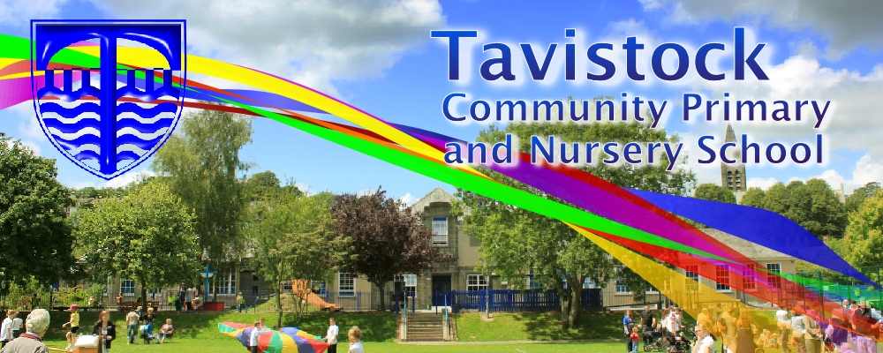

|  |
| --- |
| **This half term we plan to have a focus on the following areas:**  **Prime Areas of Learning**  **Personal, social and emotional development**  Being confident to talk about our needs, wants, interests and opinions and understanding how our actions will affect other people. We will use the stories of Elmer, The Avocado Baby, Baby Brains Eat your Peas and Two Can Toucan  **Communication and Language**  Maintaining attention, concentrating and sitting quietly during appropriate activities, listening and responding to ideas expressed by others in conversation or discussion, extending vocabulary, especially by grouping and naming, exploring the meaning and sounds of new words and using language to imagine and recreate roles and experiences in play situations.  **Physical Development**  Travelling with confidence, jumping, climbing and balance, using a range of resources safely and with control and developing our fine motor control.  **Specific Areas**  **Literacy**  Linking sounds to letters, rhyming words, enjoying a wide range of books and hearing and saying the initial sounds in words.  **Mathematics**  Recognising numbers 1-10 and beyond, recognising 2D shapes and their properties  **Understanding the World**  Celebrating family customs and celebrations, discovering Autumn, finding out about Autumn festivals and using our Learn Pads to take photographs.  **Expressive Arts and Design**  Learning songs related to our topic, portraits, weaving and model making. |

|  |
| --- |
| **We plan to change reading books every Monday. Each child will get a school reading scheme book and a picture book. You may find that you want to change your child’s book more frequently and you are very welcome to change the books yourself. Please ask a member of staff who will show you where the books are kept.**  h.jpg |

|  |
| --- |
| **Dates for your diary:**  **Parents Evening: 17th and 18th Oct**  **Nativity: 8th and 9th Dec**  **Parent Workshops:**  **Literacy – 10th Jan**  **Maths – 19th Jan** |

|  |
| --- |
| **Please remember; if you have any worries or concerns about your child, come and talk to your child’s teacher – we are always available in the morning and at the end of the day.** |

**Each half term, we talk to the children about what skills they need to be a good learner. Our skill this half term is RESILIENCE**