 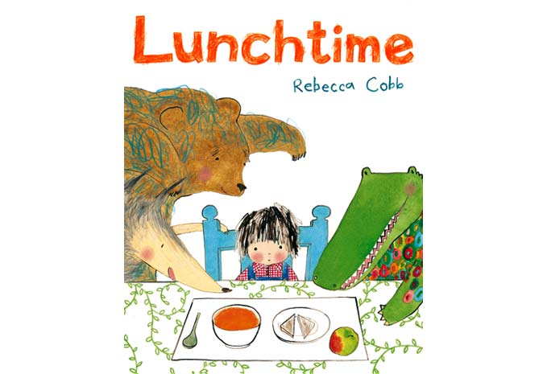

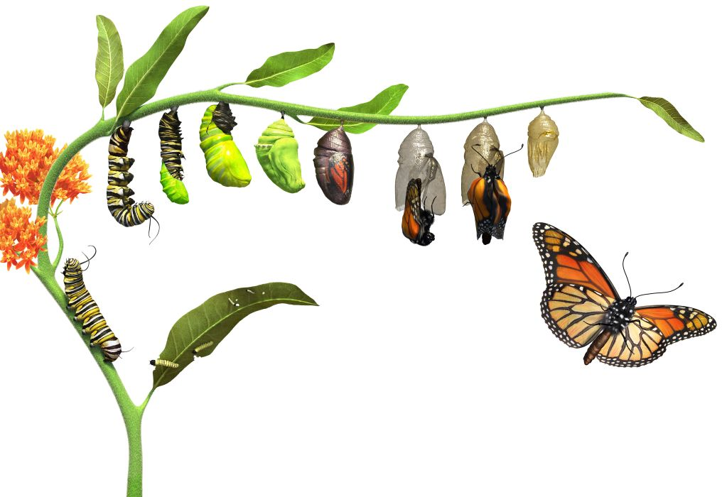

**DATES FOR YOUR DIARY**

Tuesday 3 October: Harvest Festival at St Eustachius Church

12 / 13 October: Buckland Abbey

Friday 20 October: Year 2 assembly

 [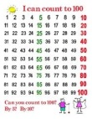](http://www.google.com/url?sa=i&rct=j&q=counting+to+100&source=images&cd=&cad=rja&uact=8&docid=-iFbK-qdjqnEPM&tbnid=40m2Q_YQqPsK4M:&ved=&url=http://www.pinterest.com/bettertolaugh/100th-day-counting-posters/&ei=7VcIVKYFk4HtBti4gcAM&psig=AFQjCNEPBm_LMc7b8ST2V1Mf9wh7ZfivNQ&ust=1409919341355597)

**MATHS**: This term, we will be learning to:

* Count forwards and backwards to at least 100
* Count in 2s and 5s from 0
* Count on and back in 10s from any number 0 -100
* Understand the value of each digit in a number
* Add and subtract a multiple of 10 to any 2-digit number

**This term we are going to be exploring:**

**Science**: Animals including humans

**Art/DT:** Portraits and Picasso

**History/Geography**: Why did Henry VIII have so many wives? Tudor life.

**Music:** South African music – singing, playing instruments and improvising

**PSHE:** I know how to keep myself safe

**COMPUTING:** Creating a program and understanding algorithms (instructions)

**ENGLISH**

**Our literacy work will include:**

* Exploring and then writing a story with a

familiar setting

* Writing across the curriculum – linked to our topics
* Developing sentences: spellings, construction, vocabulary and punctuation

[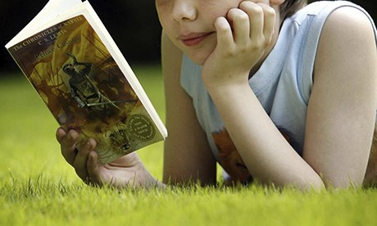](http://www.google.co.uk/url?sa=i&rct=j&q=chidlren+loving+reading&source=images&cd=&cad=rja&uact=8&docid=EDQURSyHKaQAUM&tbnid=E72TyqN2Ub9zvM:&ved=0CAUQjRw&url=http://www.theguardian.com/books/2013/oct/14/neil-gaiman-children-books-reading-lecture&ei=15OMU-GAAsaN0AXoroGABw&psig=AFQjCNHPfvQl92fqlI8I7a91ZVeIv95p6g&ust=1401808057524271) **LOVING READING**

* **LOVING READING**

***SCIENCE: ANIMALS INCLUDING HUMANS***

* **Basic needs of animals for survival**
* **Know that animals have offspring that grow into adults**
* **Describe the importance for humans of exercise, eating the right amount of different types of food and hygiene**

**7th July 1.30pm KS1 Sports Day**

**RE**

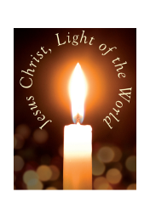

* Facts and beliefs
* Parables
* Christianity and Judaism

**REMEMBER**

Please ensure your child brings their reading book and home school diary with them EVERY day.

If you would like to come into class and help – with reading, other activities or general classroom support we would love to welcome you. Please see Mrs Alexander or Mrs Barnes.

**HOMEWORK**

**Friday: homework / spellings given out**

**Wednesday: deadline for homework to be**

**returned + spelling test**

**Daily: reading – please sign and record**

**comments in home school diary**

Our **Skill for Success** this half term is

**RESILIENCE – Keep going, even when it’s hard.**

* **Ball skills**
* **Floor movement patterns**
* **Balancing**

**PE KIT SHOULD STAY IN SCHOOL ALL WEEK: BLACK SHORTS, WHITE T- SHIRT & TRAINERS.**