

**Dates for your Diary;**

**01/03/17 World Book Day**

**24/03/17 Family Assembly/Red Nose Day**

**MATHS**: We are learning to add two groups of numbers together and how to record this using marks and numbers.

We are learning to use everyday language to talk about size, weight, capacity, position, distance and time.

**OUR THEME THIS TERM:**

**Mini-beasts**

[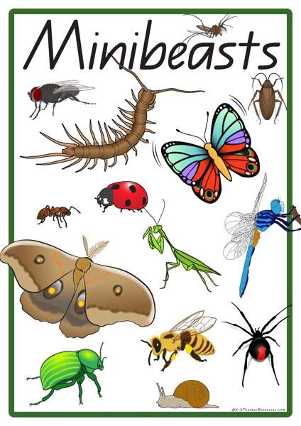](https://www.google.co.uk/url?sa=i&rct=j&q=&esrc=s&source=images&cd=&cad=rja&uact=8&ved=0ahUKEwia1s-x9ZzSAhXENhoKHVLxDTYQjRwIBw&url=https%3A%2F%2Fk-3teacherresources.com%2Fteaching-resource%2Fminibeast-vocabulary-words%2F&psig=AFQjCNG5YbKgP-4IdbXIMVZC_RLA_LoWrQ&ust=1487619690538349)

**LITERACY/COMMUNICATION AND LANGUAGE**

We will be reading, writing and talking about Mini-beasts, using fiction and non-fiction books. Some of the stories we will use are – the Bad Tempered Ladybird, the Very Hungry Caterpillar, Mad About Mini-beasts, The Very Busy Spider..

***HOW CAN YOU HELP YOUR CHILD?***

***Read to your child regularly and talk about the pictures and what has happened in the story.***

***Play number games, concentrating on numbers to 20.***

**Personal, Social and Emotional Development**

To play co-operatively with others and to talk about our feelings and how others show their feelings.

**Physical Development**

To handle tools and equipment effectively and safely and to be aware of healthy diets.

**Understanding the World**

We will be learning about Easter and Mothers’ Day.

We will be looking at similarities and differences in our own environment.

**Expressive Arts and Design**

Drawing, painting and model making based on our topic.

Listening to and making music linked to our stories.

**HOMEWORK:**

**Daily reading, including tricky words in the front of our reading records.**

Our whole school focus is on

**LITERACY!**

Our **Skill for Success** this term is

Understanding Yourself