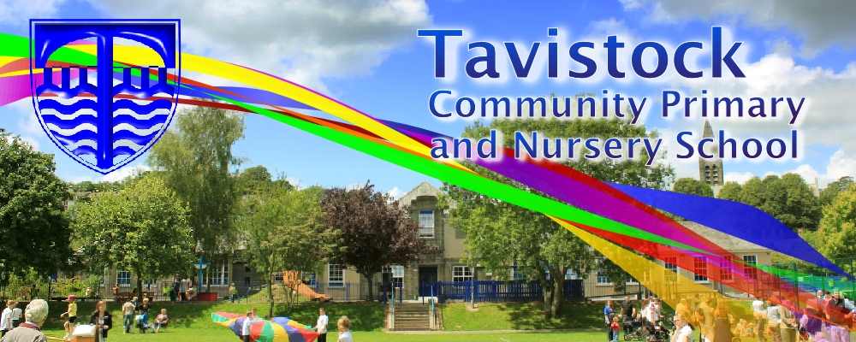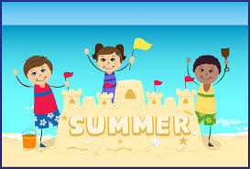

**We have not planned a theme this half term as we will be closely following the children’s current needs and interests and our activities will be responsive to the children’s thoughts and ideas:**

Our continuous provision and environment will allow children to learn through play in the following areas of learning:

* Personal, Social and Emotional Development – making relationships, behaviour and self confidence

* Communication and Language – speaking, listening and understanding

* Physical Development – moving and handling and health and self care

* Literacy – reading and writing

* Mathematics – numbers and shape

* Understanding the World – people, the world and technology

* Expressive Arts and Design – exploring materials and imagination

We will use our environment and individual assessments of the children’s knowledge skills and understanding to move the children’s learning on each of the areas above. We will be sending out reports for our children moving to Reception this term. All children’s next steps for this half term are displayed in Nursery. Please take a look. Please come and see us if you would like to know more about our curriculum.

**Mathematics**:

We are aiming for your children to be able to do the

following by the end of the school year:

N1 children –

* Recite some number names in sequence.

* Uses some language of quantities, such as *‘more’* and *‘a lot’.*

N2 children –

* Recite numbers in order to 10.

* Sometimes matches numeral and quantity correctly.

* Show an interest in numerals in the environment.

* Show an interest in representing numbers.

* Realise not only objects, but anything can be counted, including steps, claps or jumps.

Please practice these skills at home.

[](http://www.google.co.uk/url?sa=i&rct=j&q=CARTOON+IMAGE+OF+CHILD+counting&source=images&cd=&cad=rja&docid=LxqIW4TnvuWcQM&tbnid=72PGfd4phoZwsM:&ved=0CAUQjRw&url=http://www.colourbox.com/vector/planting-a-tree-vector-4146363&ei=jWZeUsO8E8eThQeC4YGoBQ&psig=AFQjCNFH6j0fVhqwr4UAbKKQ91MH-PCMQA&ust=1382004725327342)

[](http://www.google.co.uk/url?sa=i&rct=j&q=CARTOON+IMAGE+OF+CHILD+READING&source=images&cd=&cad=rja&docid=GDIKGDhxjnSlLM&tbnid=28mnPTmCZ2AjFM:&ved=0CAUQjRw&url=http://www.dreamstime.com/stock-image-family-reading-cartoon-image14049521&ei=CmZeUvbNLY6whAfrw4G4Cg&psig=AFQjCNF24QcVcYTwEw65CeNPxQ38MYm6Pw&ust=1382004602345694)

Please visit the Nursery page on the school website: <http://www.tavistock-pri.devon.sch.uk/website/nursery/46362> This page is updated weekly. Here you will find information on Nursery practice, ideas on how you can help your children at home, photos of the children in their learning, our weekly “blog” and links to resources etc.

**Nursery Trip!**

**We will be repeating our very successful trip to Play Planet again this year on 12th July. Please see separate letter.**

**Foundation Stage Sports day and curriculum sharing!**

Please come and watch your child take part in the Foundation Stage sport’s day on Monday 20th June in the morning. There are several exciting events to watch! **See details in our separate letter.**

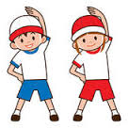

Our whole school focus is on **Communication.**

Our **Skill for Success** this term is **Risk Taking**

***HOW CAN YOU HELP YOUR CHILD WITH EARLY READING AND WRITING?***

* REGULARLY READ BOOKS WITH THEM AND TALK ABOUT THE STORIES AND INFORMATION.

*PRACTISE LEARNING LETTERSOUNDS. *ENCOURAGE THEM TO MAKE MARKS AND “HAVE A GO” AT THEIR OWN WRITING.