

**ALL ABOUT NURSERY...**

Your child will change and develop a lot in their time at Nursery. These are just some of the things they may learn to do...

* Talk and listen in lots of different situations

* Pour my own drinks

* Use the toilet independently

* Remember to wash my hands

* Dress myself e.g. put on my own coat and shoes

* Make choices e.g. what I want to play with, what I would like to choose from the snack cafe

* Tell you what I have been learning

* To have a go at new things

* Not to worry if I cannot do something the first time

* Play with others and learn to take turns

* And lots more!

***Please come and talk to a member of staff if you would like to know more about our Nursery Curriculum***

**Dates for your Diary:**

* ‘Join us’ sessions for parents.
* Foundation Stage Nativity on Monday 11th December and Tuesday 12th December. More details will follow in further letters.

**LITERACY/COMMUNICATION AND LANGUAGE**

* Listening for sounds in the environment.
* Hearing rhythm and rhyme
* Free mark making with a range of materials and media.
* Recognise and write my name.
* Looking at lots of books together. We will read non-fiction books about ‘people who help us’ and Autumn, as well as lots of stories.

**Autumn term topics!**

Our new topics this term will include ‘Let’s celebrate’ with a focus on Halloween through the story of ‘Room on a broom’, Bonfire Night, Birthdays, Weddings through the ‘Scarecrow’s wedding’ and Christmas and Winter.

We will be learning to retell stories,, talk about special events we have shared with our families and learn our Nativity songs and dances amongst other learning.

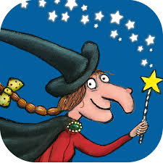 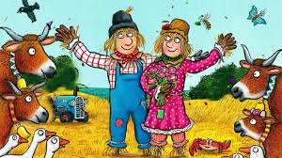 

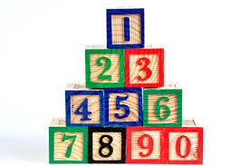

**Mathematics skills**

* Counting to 3, then 5, then 10 and beyond!
* Recognising and drawing numbers and matching to an amount.
* Playing number games and solving number related questions with toys.
* Singing and doing number songs and action rhymes.
* Recognising and naming the shapes around me.

[](http://www.google.co.uk/url?sa=i&rct=j&q=CARTOON+IMAGE+OF+CHILD+READING&source=images&cd=&cad=rja&docid=GDIKGDhxjnSlLM&tbnid=28mnPTmCZ2AjFM:&ved=0CAUQjRw&url=http://www.dreamstime.com/stock-image-family-reading-cartoon-image14049521&ei=CmZeUvbNLY6whAfrw4G4Cg&psig=AFQjCNF24QcVcYTwEw65CeNPxQ38MYm6Pw&ust=1382004602345694)

***How can I help my child***

***with early reading and writing?***

* Share books with them every day and talk about stories.
* Encourage them to make marks and have a go at their own writing.
* Role model reading books and writing e.g. shopping lists and cards.

**Nursery information**

* *Please read the “Ask me about” whiteboard on the Nursery door and ask your children about today’s learning and fun!*
* *We have many informative displays in Nursery including one with information about the local Children’s Centre- please take a look.*
* *All Nursery children have a key person. You will receive a letter shortly providing more details about this and who your child’s key person will be.*
* *We enjoy sharing information with you about your child’s time at Nursery. You are always welcome to ask about their day!*
* *We take part in daily physical activity as well as messy play. Please ensure that your child comes to Nursery in**named practical**clothing and has spare clothes on their peg.*

Our **Skill for Success** this term is

**Self-belief.**

