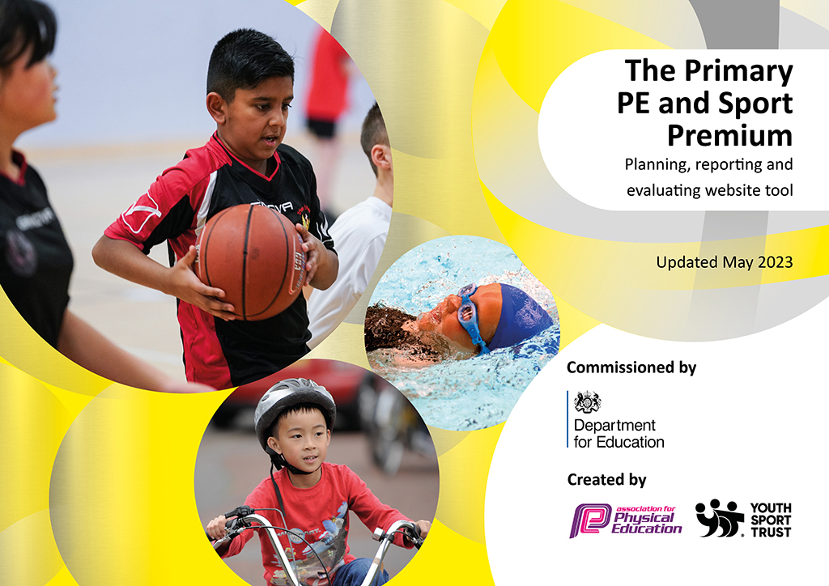
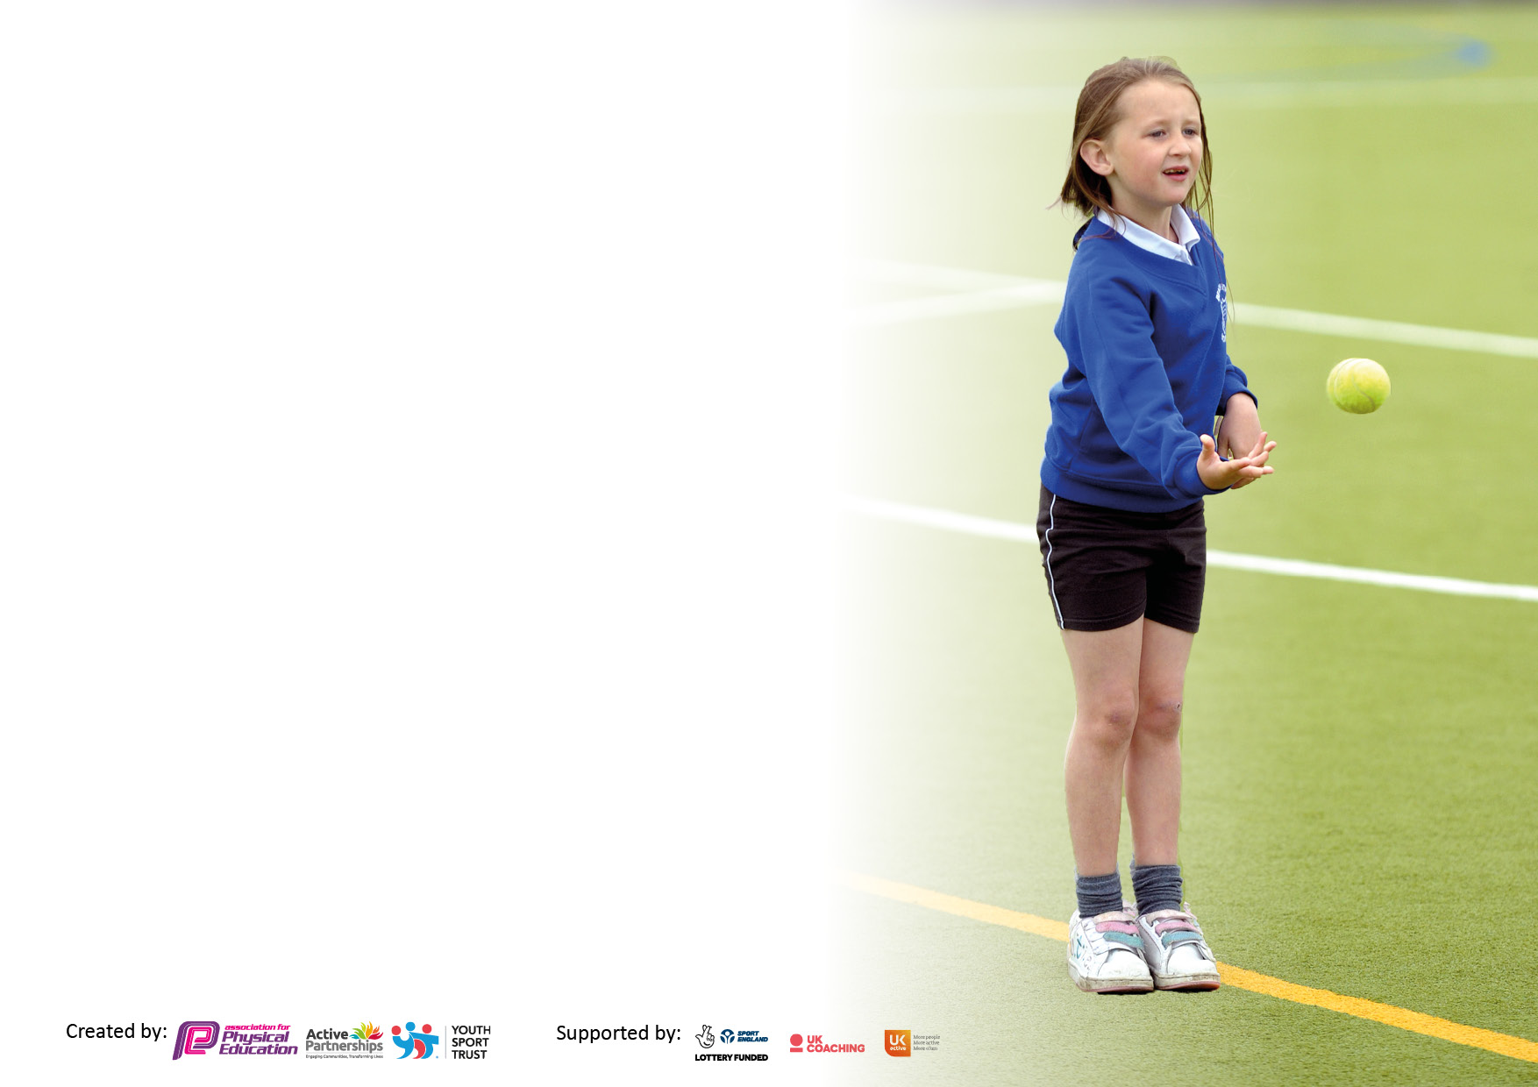

It is important that your grant is used effectively and based on school need. The Education Inspection Framework makes clear there will be a focus on ‘whether leaders and those responsible for governors all understand their respective roles and perform these in a way that enhances the effectiveness of the school’.

Under the Quality of Education Ofsted inspectors consider:
Intent - Curriculum design, coverage and appropriateness
Implementation - Curriculum delivery, Teaching (pedagogy) and Assessment
Impact - Attainment and progress

To assist schools with common transferable language this template has been developed to utilise the same three headings which should make your plans easily transferable between working documents.

Schools must use the funding to make additional and sustainable improvements to the quality of Physical Education, School Sport and Physical Activity (PESSPA) they offer. This means that you should use the Primary PE and sport premium to:

- Develop or add to the PESSPA activities that your school already offer
- Build capacity and capability within the school to ensure that improvements made now will benefit pupils joining the school in future years
- The Primary PE and sport premium should not be used to fund capital spend projects; the school’s budget should fund these.

Please visit gov.uk for the revised DfE guidance including the5keyindicatorsacrosswhichschoolsshoulddemonstrate an improvement. This document will helpyoutoreviewyourprovisionandtoreportyourspend.DfEencouragesschools to use this template as an effective way of meeting the reporting requirements of the Primary PE and Sport Premium.

We recommend you start by reflecting on the impact of current provision and reviewing the previous spend.

Schools are required to publish details of how they spend this funding, including any under-spend from 2021/2022, as well as on the impact it has on pupils’ PE and sport participation and attainment. The funding should be spent by 31st July but the DfE has stated that there will be no clawback of any unspent money so this can be carried forward into 2023/24.

We recommend regularly updating the table and publishing it on your website throughout the year. This evidences your ongoing self-evaluation of how you are using the funding to secure maximum, sustainable impact. Final copy must be posted on your website by the end of the academic year and no later than the 31st July 2023. To see an example of how to complete the table please click HERE.

Details with regard to funding
Please complete the table below.

Total amount carried over from 2021/22 | £N/A
Total amount allocated for 2021/22 | £18,809
How much (if any) do you intend to carry over from this total fund into 2022/23? | £N/A
Total amount allocated for 2022/23 | £18,930
Total amount of funding for 2022/23. Ideally should be spent and reported on by 31st July 2023. | £ 17,390
Swimming Data
Please report on your Swimming Data below.

Meeting national curriculum requirements for swimming and water safety.  N.B. Complete this section to your best ability. For example you might have practised safe self-rescue techniques on dry land which you can then transfer to the pool when school swimming restarts.  Due to exceptional circumstances priority should be given to ensuring that pupils can perform safe self rescue even if they do not fully meet the first two requirements of the NC programme of study | 75%
What percentage of your current Year 6 cohort swim competently, confidently and proficiently over a distance of at least 25 metres?  N.B. Even though your pupils may swim in another year please report on their attainment on leaving primary school at the end of the summer term 2023.  Please see note above | 75%
What percentage of your current Year 6 cohort use a range of strokes effectively [for example, front crawl, backstroke and breaststroke]?  Please see note above | 75%
What percentage of your current Year 6 cohort perform safe self-rescue in different water-based situations? | 75%
Schools can choose to use the Primary PE and sport premium to provide additional provision for swimming but this must be for activity over and above the national curriculum requirements. Have you used it in this way? | Yes

Action Plan and Budget Tracking
Capture your intended annual spend against the 5 key indicators. Clarify the success criteria and evidence of impact that you intend to measure to evaluate for pupils today and for the future.

Academic Year: 2022/23 | Total fund allocated: | Date Updated:
Key indicator 1: The engagement of all pupils in regular physical activity – Chief Medical Officers guidelines recommend that primary school pupils undertake at least 30 minutes of physical activity a day in school |  |  |  | Percentage of total allocation:
 |  |  |  | %
Intent | Implementation |  | Impact
Your school focus should be clear what you want the pupils to know and be able to do and about  what they need to learn and to  consolidate through practice: | Make sure your actions to achieve are linked to your intentions: | Funding allocated: | Evidence of impact: what do pupils now know and what can they now do? What has changed?: | Sustainability and suggested next steps:
Increase opportunities for pupils to participate in activities across the school day. External providers to provide PE twice weekly across a range of year groups | All teachers to timetable the 'Daily Mile’ into their curriculum time.  All pupils given the opportunity to improve running ability and stamina across the year.  Train young leaders to provide extra opportunities for KS1 children at lunch times  As many extracurricular clubs as possible from staff or external providers  Annual sports day | £0 | Daily mile is timetabled for all teachers.  Young leaders were trained across ear ¾ and they successfully delivered and supported KS1 children at lunchtimes.  Staff and external providers offered a range of after school clubs to give children plenty of opportunities.  Sports day was held in the Summer term. | Try to increase the range of sports provided at our school, e.g. Frisbee, golf. Handball  More inter school competition (house competitions)
Key indicator 2: The profile of PESSPA being raised across the school as a tool for whole school improvement |  |  |  | Percentage of total allocation:
 |  |  |  | %
Intent | Implementation |  | Impact
Your school focus should be clear what you want the pupils to know and be able to do and about  what they need to learn and to  consolidate through practice: | Make sure your actions to achieve are linked to your intentions: | Funding allocated: | Evidence of impact: what do pupils now know and what can they now do? What has changed?: | Sustainability and suggested next steps:
Recognise sporting achievements of pupils and staff. Promote participation in sport to encourage pupils to think about lifestyle choices. Introduce more competitive lunchtime activities that will encourage children to take part | Sporting achievements within and outside of school on PE board. Individual and team achievements to be recognised on PE board and assemblies  Young leaders to provide opportunities for KS1 children.  Lunchtime play to be monitored by external provider Ben Jones 2x weekly | £120 (supply for training young leaders | Sporting achievements are regularly celebrated in assembly or in classes during show and tell.  Football and basketball every break time for children | Ensure that the celebration board is used more consistently. Ensure staff know we can all contribute and share children’s successes on the board.  Can we introduce a range of sports at lunch times?

Key indicator 3: Increased confidence, knowledge and skills of all staff in teaching PE and sport |  |  |  | Percentage of total allocation:
 |  |  |  | %
Intent | Implementation |  | Impact
Your school focus should be clear | Make sure your actions to | Funding | Evidence of impact: what do | Sustainability and suggested
what you want the pupils to know | achieve are linked to your | allocated: | pupils now know and what | next steps:
and be able to do and about | intentions: |  | can they now do? What has
what they need to learn and to |  |  | changed?:
consolidate through practice:
Ensure all pupils, including SEND/ vulnerable/ less active and more able have equal opportunities to participate in sport. Provide opportunities for staff to further their knowledge and delivery of some sport | Specialist coach, Ben Jones (Optimum coaching) employed across the academic year supporting a different target group each half term.  PDM's provided by Optimum coaching PE leader to attend annual conference PE leader time to monitor and promote excellence in PE Pass on emails and opportunities for training/ courses. | £12,540 (Optimum coaching)  £120 supply | Inspiration for children to take part in a variety of different sports.  Ensure all pupils, including SEND/ vulnerable/ less active and more able have equal opportunities to participate in sport.  All children able to access provision from external provider.  Vulnerable and SEND children also participated in events throughout the year in the park and school field. This demonstrated increased self confidence and opportunity to try new activities.  Provide opportunities for staff to further their knowledge and delivery of some sports  Where training was attended, resources were shared and are accessible for all staff who want to improve their CPD | More opportunities to attend training, then pass this on to school staff would be invaluable – allows practice to be up to date.
Key indicator 4: Broader experience of a range of sports and activities offered to all pupils |  |  |  | Percentage of total allocation:
Intent | Implementation |  | Impact
Your school focus should be clear | Make sure your actions to | Funding | Evidence of impact: what do | Sustainability and suggested
what you want the pupils to know | achieve are linked to your | allocated: | pupils now know and what | next steps:
and be able to do and about | intentions: |  | can they now do? What has
what they need to learn and to |  |  | changed?:
consolidate through practice:
Additional achievements: A range of after school clubs lead by staff or external providers, offering more a more diverse range of sporting activities Signpost children to local clubs and half term/holiday camps Ensure all children are able to swim confidently, competently and proficiently the recommended distance of 25m | Teachers to offer a range of after school clubs Up-skill staff in a range of sports  Continue to develop the environmental garden by installing new equipment  Provide specialist swimming instructors and catch up sessions at the local swimming pool | £2000  £700 | Money spent on redevelopment of environmental garden. Plan to be made to improve this annually so that it is an effective and usable space.  Children have participated in local events creating a sense of community and achievement.  Swimming lessons have given the opportunity for children to gain a life skill. Catch up lessons have allowed older children to develop skills further. | Exposure to a wider range of sporting opportunities  Part of the school plan for following year

Key indicator 5: Increased participation in competitive sport |  |  |  | Percentage of total allocation:
 |  |  |  | %
Intent | Implementation |  | Impact
Your school focus should be clear | Make sure your actions to | Funding | Evidence of impact: what do | Sustainability and suggested
what you want the pupils to know | achieve are linked to your | allocated: | pupils now know and what | next steps:
and be able to do and about | intentions: |  | can they now do? What has
what they need to learn and to |  |  | changed?:
consolidate through practice:
Ensure all pupils, including SEND/ vulnerable/ less active and more able have equal opportunities to participate in local competitions | Buy into OCRA sports provision to support the school with the provision of multi-skills festival opportunities. Choose a range of events delivered by OCRA to provide an opportunity for all abilities. | £1750  £720 | OCRA have provided opportunities for these groups of children at other schools, our school and the local park. The events have been inclusive and encouraging, allowing children to feel a sense of belonging and achievement. | Continue with OCRA events

Signed off by
Head Teacher:
Date:
Subject Leader:
Date:
Governor:
Date:

