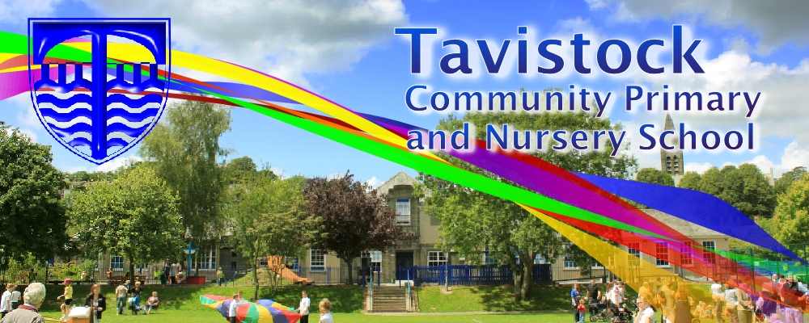

**Dates for your Diary:**

**10/01/17 Literacy workshop**

**19/01/17 Maths workshop**

**06 & 07/02/17 Parent consultations**

**24/03/17 Family Assembly**

**OUR THEME THIS TERM:**

**Traditional Tales**

**[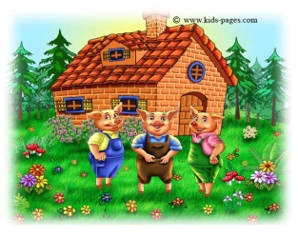](http://www.google.co.uk/url?sa=i&rct=j&q=&esrc=s&source=images&cd=&cad=rja&uact=8&ved=0ahUKEwiJ0d_Cn5jKAhUHWhQKHXtgAXEQjRwIBw&url=http://www.kids-pages.com/folders/stories/The_Three_Little_Pigs/page10.htm&psig=AFQjCNHZcxFgpX2rV070r8kgGf0b1Fla0g&ust=1452274828894830)**

**MATHS**: We are learning to estimate and check by counting carefully.

Adding two groups of objects together.

Beginning to record using marks and numbers.

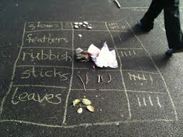

**LITERACY/COMMUNICATION AND LANGUAGE**

We will be reading, writing and talking about Traditional Tales, particularly about The Three Little Pigs, The Gingerbread Man, The Runaway Pancake and The Three Billy Goats Gruff.

**Physical Development** Being able to look out for others whilst running and chasing. To know what our bodies need to stay healthy.

**Personal, Social and Emotional Development**

Playing successfullly with others and using words to explain feelings. Talking with others and having the confidence to explore new activities.

***HOW CAN YOU HELP YOUR CHILD?***

***Read to your child regularly and talk about the pictures and what has happened in the story.***

***Play number games.***

**Understanding the World**

Talking about things that are the same and things that are different in the world around us.

Using our LearnPads.

**Expressive Arts and Design**

Drawing, painting and model making based on our topic.

Listening to and making music linked to our stories.

Our whole school focus is on

**LITERACY!**

Our **Skill for Success** this term is

Responsibility

**HOMEWORK:**

**Daily reading and talking about and finding numbers around us.**