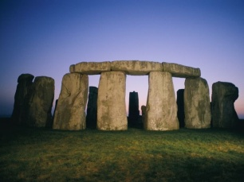

***HOW CAN YOU HELP YOUR CHILD?***

* READ with them EVERY night and TALK about the book – thoughts and understanding.
* SUPPORT them with their Maths homework by letting them SHOW YOU methods they have learnt at school.
* PRACTICE spellings daily, putting them into sentences to check understanding.
* **Talk, play and involve them with what you do. Always come and talk if you have any concerns.**

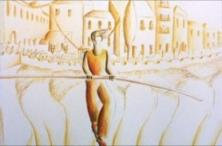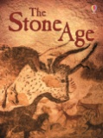

**English**

* To write a story based   
  on the animation   
  ‘El Caminante’
* Focusing on the book ‘Paint Me a Poem’, Year 4 will create a poem using a piece of art work as inspiration.

**THE STONE AGE IS OUR THEME THIS TERM:**

**Science**:

Sound, exploring how sound is generated and travels, including design a set of ear defenders.

**Art:**

Painting a self portrait to be linked with ‘Paint Me a Poem’ in English.

**History**:

How did life change for the people on Dartmoor between the Stone age and Iron age?

**Music:**

Playing steel drums to ‘Hot cross buns’

**READING & SPELLING**

* Children should **read for a**

**minimum of 15 mins** at home every

night – children should change their

books whenever they need to and record   
their reading in the Home School Diary.

PLEASE DISCUSS WITH YOUR CHILDREN WHAT THEY HAVE READ – ENCOURAGING THEM TO EXPAND ON THEIR THOUGHTS.

* **Spellings** sent home on **Fridays, spelling** **quiz** on **following Friday.** These are linked to our spelling, grammar and handwriting lessons. (Reading books & home/school diaries should come in every day).



**Children will have P.E. twice per week**

**KIT SHOULD STAY IN SCHOOL ALL WEEK: BLACK SHORTS, WHITE T SHIRT & TRAINERS.**

**Fundamental movement skills:** Mark Wicket will be focusing on movement skills needed for all sports during this one hour session

**Outdoor PE:** Orienteering, developing and understanding the skills needed to read a map and find locations.

**RE**

**Topics covered include**:  
Why are some journeys and places special? To include Islam, Hinduism, Buddhism, Judaism, and Christianity.

**Computing**This term, Year 4 will be focusing on online safety and how to create a safe online presence.



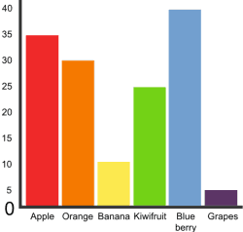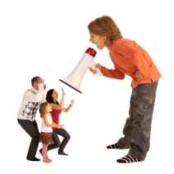

**MATHS:**

Pupils will be focusing on solving addition and subtraction problems in different contexts, explain their decision making and justify their answers.

Pupils can multiply numbers extending into decimals whole number are divided into 10 or 100 and connect this understanding to units of measure.

**HOMEWORK**Set on Friday and needs returning by the following Wednesday. Phonics/spelling relationships will be practised in class and consolidated through homework. Reading homework will alternate with English homework.

**Skill for Success** this term is

Responsibility