

***HOW CAN YOU HELP YOUR CHILD?***

* READ with them EVERY night and TALK about the book – thoughts and understanding.
* SUPPORT them with their Maths homework by letting them SHOW YOU methods they have learnt at school.
* PRACTICE spellings daily, putting them into sentences to check understanding.
* **Talk, play and involve them with what you do. Always come and talk if you have any concerns.**

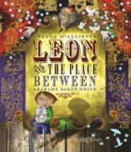

**THE UNITED KINGDOM IS OUR THEME THIS TERM:**

**Science**:

Investigating states of matter.

**Art/DT:**

Designing, building and a lighthouse with an electrical circuit

**Geography**:

Why do people think that England is the UK?

**Music:**

Learning the ukulele.

**LITERACY**

**Imaginative writing:** developing sentence   
structure and composition, vocabulary and organisation. Understanding and applying   
speech.

**Poetry:** writing Christmas poems which focus on poetic devices including similes, rhyming words and alliteration.



**READING & SPELLING**

* Children should **read for a**

**minimum of 15 mins** at home every

night – children should change their

books whenever they need to and record

their reading in the Home School Diary.

Please discuss with your children what they have read – encouraging them to expand on their thoughts.

* **Spellings** sent home on **Fridays, spelling** **quiz** on **following Friday.** These are linked to our spelling, grammar and handwriting lessons. (Reading books & home/school diaries should come in every day).

**Children will have P.E. twice per week**

**KIT SHOULD STAY IN SCHOOL ALL WEEK: BLACK SHORTS, WHITE T SHIRT & TRAINERS.**

**Swimming:** the children attend 45 minute ability grouped lessons. Children are assessed continually and move between groups as appropriate.

**Outdoor PE: invasion games. Children will be developing the range and consistency of their skills in basket ball.**



**ICT**

Toy designer:

Prototyping an interactive town using Scratch programme.

**PSHE/RE**

* Skills for success – self belief
* Caring for self and others.
* The Christmas journey.



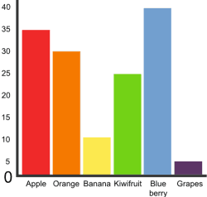

**MATHS:**

**Multiplicative Reasoning:** Pupils can explain the relationship between multiplication and division and the distributive and associative laws. They use this understanding to derive facts and solve problems.

**Geometric reasoning:** Pupils can explain the properties of the different triangles and quadrilaterals including angles and lines of symmetry.

**Number sense**: Pupils can make appropriate decisions about when to use their understanding of counting, place value and rounding for solving problems. Pupils can also explain representations of roman numerals.

**HOMEWORK**Set on Friday and needs returning by the following Wednesday. A grammar and phonic activities will be sent out on Friday and a challenge set on the Monday. There is also a times table /multiplicationchallenge every Friday.

Our whole school focus is on **reading!**

Our **Skill for Success** this term is

Self-Belief