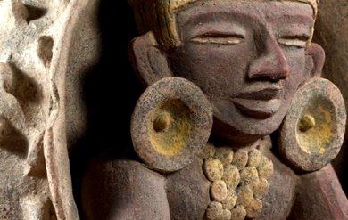

***HOW CAN YOU HELP YOUR CHILD?***

* READ with them EVERY night and TALK about the book – thoughts and understanding.
* SUPPORT them with their Maths homework by letting them SHOW YOU methods they have learnt at school.
* PRACTICE spellings daily, putting them into sentences to check understanding.
* **Talk, play and involve them with what you do. Always come and talk if you have any concerns.**



**THE MAYANS IS OUR THEME THIS TERM:**

**Science**:

Electricity, exploring electrical games and how to make an electric circuit sing appropriate materials.

**Art/DT:**

Researching Mayan art, designing and creating 3D Mayan masks.

**History**:

Who were the Mayans? Timelines, understanding and using the Mayan alphabet and number system, clothing and the Mayan creation story.

**Music:**

Singing and vocal arrangements – Mama Mia!

**LITERACY**

* **Imaginative writing:** developing sentence structure and composition, vocabulary and organisation. Understanding and applying speech.
* **Non-fiction texts:** writing letters focussing on sentence openers, technical vocabulary and using a wide range of sentence constructions.

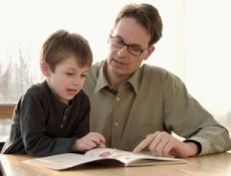

**READING & SPELLING**

* Children should **read for a**

**minimum of 15 mins** at home every

night – children should change their

books whenever they need to and record their reading in the Home School Diary.

PLEASE DISCUSS WITH YOUR CHILDREN WHAT THEY HAVE READ – ENCOURAGING THEM TO EXPAND ON THEIR THOUGHTS.

* **Spellings** sent home on **Fridays, spelling** **quiz** on **following Friday.** These are linked to our spelling, grammar and handwriting lessons. (Reading books & home/school diaries should come in every day).

**Children will have P.E. twice per week**

**KIT SHOULD STAY IN SCHOOL ALL WEEK: BLACK SHORTS, WHITE T SHIRT & TRAINERS.**

**Swimming:** the children attend 45 minute ability grouped lessons. Children are assessed continually and move between groups as appropriate.

**Outdoor PE: invasion games. Children will be developing the range and consistency of their skills in basket ball.**



**PSHE/RE**

* Skills for success – Resilience
* Caring for self and others, understanding emotions.

**ICT**

Designing and producing digital music altering pitch, pace and tone.



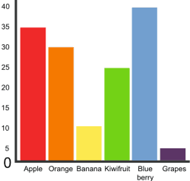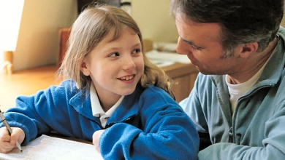

**HOMEWORK**Set on Friday and needs returning by the following Wednesday. Phonics/spelling relationships will be practised in class and consolidated through homework. Reading homework will alternate with literacy homework. There is also a times table /multiplicationchallenge every Friday.

**MATHS:**

* Learning and consolidation of multiplication

facts for 1 – 12 time tables.

* Number sense – understanding place values

to 1000, ordering, rounding and estimating number to 1000, solving number and practical problems.

* Additive reasoning – adding and subtraction number to 1000 using columnar method, understand the inverse of operations and solve two step problems.
* Measure – compare and calculate including money.
* Statistics – bar charts and time graphs.

Our whole school focus is on **communication!**

Our **Skill for Success** this term is

Resilience.