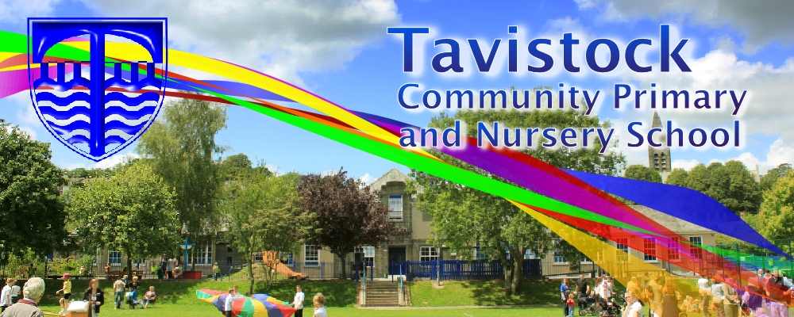 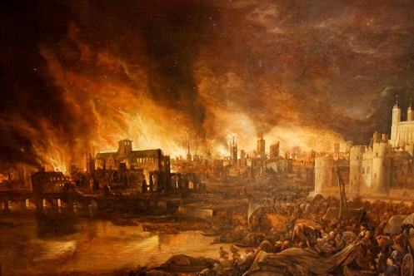

**DATES FOR YOUR DIARY**

* **2nd March World Book Day**
* **12th March class photos**
* **23rd March Year 2 assembly and book look**
* **27th March end of term assembly at St Eustachius 9.45am**



**ENGLISH**

**Our English work will include:**

* Writing information texts
* Writing instructions
* Developing reading comprehension and inference skills
* Developing sentences: using past tense correctly, adding suffixes, using a variety of punctuation

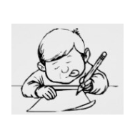

**This term we are going to be exploring:**

**Science**: Plants including investigations

**Art/DT:** Using clay and printing techniques.

**History/Geography**: What happened in the Great Fire of London and how we know

**Music:** Singing

**PSHCE:** Feeling good about myself

**ICT:** Researching areas of interest

**PE:** Coordination and ball skills

**MATHS**: This term, we will be learning to:

* Count in 2s, 3s, 5s and 10s from 0, know the

2x, 5x, and 10x table

* Adding and subtracting two 2-digit numbers mentally
* Finding difference
* Properties of 2D and 3D shapes and symmetry in 2D shapes
* Tell the time to the 5 minutes

**walked**, **hopped**,

**cried, baked, ran**

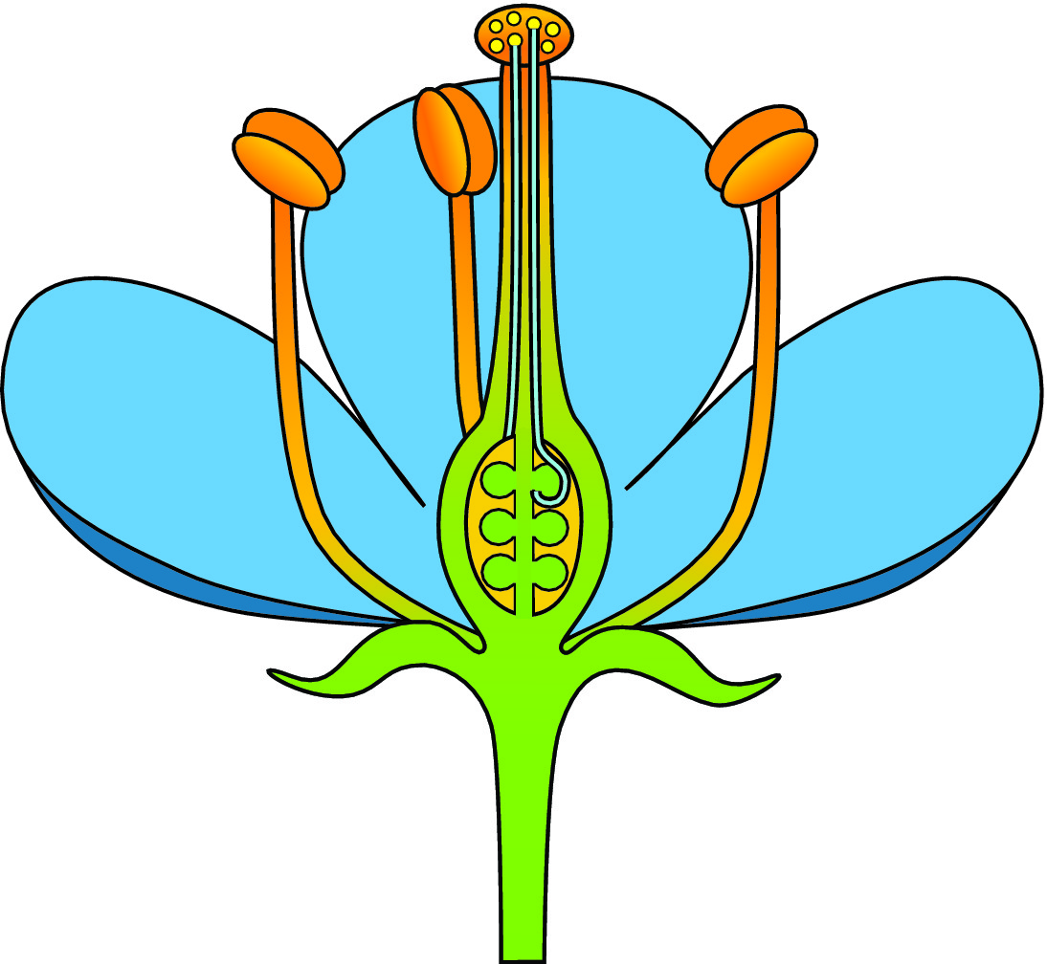

***SCIENCE***

* Pollination of plants
* What plants need to grow
* How plants take in water
* Plants for food

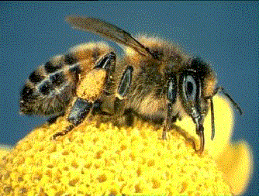

[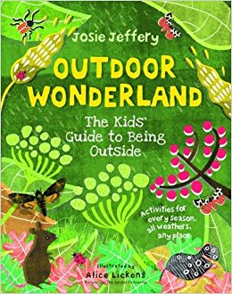](https://www.amazon.co.uk/Outdoor-Wonderland-Guide-Being-Outside/dp/1782400826)v

**LOVING READING**

Ask your child:

* to tell you about the book so far – what has happened
* to give alternative meanings for words and phrases
* what the author is telling the reader

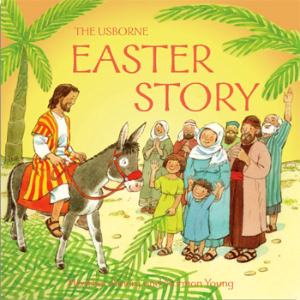

**RE**

* Jesus as a Leader
* Jesus healing people
* Easter story

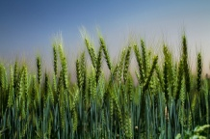

**HOT READS IN THE SCHOOL LIBRARY**

* Princess Scallywag and the Brave, Brave Knight
* Little Red Riding Hood

Our **Skill for Success** this half term is

**UNDERSTANDING YOURSELF – I know how I feel**

**HOMEWORK:**

**SET ON FRIDAY: IN ON WEDNESDAY**

**SPELLING TEST ON FRIDAY**