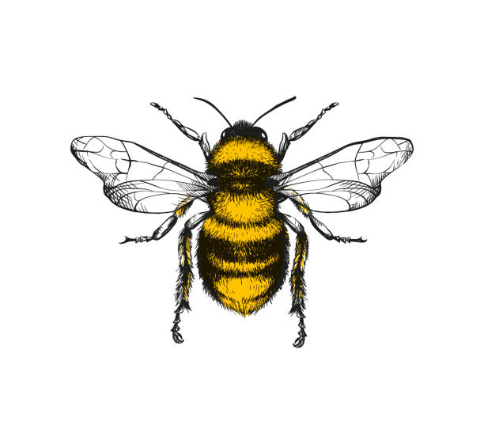

I can follow a two-part instruction

I can give my attention to an activity not of my own choosing

I understand how others may show their feelings

I can tidy up resources after using them and support others

I know how to keep my body healthy

I can talk about my feelings using a range of emotions

I know that I am special and unique and can talk about what I am good at

I can express my own needs/wants/opinions to others and elaborate on these

I understand that my words/actions affect others

I understand that others might look or act differently to me

I am confident to try new activities and enjoy challenges with adult support

I can say what I could do better next time when completing a task (Review my work)

I can go to the toilet independently and wash my own hands

I demonstrate perseverance and resilience if something gets tricky and am proud when I accomplish tasks.

I can problem solve and demonstrate my thinking

I can make independent choices

I can put on most items of clothing independently, including shoes

I understand and can apply the rules at nursery and I know how to behave in different contexts outside of nursery

I know how to keep my teeth and mouth healthy

I treat my own belongings, others belongings and nursery resources with respect

I can take simple steps to resolve conflict

**PSED**  
Every child will be able to happily greet and interact with others, sharing thoughts and resources patiently; valuing self and others and willing to persist and not be daunted by failure.

I have good relationships with adults and children

I can take turns with others with little support

I can work co-operatively as part of a team to solve a problem

I treat others fairly and kindly and demonstrate sensitivity to their needs

I have one or two special friends and can ask my friend if they are OK whilst upset