

***HOW CAN YOU HELP YOUR CHILD?***

* READ THEIR READING BOOKS WITH THEM EVERY DAY
* READ TOGETHER DAILY AND TALK ABOUT STORIES
* ASSIST WITH HOMEWORK ACTIVITIES AND SUPPORT THEIR LEARNING OF PHONICS SOUNDS.

[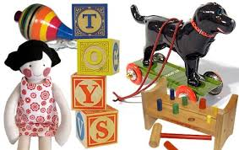](http://www.google.co.uk/url?sa=i&rct=j&q=&esrc=s&source=images&cd=&cad=rja&uact=8&ved=0ahUKEwj8jMaSz6PSAhVJbRQKHR1_BmwQjRwIBw&url=http%3A%2F%2Fsmallmagazine.typepad.com%2Fsmaller%2F2009%2F09%2Fsmall-play-old-fashioned-fun.html&psig=AFQjCNHAn6hC9ToYlxyb2uFNRwKEc4__Jg&ust=1487849774348981)

**LITERACY**

**Our literacy work will be based on our topic about toys:**

* **The Train Ride**
* **How to Wash a Woolly**

**Toys! IS OUR**

**THEME THIS TERM:**

**Science**: Identifying, naming, sorting and and describing common materials.

Designing a magnetic game.

**Art/DT:** Exploring and designing toys

with push, pull and hinge mechanisms.

**History/Geography**:

Comparing and describing old and new toys

**Music:** Singing and percussion – The train ride, Ship on the ocean, in the rhythm we walk and banana rap.

[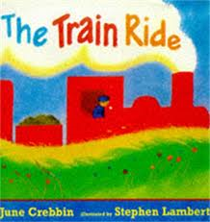](http://www.google.co.uk/url?sa=i&rct=j&q=&esrc=s&source=images&cd=&cad=rja&uact=8&ved=0ahUKEwj8i8qvzaPSAhXJvhQKHRVCD3AQjRwIBw&url=http%3A%2F%2Fwww.lovemybooks.co.uk%2Fthe-train-ride&psig=AFQjCNHDgveCsfI_EP9chdvuuRzOllreIg&ust=1487849478619698)

[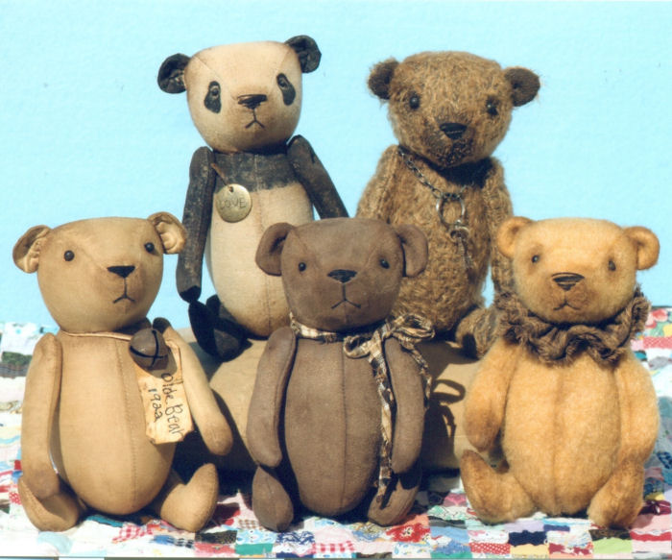](https://www.google.co.uk/url?sa=i&rct=j&q=&esrc=s&source=images&cd=&cad=rja&uact=8&ved=0ahUKEwiag4DJzqPSAhWDXhQKHRA9C2sQjRwIBw&url=https%3A%2F%2Fwww.pinterest.com%2Fmanonpopjes%2Fteddy-bears%2F&psig=AFQjCNFowOEQUXnSa8uZU-1QYnXbtOvJXQ&ust=1487849792495012)

**READING & SPELLING**

* Children should **read for a**

**minimum of 15 mins** at home every night – children should change their

books whenever they need to, on entry or at the end of the day.

* Reading books and home/school diaries should come into school every day.

Every half-term, new copies of recently published books will be available in the School Library. This half-term, the new books will be as follows:

* The Lumberjack's beard by Duncan Beedie
* Odd dog out by Rob Biddulph
* Mr Bunny's chocolate factory by Elys Dolan

Tell your children to look out for these in the School Library!

* Coordination: Ball skills
* Counter balance in pairs

**KIT SHOULD STAY IN SCHOOL ALL WEEK: BLACK SHORTS, WHITE TEE SHIRT & TRAINERS/PLIMSOLLS.**

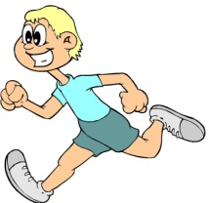

[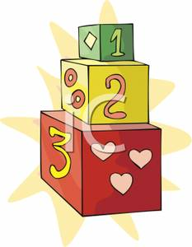](http://www.google.co.uk/url?sa=i&rct=j&q=cartoom+image+counting&source=images&cd=&cad=rja&docid=P5LnG7W1G413sM&tbnid=ElJIdtDFu5cwdM:&ved=0CAUQjRw&url=http%3A%2F%2Fwww.clipartreview.com%2Fpages%2F110824-235560-163009.html&ei=lBKvUpeqKOLA7Ab3s4AY&psig=AFQjCNFWo-dPPyBIaveit4Xqj-O7knGEzQ&ust=1387291653202545)

**MATHS**: In this year group the minimum

expectation is for your child to be able to:

* Read and write numbers from 1 to 100 in

numerals and to 20 in words as well

* Read, write and interpret mathematical statements involving addition (+), subtraction (-) and equals (=) signs
* Solve simple problems, with support, involving multiplication and division using objects or pictures

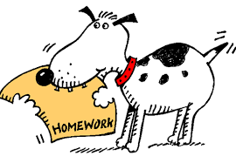



Our whole school focus is on

**Literacy**

Our Skill for Success this term is

**Understanding Yourself**

**HOMEWORK:**

**SET ON FRIDAYS**

**IN ON WEDNESDAYS**

**RE & PSHE**

Celebrations - birthdays and weddings!

**ICT**

We are Collectors – grouping and sorting toys.