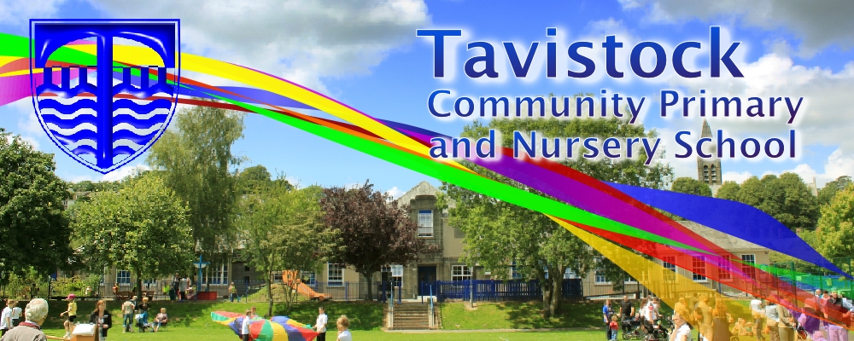
HOW CAN YOU HELP YOUR CHILD?
READ THEIR READING BOOKS WITH THEM EVERY DAY AND RECORD PROGRESS IN YOUR HOME SCHOOL DIARY.
ENJOY STORY TIME TOGETHER
ASSIST WITH HOMEWORK ACTIVITIES.
ALL ABOUT ME IS OUR THEME THIS HALF TERM:
Science: Naming parts of the human body and exploring our five senses.
Seasonal Changes: Autumn
Art/DT: portrait and autumn studies in paint and collage.
History/Geography: Where in the world have we been on holiday? Where in the world do we live? Identifying features of our local area.
Music: ‘Me and my body’ percussion. Dem bones, dem bones song and percussion.

LITERACY
Our literacy work will be based
on our all about me topic:
- All about me writing
- Funny Bones by Allan Ahlberg
- Senses Poems
We will be retelling the Funny Bones story using puppets and actions.

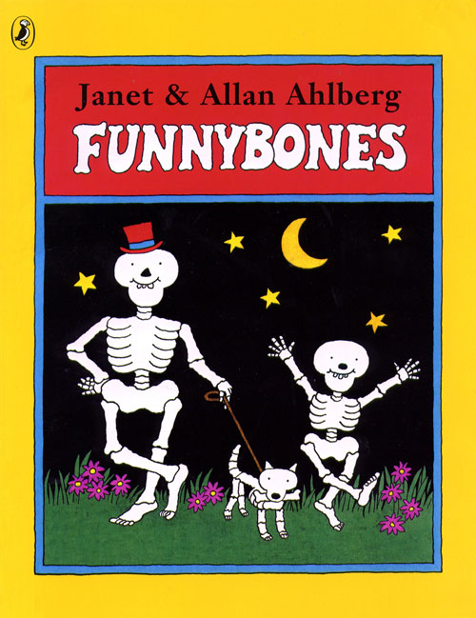

PE
Coordination: Floor movement patterns
Static balance: One leg standing
KIT SHOULD STAY IN SCHOOL ALL WEEK: BLACK SHORTS, WHITE TEE SHIRT & TRAINERS/PLIMSOLLS.

READING
- Children should read for a
minimum of 15 mins at home every
night – children should change their
books whenever they need to, on entry or at the end of the day.

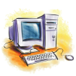
ICT
We are treasure hunters: Exploring algorithms.

RE & PSHE
New beginnings and myself.

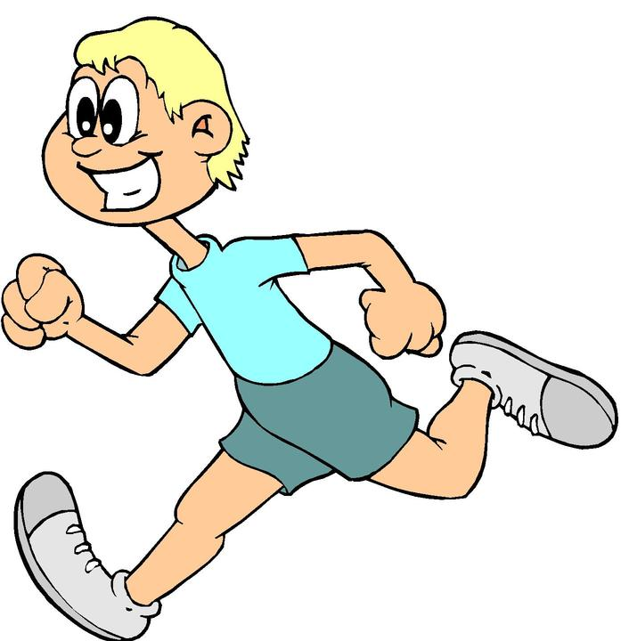
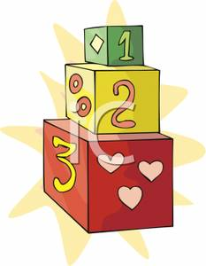
MATHS: In this year group the minimum
expectation is for your child to be able to:
- Read and write numbers from 1 to 100 in
numerals and to 20 in words.
- Read, write and interpret mathematical statements involving addition (+), subtraction (-) and equals (=) signs
- Solve simple problems, with support, involving multiplication and division using objects or pictures

Our whole school focus is on Communication
Our Skill for Success this term is
Resilience
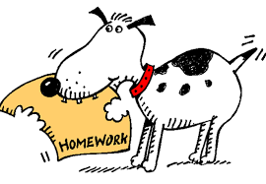
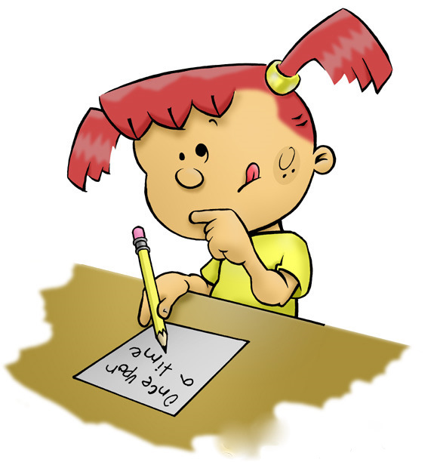
HOMEWORK:
SET ON FRIDAYS
IN ON WEDNESDAYS

