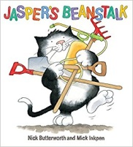

**Dates for your Diary:**

**We are arranging more drop-in sessions with the Health Visitor, Tavistock Library and the Children’s Centre. Further details will follow through letters and texts.**

**Outside play**

***We play outside every day, whatever the weather! This term we will be:***

* ***Searching for minibeasts***
* ***Making rockets to go to space***
* ***Growing beans and planting seeds***
* ***Role playing***
* ***Exploring in the sand, the water and the mud***
* ***Climbing up, over and under and riding around***

**Let’s Talk More!**

Give a choice of 2:

* At snack time, ‘apple or banana?’
* At bath time, ’wash tummy or toes?’
* At play, ‘Shall we play with cars or jigsaws?’

Why do this?

* Giving choices helps children realise their words can influence their environment
* Children learn new words and have more opportunities to talk

**Summer term topics!**

**‘Jasper’s Beanstalk’, ‘Minibeasts’ and**

**‘Space’**

* Planting our own beanstalks
* Playing the ‘Bean game’
* Minibeasts vocabulary
* Expressing our feelings like ‘The Bad Tempered Ladybird’
* Observing caterpillars change into butterflies
* Retelling ‘the Very Hungry Caterpillar’ story
* In Phonics we will be learning about our voice

sounds and initial letter sounds.

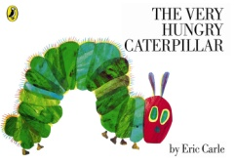

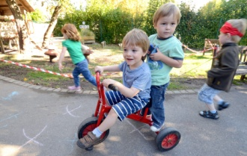

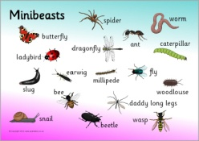

**Mathematics skills**

* Counting, counting, counting!
* Recognising and drawing numbers and matching numbers to groups of objects.
* Playing number games and solving number problems.
* Singing number songs and action rhymes.
* Recognising and naming the shapes.

***How can I help my child***

***with early reading and writing?***

* Share books with them every day and talk about stories.
* Encourage them to make marks and have a go at their own writing.
* Role model reading books and writing e.g. shopping lists and cards.

**Nursery information**

* *Our “Ask me about” whiteboard tells you all about the day’s learning.*
* *All Nursery children have a* ***key person****, we all know your child, but this person will know him or her best.*
* *We take part in daily physical activity as well as messy play. Practical clothing and spare clothes on a child’s peg are a great help!*







Ask me about...

Our **Skill for Success** this term is

**Co-operation**

