|  |
| --- |
| Our theme this half term is:  **Mini-beasts**  **bb.jpg** |

|  |
| --- |
| Our whole school focus is on **TALK**  C:\Users\00CSmith\AppData\Local\Microsoft\Windows\Temporary Internet Files\Content.IE5\3VOT9909\Talk_WAlk[1].png |

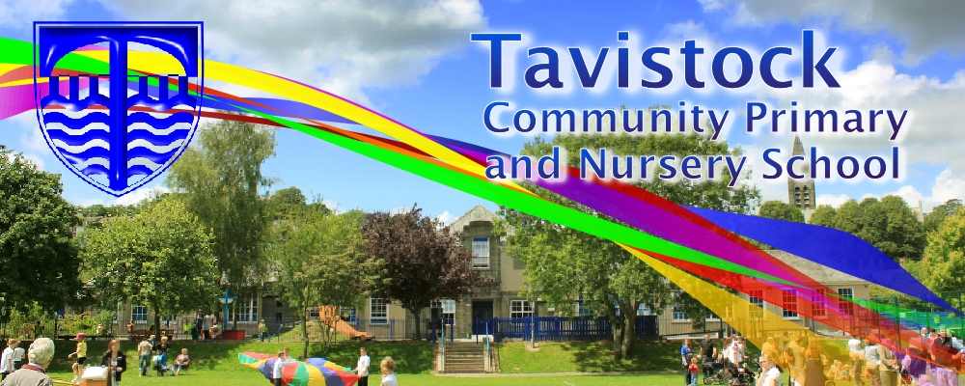

|  |
| --- |
| This half term we plan to have a focus on the following areas:  **Prime Areas of Learning**  **Personal, social and emotional development**  Taking account of one another’s ideas about how to organize an activity.  Identifying when help is needed. Being aware of the feelings of others.  **Communication and Language**  Listening attentively in a range of situations. Responding to ideas expressed by others in conversation or discussion.  **Physical Development**  Understanding why we need a range of healthy foods. Traveling with confidence and skill around, under, over and through balancing and climbing equipment.  **Specific Areas**  **Literacy**  Linking sounds to letters (Phase 3 and 4 Letters and Sounds,) blending and segmenting simple words to read and write simple sentences, developing sight vocabulary of ‘tricky words’ and common decodeable words. (Please see the front of your child’s reading diary for a list of them.) Tackling a wider range of text with confidence.  **Mathematics**  Counting accurately to 20 and beyond, adding and subtracting two single-digit numbers and counting on or back on a number line to find the answer. Solving problems, including doubling, halving and sharing.  **Understanding the World**  Developing ICT skills using Learn Pads. Noticing similarities and differences in relation to places, objects, materials and living things.  **Expressive Arts and Design**  Building up a repertoire of songs, exploring the sounds different musical instruments make, using and exploring a variety of materials, tools and techniques, experimenting with colour, design, texture, form and function. |

|  |
| --- |
| **We plan to change reading books on Monday and Thursday. You are welcome to change your child’s book more frequently if you want to.**  **Curious%20kids%20guide%20insects%20and%20bugs.png** |

|  |
| --- |
| Skill for Success  Co-operation |

|  |
| --- |
| **Dates for your diary:**  **18/4 – Parents’ evening 3.30pm onwards**  **19/4 Parents’ evening 5.00pm onwards**  **20/5 Class 2and 3 Family Assembly**  **17/6 Class 2 and 3 trip to Wembury – details to follow**  **20/6 TBC Sports Morning**  **27/6 ‘Moving on up’ day – details to follow**  **18/7 End of year assembly (tbc)** |

|  |
| --- |
| **Please feel free to come and talk to your child’s class teacher after school if you have any worries or concerns. We have an open door policy!**  **door.jpg** |