

***HOW CAN YOU HELP YOUR CHILD?***

* READ with them EVERY night and TALK about the book – thoughts and understanding.
* SUPPORT them with their Maths homework by letting them SHOW YOU methods they have learnt at school.
* PRACTISE spellings daily, putting them into sentences to check understanding.
* Talk, play and involve them with what you do. Always come and talk if you have any concerns.



**Living things and their   
habitats   
is our theme this term:**

**Science**:

**Living things and their habitats,** we will be looking at a variety of habitats and the living things that are found there.

**Art/DT:**

Designing and creating bug hotels.

**Geography**:

**What does the captain of a ship need to be able to navigate safely at sea?** Exploring oceans and continents, reading longitude and latitude on a world map and exploring the effects of different time zones.

**LITERACY**

* **Imaginative writing:  
  Newspaper article -** To be able to write a descriptive newspaper report to include interviews, images, facts and speculation.
* **Non-fiction texts:** **Persuasive letter writing -** To create a persuasive letter using literary features to provoke thought and emotion.

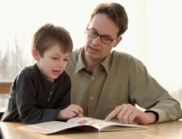

**READING & SPELLING**

* Children should **read for a minimum of 15   
  mins** at home every night – children should   
  change their books whenever they need to   
  and record their reading in the Home School Diary.

PLEASE DISCUSS WITH YOUR CHILDREN WHAT THEY HAVE READ – ENCOURAGING THEM TO EXPAND ON THEIR THOUGHTS.

* **Spellings** sent home on **Fridays, spelling** **quiz** on **following Friday.** These are linked to our spelling, grammar and handwriting lessons. (Reading books & home/school diaries should come in every day).

**PE**

**KIT SHOULD STAY IN SCHOOL ALL WEEK: BLACK SHORTS, WHITE T SHIRT & TRAINERS.**

**Outdoor and indoor PE: Cricket, Children will be developing movement skills, team work, bat and ball skills as well as team strategies.**

**Swimming sessions (each Wednesday afternoon at meadowlands)**



**PSHE/RE**

**PSHE** – Liking and loving, how do we care for people, transition to new year group, sharing.  
**RE** – Buddhism.

**ICT**  
To research   
and create   
an information presentation relating to geographical features and time zones of the world.

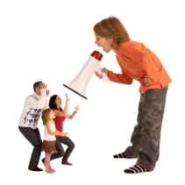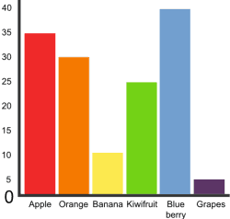

Our whole school focus is on

literacy

Our **Skill for Success** this term is   
Risk Taking!

**MATHS:**

* Pupils can represent and explain how the   
  multiplicative nature of the number system   
  extends into decimal numbers, as whole numbers  
   are divided by 10 or 100 and connect this understanding to units of measure
* Multiplicativereasoning - Pupils can solve problems involving multiplication, division and fractions in different contexts.
* Geometric reasoning - pupils can explain how to find the perimeter and area of a shape and how to complete a symmetrical shape with a given line of symmetry, using this knowledge and understanding to solve problems

**HOMEWORK**Set on Friday and needs returning by the following Wednesday. Phonics/spelling relationships will be practised in class and consolidated through homework. Reading homework will alternate with literacy homework. There is also a times table /multiplicationchallenge every Friday.