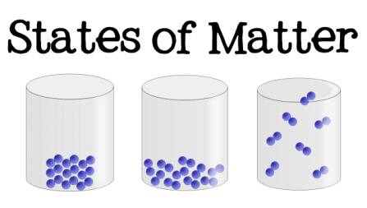

***HOW CAN YOU HELP YOUR CHILD?***

* READ with them EVERY night and TALK about the book – thoughts and understanding.
* SUPPORT them with their Maths homework by letting them SHOW YOU methods they have learnt at school.
* PRACTISE spellings daily, putting them into sentences to check understanding.
* **Talk, play and involve them with what you do. Always come and talk if you have any concerns.**

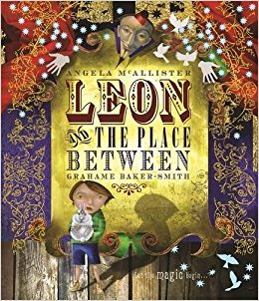

**English**

This half term we will be focusing on  
the book Leon and The Place   
Between  
by Angela McAllister.

The key outcome is for children to create their own version of Leon’s story from the point that he travels though a magical portal into a mysterious world

**States of Matter is our theme this term:**

**Science**:

States of Matter, we will be exploring different states of matter and how an object can change between the states.

**Art/DT:**

In Design and Technology we will be making an electronic steady hand game using a simple circuit.

**Geography**:

Which countries form the UK?

The class will be exploring the countries within the UK and the local history of Tavistock.

**Music:**

Singing and vocal arrangements –Christmas songs.

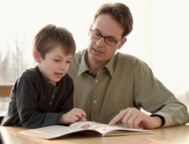

**READING & SPELLING**

* Children should **read for a**

**minimum of 15 mins** at home every

night – children should change their

books whenever they need to and record their reading in the Home School Diary.

PLEASE DISCUSS WITH YOUR CHILDREN WHAT THEY HAVE READ – ENCOURAGING THEM TO EXPAND ON THEIR THOUGHTS.

* **Spellings** sent home on **Fridays, spelling** **quiz** on **following Friday.** These are linked to our spelling, grammar and handwriting lessons. (Reading books & home/school diaries should come in every day).

**Children will have P.E. twice per week**

**KIT SHOULD STAY IN SCHOOL ALL WEEK: BLACK SHORTS, WHITE T SHIRT & TRAINERS.**

**Swimming:** the children attend 45 minute ability grouped lessons. Children are assessed continually and move between groups as appropriate.

**Outdoor PE: invasion games. Children will be developing the range and consistency of their skills in basket ball.**

**Computing**Cross curricular link with ‘Why do people think that England is in the UK?’   
using research  
 tools.

**PSHE/RE**

Skills for success – Self-belief.

Caring for self and others, understanding emotions.



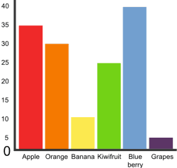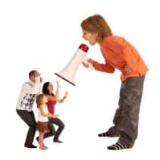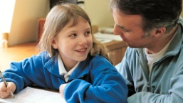

**MATHS:**

Pupils can explain the relationship between multiplication and division. They use this   
understanding to derive facts and solve problems.

We will also be focusing on explaining the properties of different triangles and quadrilaterals including angles and lines of symmetry.

Our **Skill for Success** this term is

Self-belief.

**HOMEWORK**Set on Friday and needs returning by the following Wednesday. Phonics/spelling relationships will be practised in class and consolidated through homework. Reading homework will alternate with literacy homework. There is also a times table /multiplicationchallenge every Friday.