 

***HOW CAN YOU HELP YOUR CHILD?***

* READ THEIR READING BOOKS WITH THEM EVERY DAY AND TALK ABOUT STORIES
* INVOLVE THEM IN CONVERSTAIONS ABOUT WHAT YOU ARE DOING AND THEIR DAY.
* ASSIST WITH HOMEWORK ACTIVITIES AND SUPPORT THEIR LEARNING OF PHONICS SOUNDS.

**Plants and growing IS**

**OUR THEME THIS TERM:**

**Science**: Plants (growing cress)

and seasonal changes

**Art/DT:** Eric Carle inspired printing and painting, forest animals

**History/Geography**: Exploring the Rainforest and its layers.

**Music:** Singing, rhythm and pulse and assembly songs.

**English**

Our English work will be based on our plants and growing theme. The following books will be our key texts:

* **The Tiny Seed**
* **Oi Frog!**

We will use our assembly to improve

our speaking and performance skills.

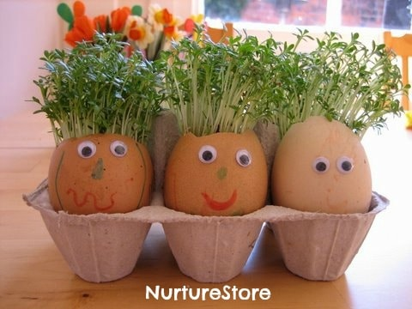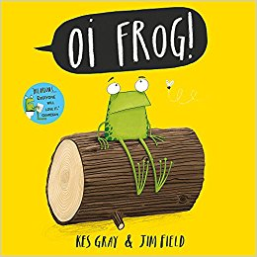 [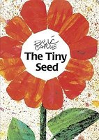](http://www.google.co.uk/url?sa=i&rct=j&q=&esrc=s&source=images&cd=&cad=rja&uact=8&ved=0ahUKEwil7p6l463TAhXB2xoKHdzaDyoQjRwIBw&url=http://www.goodreads.com/book/show/241074.The_Tiny_Seed&psig=AFQjCNHc-pCD7c8vxCU4RfJ-lvooCvlDlQ&ust=1492597003366345)

**Reading & Spelling**

* Children should **read for a minimum of 15 minutes** at home every day – children should change their books on entry when required.
* Reading books and home/school

diaries should come into school

every day.



**RE & PSHE**

* Relationships and special people.
* Belonging
* Coordination with equipment.
* Sports day practice
* **NO KIT IS REQUIRED IN YEAR 1 FOR PE**

**Computing**

We are storytellers using the learn pads.



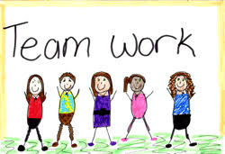

**MATHS**: This term we will be:

* Read and write numbers from 1 to 20 in

numerals and words

* Count in multiples of 2, 5 and 10
* Measurement - time – hours, minutes and seconds
* Adding and subtracting two digit numbers to 20
* Recording number sentences in different ways,

e.g. 16 = 10 + 6 20 – 14 = 6

[](http://www.google.co.uk/url?sa=i&rct=j&q=cartoom+image+counting&source=images&cd=&cad=rja&docid=P5LnG7W1G413sM&tbnid=ElJIdtDFu5cwdM:&ved=0CAUQjRw&url=http://www.clipartreview.com/pages/110824-235560-163009.html&ei=lBKvUpeqKOLA7Ab3s4AY&psig=AFQjCNFWo-dPPyBIaveit4Xqj-O7knGEzQ&ust=1387291653202545)



Our Skill for Success this term is

**Co-operation – Let’s work together**

**HOMEWORK:**

**SET ON FRIDAYS**

**IN ON WEDNESDAYS**