[](https://www.google.co.uk/url?sa=i&source=images&cd=&cad=rja&uact=8&ved=2ahUKEwi44OaF0KXbAhUCvRQKHV4ZCYIQjRx6BAgBEAU&url=https://www.amazon.co.uk/Billys-Bucket-Kes-Gray/dp/0099438747&psig=AOvVaw16A7Dpe3MUEyp0ThlUBDnD&ust=1527501334966220)[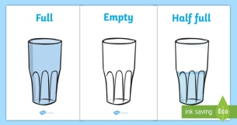](https://www.google.co.uk/url?sa=i&source=images&cd=&cad=rja&uact=8&ved=2ahUKEwjK3oOj0KXbAhXKchQKHZZBD80QjRx6BAgBEAU&url=https://www.twinkl.co.uk/resource/t-n-116-capacity-display-posters-cups&psig=AOvVaw1UvPEamyjCNTr01f0VgftF&ust=1527501392097431)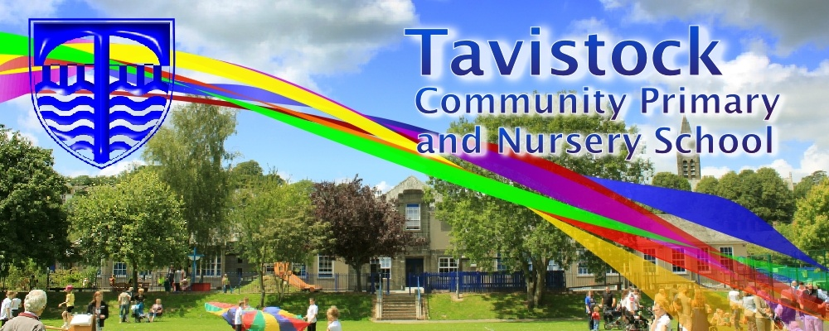

**Dates for your Diary;**

**15/6/18** Reception trip to Plymouth Aquarium

**22/6/18** Family Assembly

**22/6/18** Summer Fayre

**25/6/18** Multi Skills

**2/7/18** Reception/KS1 Sports Day

**5/7/18** Reports home

**9/7/18** Parents’ Eve

**11/7/18** Moving on up day

**23/7/18** End of Year assembly

**MATHS**: This term we will be:

* Counting with numbers up to 20 and

beyond

* Solving problems including doubling
* Halving and sharing and multiplying numbers
* Investigating 2D and 3D shapes
* Using mathematical language to describe shapes
* Finding out about capacity

**OUR THEME THIS TERM:**

***The Sea***

[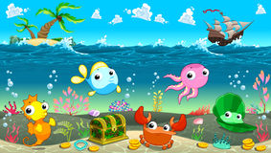](https://www.google.co.uk/url?sa=i&rct=j&q=&esrc=s&source=images&cd=&cad=rja&uact=8&ved=0ahUKEwiP3p7wh4bUAhWE2hoKHTXECUEQjRwIBw&url=https://clipartfest.com/categories/view/8bf4d9d9041389cf336af476d723fc69bbedf1b2/free-clipart-under-the-sea.html&psig=AFQjCNH_rf2iDbUGt3fN0b5dBxZIiQlXPA&ust=1495630464596070)

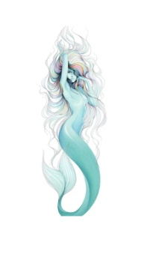

**LITERACY/COMMUNICATION**

**AND LANGUAGE**

We will be reading, writing and talking about

sea animals, mermaids, pirates, rock-pools,

sharks, submarines and boats using fiction and non-fiction books.

Key texts include: **Commotion in the Ocean, Billy’s Bucket, The Singing Mermaid, Tiddler, Submarines and Surprising Sharks**.

***HOW CAN YOU HELP YOUR CHILD?***

***Read to your child regularly and talk about what has happened in the story. Widen vocabulary by asking for alternative words.***

***Talk about number problems using numbers to 20 and beyond and doubling, halving and sharing. Names and properties of 2D and 3D shapes***



**Physical Development**

We will be practising for sports day. **Your child will need a P.E kit in school each day.**

**Personal, Social and Emotional Development**

We will be developing our ability to work as part of a group and be sensitive to other people’s needs and feelings.

**Understanding the World**

* We will be using Google Earth to look at the sea and our world.
* We will be looking at different experiences at the seaside.

**Expressive Arts and Design**

We will be drawing, painting and model making, listening to and

Making music linked to our theme.

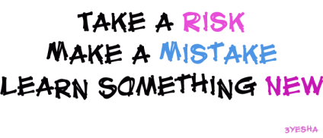[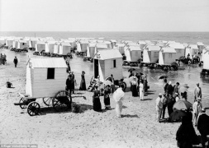](https://www.google.co.uk/url?sa=i&source=images&cd=&cad=rja&uact=8&ved=2ahUKEwiji4jJ0KXbAhUEShQKHS9VAiYQjRx6BAgBEAU&url=https://www.pinterest.co.uk/pin/541276448938615391/&psig=AOvVaw2Y9UA5lCDPGJ0MEjKCxGRo&ust=1527501451234286)

**HOMEWORK:**

10-15 minutes of daily reading, including tricky words and letter sounds labelled ‘Phase 4’ in the front of our reading diaries. Continue to practise correct formation of cursive letters using the guide that you had last term.

Our **Skill for Success** this term is

**Risk-Taking**