 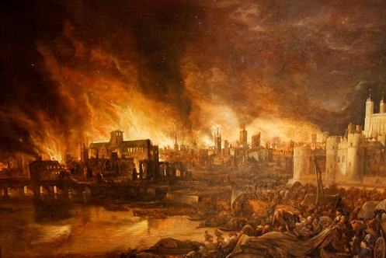

**DATES FOR YOUR DIARY**

**3rd March – World Book Day**

**4th March - Year 2 assembly 9.15am**

**8th March - Year 2 Come and read 9.00 – 9.30am**

**23rd March – Curriculum sharing 2.15pm – 3.00pm**



**LITERACY**

**Our literacy work will include:**

* Writing diary entries
* Writing a newspaper report
* Descriptive writing
* Developing sentences: using past tense correctly, adding suffixes, using a variety of punctuation

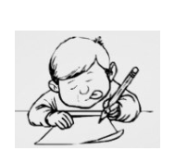

**This term we are going to be exploring:**

**Science**: Plants including investigations

**Art/DT:** Using a variety of media to create imagery including puppets

**History/Geography**: What happened in the Great Fire of London and how we know

**Music:** Playing the glockenspiel, musical language and notation, singing

**PSHE:** Feeling good about myself

**ICT:** Coding and debugging programs

**PE:** Sequencing balances using apparatus

**MATHS**: This term, we will be learning to:

* Count in 2s, 3s and 5s from 0
* Adding and subtracting two 2-digit numbers
* Compare and order measurements including length, volume, mass, temperature and time intervals
* Properties of 2D and 3D shapes and symmetry in 2D shapes

**walked**, **hopped**,

**cried, baked, ran**

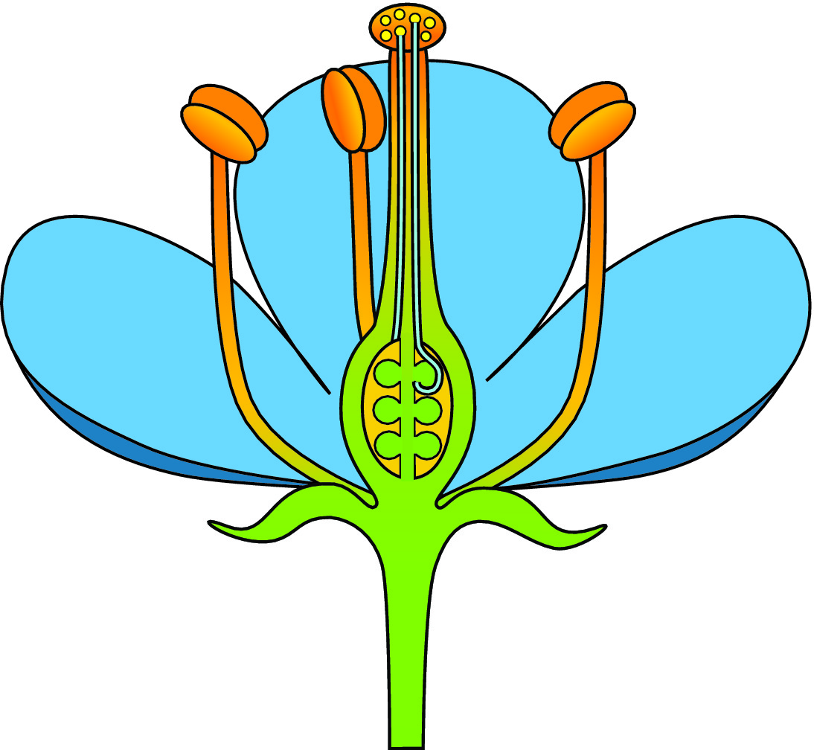

***SCIENCE***

* Pollination of plants
* What plants need to grow
* How plants take in water
* Plants for food

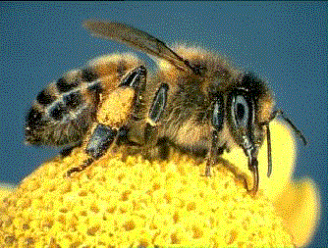

**LOVING READING**

Sharing reading with your child is invaluable – discuss your favourite parts of a story, how it made you feel and what you thought about the characters.

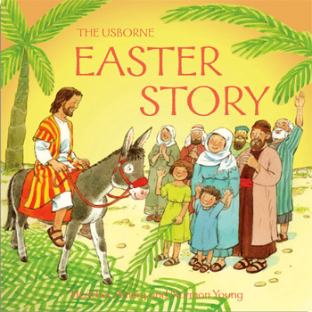

**RE**

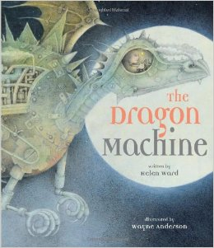

* Jesus as a Leader
* Jesus healing people
* Easter story

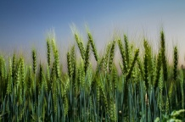

**Maths course for parents and children Fridays 26/2, 4/3, 11/3 and 18/3 – please sign up at office.**

**LOTS OF TOP TIPS TO MAKE MATHS FUN!**

Our **Skill for Success** this half term is

**UNDERSTANDING YOURSELF – I know how I feel**

**HOMEWORK:**

**SET ON FRIDAY: IN ON WEDNESDAY**

**SPELLING TEST ON FRIDAY**