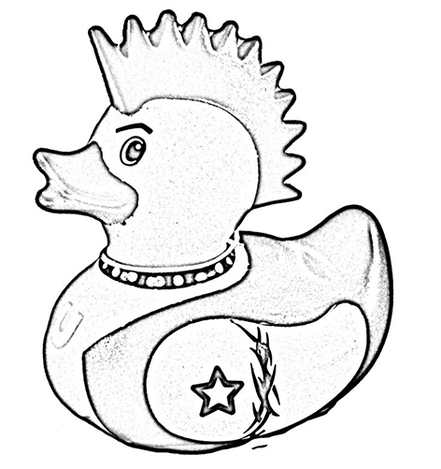
Tavistock Community Primary & Nursery School

HSA Newsletter Easter 2017

Fundraising updates ...
The Valentine's Disco was enjoyed by all the children (and the dancing staff) and raised over £200 which is a fantastic amount! Thank you to everyone who donated cakes.

Bags 2 school is THIS FRIDAY – 3rd March. You should have already received your bag to fill.

Coming up ...
It's that time of year again. The tension is palpable and the eggs-itement almost unbearable. The Great Tavy Duck Race looms large on the horizon - Friday 31st March at 3.30pm to be precise, the last day of term. This year things will be a little different. We (the lovely ladies of the HSA) plan to sell numbers for the school ducks in the week running up to the race itself to reduce the mad rush on the day. In addition to this, people are welcome to bring their own duck(s), but there will NOT be a competition for decoration this year. Entry is £1 per duck (whether school or own). Donations of Easter Eggs are also welcome and can be left at the school office from Monday 27th March. We look forward to seeing you all there for this eggs-iting end of term celebration.

Later in the year ...
This year’s Summer Fair will be on Friday 23rd June 2017 and the theme is “Beside The Seaside”. Any volunteers to help before, or on the day would be gratefully received. Either speak to one of the HSA members or email Katherine Wing on kwing1st@gmail.com.
Also in June/July, the HSA need to start planning the coming year’s Christmas Card arrangements. Shaun West has managed this brilliantly in the past few years, but is unable to do it this year – huge thanks to Shaun for your efforts in previous years. If you would like to be involved in helping in this way, please get in touch (email as above). You do not need to be able to attend our normal HSA meetings, as long as you can update one of us, so if you would like to help but can’t come along to our usual meetings, don’t let that put you off. We’d love to hear from you!

Ongoing fundraising..
2 ways you can help without giving up time or money…
If you are shopping online, please go through our Easyfundraising page. It is free for you, and we get a proportion of what you spend – give it a try!
If you receive a Riverford box, or are thinking of trying it, please quote our school reference – SCH1174 and we will get a donation from them.

* * * * * * * * * * * * * * * * * * * * * * * * * * * * * * * * * * * * * * * * * * * * * * * * * * * * * * * * * * * * * * * * * * *

The HSA meets every Friday morning between 9am and 9.45am in the old nursery building (now where Breakfast Club & After School Club are based). Come and have A COFFEE AND A CHAT, and meet other parents while younger children can play - you can be assured of a warm welcome.

