

**Please Remember!**

**We take part in daily physical activity as well as messy play. Please ensure that your child comes to Nursery in named practical clothing.**

**Spring term topics!**

This term our first topic will be all about toys!

Learning will include talking about what toys we got for Christmas, junk-modelling toys, toy shop role-play, observational drawings of toys, writing shopping lists, estimating and counting sets of toys.

  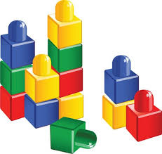

Other topics this term will include Chinese New Year, people who help us and Valentines Day.

**Coming up!**

Phonics and early reading workshop will be Tuesday 10th January 2017.

Early Mathematics workshop will be Thursday 19th January 2017.

**ALL ABOUT NURSERY...**

Your child will change and develop a lot in their time at Nursery. These are just some of the things they may learn to do...

* Talk and listen in lots of different situations

* Recognise and maybe write my name

* Pour my own drinks

* Use the toilet independently

* Remember to wash my hands

* Dress myself e.g. put on my own coat and shoes

* Make choices e.g. what I want to play with, what I would like to choose from the snack cafe

* Tell you what I have been learning

* To have a go at new things

* Not to worry if I cannot do something the first time

* Play with others and learn to take turns

* Talk about and use numbers and shapes

* And lots more!

***Please come and talk to a member of staff if you would like to know more about our Nursery Curriculum***

***How can I help my child with early reading and writing?***

* Share books with them every day and talk about stories.
* Encourage them to make marks and have a go at their own writing.
* Role model reading books etc and writing e.g. shopping lists, cards etc.

Our whole school focus is on **Literacy!**

Our **Skill for Success** this term is Responsibility.

**Mathematics**

**Examples of Nursery targets are**:

* I am starting to use different things to help me count.

* I can sometimes match a number with an amount correctly.

* I try and answer number questions.

* I am beginning to enjoy drawing numbers in different ways.

* I am starting to realise that a group can be split into various smaller groups, but still add up to the same number.

**Please also encourage these skills in your play at home.** 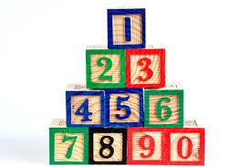

[](http://www.google.co.uk/url?sa=i&rct=j&q=CARTOON+IMAGE+OF+CHILD+READING&source=images&cd=&cad=rja&docid=GDIKGDhxjnSlLM&tbnid=28mnPTmCZ2AjFM:&ved=0CAUQjRw&url=http://www.dreamstime.com/stock-image-family-reading-cartoon-image14049521&ei=CmZeUvbNLY6whAfrw4G4Cg&psig=AFQjCNF24QcVcYTwEw65CeNPxQ38MYm6Pw&ust=1382004602345694)