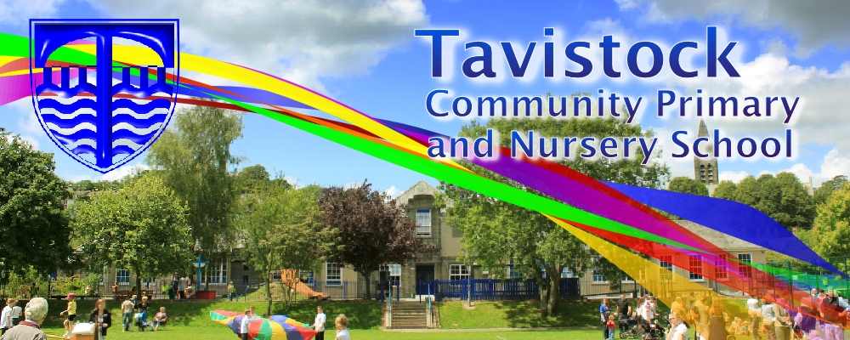

**Dates for your Diary;**

**9th June** – Multi cultural day at College of St Mark and St John

**23rd June** – Summer Fayre – 6.00pm

**5th July** – Sports Day – details to follow

**3rd July** – Moving on up day

**6th July** – Reports to parents

**7th July** – Trip to the Aquarium

**10th July** – drop in parents evening 3.15-5pm

**12th July** – ‘join us in class’ session

**OUR THEME THIS TERM:**

The Sea

[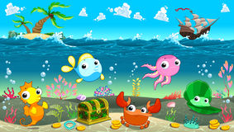](https://www.google.co.uk/url?sa=i&rct=j&q=&esrc=s&source=images&cd=&cad=rja&uact=8&ved=0ahUKEwiP3p7wh4bUAhWE2hoKHTXECUEQjRwIBw&url=https%3A%2F%2Fclipartfest.com%2Fcategories%2Fview%2F8bf4d9d9041389cf336af476d723fc69bbedf1b2%2Ffree-clipart-under-the-sea.html&psig=AFQjCNH_rf2iDbUGt3fN0b5dBxZIiQlXPA&ust=1495630464596070)

**MATHS**: We will be counting with numbers up to 20 and beyond. Solving problems including doubling, halving and sharing and multiplying numbers. Investigating 2d and 3d shapes and using mathematical language to describe them.

**LITERACY/COMMUNICATION AND LANGUAGE**

We will be reading, writing and talking about the sea animals, mermaids, pirates, rock-pools, sharks, submarines and boats using fiction and non-fiction books. Key texts include: Sally and the limpet, Barry the fish with fingers, Tiddler, The Storm Whale and the Snail and the Whale.

***HOW CAN YOU HELP YOUR CHILD?***

***Read to your child regularly and talk about what has happened in the story. Widen vocabulary by asking for alternative words.***

***Talk about number problems using numbers to 20 and beyond.***

**Physical Development**

We will be practising for sports day. **Your child will need a P.E kit in school each day.**

**Personal, Social and Emotional Development**

We will be developing our ability to work as part of a group and be sensitive to other people’s needs and feelings.

**Understanding the World**

We will be using Google Earth to look at the sea and our world.

We will be looking at differences between

seaside holidays now and in the past.

**Expressive Arts and Design**

We will be drawing, painting and model making.

listening to and making music linked to our theme.

**HOMEWORK:**

**Daily reading, including tricky words (these are in the front of our reading records.)**

Our whole school focus is on

**LITERACY!**

Our **Skill for Success** this term is

**Risk-Taking**