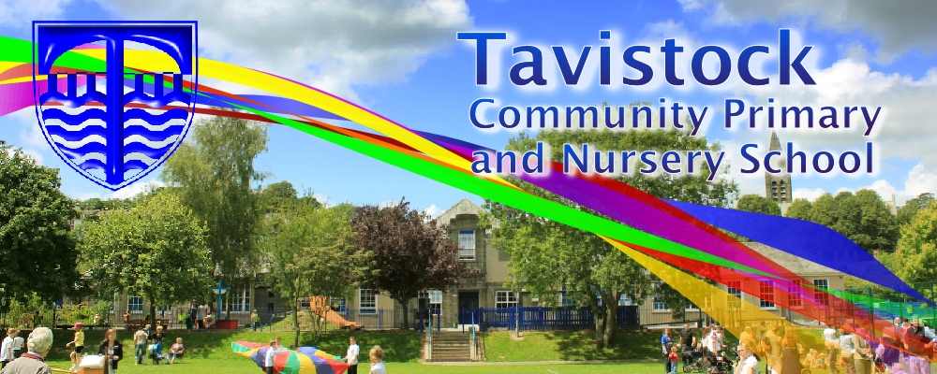

Dates for your Dairy:

8th January – Cross country trials for school team 1.30pm school field.

27th January - Year 3 assembly 9.15am

6th & 7Th February Parent’s evening

7th February – Safer Internet day.

9h February – Cross country race at TCPS after school.

9th February - Valentine’s disco

10th February – Last day of half term.

**OUR THEME THIS TERM:**

**Ancient Egypt** 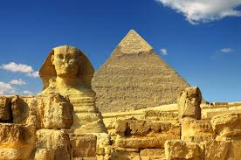

**Science**: Forces and Magnets

**History**: Ancient Egypt

**Music:** Recorders and Benjamin Britten – There was a monkey.

**PE:** Gymnastics, tennis, movement and balance

**MFL:** Bonne Annee! Action words, Les Saisons Recap on numbers, Alphabet and spelling,

**PSHE:** Keeping myself safe.

**RE**: Hindu worship, Shrines in Hindu homes, Aum symbol and its importance to Hindus, Religious meanings, Symbols in places of worship, Everyday signs and symbols

**MATHS**: In maths we are covering:

*Adding and subtracting*

*Measuring*

*Statistics*

*Place Value*

*Fractions*

**LITERACY**

**Fiction Writing** – We will be watching the animated film – What’s new Scooby Doo - to use the main features of the film to write the story; creating a response in the reader through the use of sentence construction and rich and varied vocabulary choice. We will also learn to to organise writing into paragraphs.

**Non-Fiction writing** – We will be learning the format and layout of a historical recount about an Ancient Egyptian Pharaoh.

MC900233964[1]

***HOW CAN YOU HELP YOUR CHILD?***

***Listen to your children read on a regular basis and discuss what has been read.***

***Encourage a wide variety of texts.***

***Practise times tables.***

[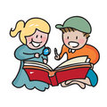](http://www.google.co.uk/url?sa=i&rct=j&q=CARTOON+IMAGE+OF+CHILD+READING&source=images&cd=&cad=rja&docid=GDIKGDhxjnSlLM&tbnid=28mnPTmCZ2AjFM:&ved=0CAUQjRw&url=http%3A%2F%2Fwww.dreamstime.com%2Fstock-image-family-reading-cartoon-image14049521&ei=CmZeUvbNLY6whAfrw4G4Cg&psig=AFQjCNF24QcVcYTwEw65CeNPxQ38MYm6Pw&ust=1382004602345694)

**READING & SPELLING**

* Children should **read for a**
* **minimum of 15 mins** at home

every day.

* Reading books and home school diaries should come in every day.
* Children should know common words and target spellings.



**Art/DT:**

**Ancient Egypt.**

Children will be designing and creating ancient Egyptian death masks and creating their own torches for DT.

**ICT**

We will be collecting data to record in charts and discuss the results.

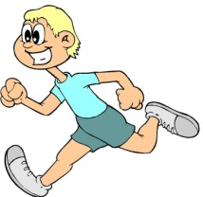

**KIT SHOULD STAY IN SCHOOL ALL WEEK: BLACK SHORTS, WHITE T-SHIRT & TRAINERS/PLIMSOLLS.**

Our whole school focus is on

Literacy**!**

Our **Skill for Success** this term is

**Responsibility**

**HOMEWORK:**

**SET ON FRIDAYS**

**IN ON WEDNESDAYS**