

[](https://www.google.co.uk/url?sa=i&rct=j&q=&esrc=s&source=images&cd=&cad=rja&uact=8&ved=0ahUKEwjtx47rw-bKAhVFfRoKHQ-lDzEQjRwIBw&url=https%3A%2F%2Fcommons.wikimedia.org%2Fwiki%2FFile%3ATudor_Crown_(Heraldry).svg&psig=AFQjCNFbmJ3QRrOLIRcdX23jNNeL3GVu6Q&ust=1454964643060794)

**DIARY DATES:**

* 3rd March World Book Day
* 11th March Year One family assembly and curriculum sharing
* 22nd March Class 4 come and read / 23rd March Class 5 come and read

***HOW CAN YOU HELP YOUR CHILD?***

* READ THEIR READING BOOKS WITH THEM EVERY DAY
* READ TOGETHER DAILY AND TALK ABOUT STORIES
* ASSIST WITH HOMEWORK ACTIVITIES AND SUPPORT THEIR LEARNING OF PHONICS SOUNDS.

**LITERACY**

**Our literacy work will be based on our topic about The Queen:**

* **Asking and answering questions about The Queen**
* **Writing a letter to the Queen**
* **The Queen’s Hat by Steve Antony**
* **Royal poetry**

**Queen Elizabeth II IS OUR**

**THEME THIS TERM:**

**Science**: Identifying, naming, sorting and describing common materials.

Designing a waterproof hat for The

Queen.

**Art/DT:** Sewing hats

**History/Geography**: Finding out

about the life of Queen

Elizabeth II

**Music:** Tudor dancing and

The Queen’s Diamond Jubilee Song

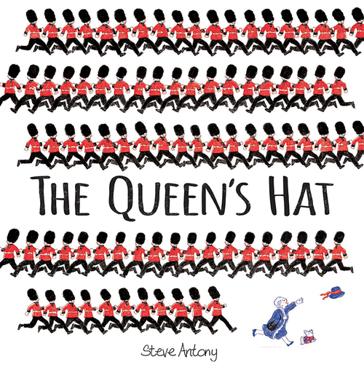

[](http://www.google.co.uk/url?sa=i&rct=j&q=&esrc=s&source=images&cd=&cad=rja&uact=8&ved=0ahUKEwjosLuExebKAhXJ7hoKHTj_DXYQjRwIBw&url=http%3A%2F%2Fsavvyseniorswork.com%2Ftag%2Fqueen-elizabeth-ii%2F&psig=AFQjCNGVWm01KpHp-kF_gvJghs70dA1KWw&ust=1454964957199123)

**READING & SPELLING**

* Children should **read for a**

**minimum of 15 mins** at home every

night – children should change their

books whenever they need to, on entry or at the end of the day.

* Reading books and home/school diaries should come into school every day.



* Coordination: Ball skills
* Counter balance in pairs

**KIT SHOULD STAY IN SCHOOL ALL WEEK: BLACK SHORTS, WHITE TEE SHIRT & TRAINERS/PLIMSOLLS.**

**ICT**

We are collectors.

**RE & PSHE**

* Going for goals
* Healthy Eating
* Drugs Education



[](http://www.google.co.uk/url?sa=i&rct=j&q=cartoom+image+counting&source=images&cd=&cad=rja&docid=P5LnG7W1G413sM&tbnid=ElJIdtDFu5cwdM:&ved=0CAUQjRw&url=http%3A%2F%2Fwww.clipartreview.com%2Fpages%2F110824-235560-163009.html&ei=lBKvUpeqKOLA7Ab3s4AY&psig=AFQjCNFWo-dPPyBIaveit4Xqj-O7knGEzQ&ust=1387291653202545)

**MATHS**: In this year group the minimum

expectation is for your child to be able to:

* Read and write numbers from 1 to 100 in

numerals and to 20 in words as well

* Read, write and interpret mathematical statements involving addition (+), subtraction (-) and equals (=) signs
* Solve simple problems, with support, involving multiplication and division using objects or pictures





Our whole school focus is on **Communication**

Our Skill for Success this term is

**Understanding Yourself**

**HOMEWORK:**

**SET ON FRIDAYS**

**IN ON WEDNESDAYS**