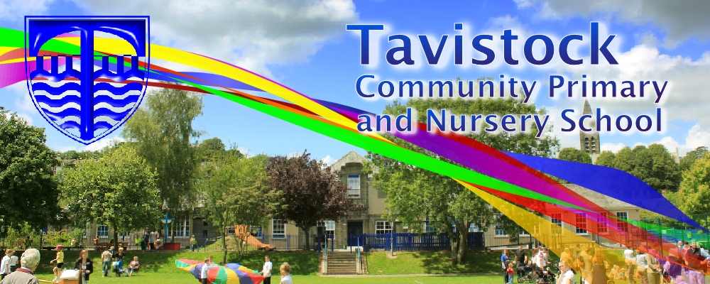 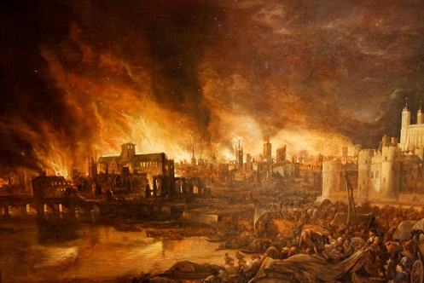

**DATES FOR YOUR DIARY**

* **17th March Year 2 assembly and curriculum sharing**
* **30th March end of term assembly**
* **Week commencing 27th March: Easter experience at Methodist church**



**LITERACY**

**Our literacy work will include:**

* Writing diary entries
* Writing a newspaper report
* Writing instructions
* Developing sentences: using past tense correctly, adding suffixes, using a variety of punctuation

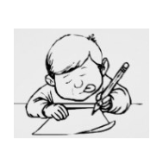

**This term we are going to be exploring:**

**Science**: Plants including investigations

**Art/DT:** Art based on the style of a renowned artist.

**History/Geography**: What happened in the Great Fire of London and how we know

**Music:** Playing the glockenspiel, musical language and notation, singing

**PSHE:** Feeling good about myself

**ICT:** Taking and editing photographs

**PE:** Coordination and ball skills

**MATHS**: This term, we will be learning to:

* Count in 2s, 3s, 5s and 10s from 0, know the

2x, 5x, and 10x table

* Adding and subtracting two 2-digit numbers mentally
* Know units of measure for length, volume, mass, temperature and time intervals
* Properties of 2D and 3D shapes and symmetry in 2D shapes

**walked**, **hopped**,

**cried, baked, ran**



***SCIENCE***

* Pollination of plants
* What plants need to grow
* How plants take in water
* Plants for food

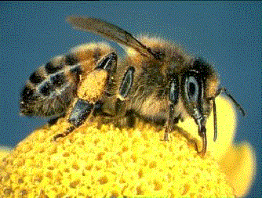

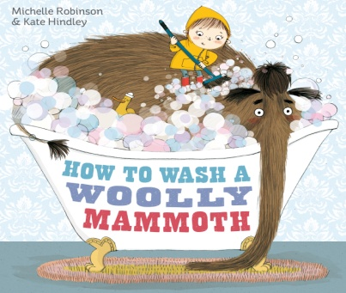

**LOVING READING**

Ask your child:

* to tell you about the book so far – what has happened
* to give alternative meanings for words and phrases
* what the author is telling the reader

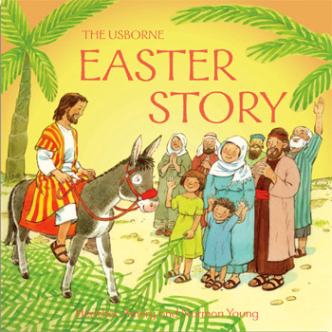

**RE**

* Jesus as a Leader
* Jesus healing people
* Easter story

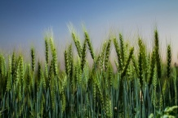

**HOT READS IN THE SCHOOL LIBRARY**

* The Lumberjack's Beard by Duncan Beedie
* Odd Dog Out by Rob Biddulph
* Mr Bunny's Chocolate Factory by Elys Dolan

Our **Skill for Success** this half term is

**UNDERSTANDING YOURSELF – I know how I feel**

**HOMEWORK:**

**SET ON FRIDAY: IN ON WEDNESDAY**

**SPELLING TEST ON FRIDAY**