[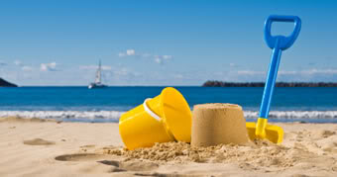](http://www.google.co.uk/url?sa=i&rct=j&q=&esrc=s&source=images&cd=&cad=rja&uact=8&ved=0ahUKEwjIzemhxavUAhUDtBQKHVSeCxgQjRwIBw&url=http://www.ebay.co.uk/itm/SOUNDS-OF-THE-SEASIDE-CD-NATURAL-SOUNDS-CHILDHOOD-MEMORIES-THE-BEACH-/230796820635&psig=AFQjCNFgJwHxuykYOLBk9aWrYcF37Uz-Kg&ust=1496918269690139)

***HOW CAN YOU HELP YOUR CHILD?***

* READ THEIR READING BOOKS WITH THEM EVERY DAY
* READ TOGETHER DAILY AND TALK ABOUT STORIES
* ASSIST WITH HOMEWORK ACTIVITIES AND SUPPORT THEIR LEARNING OF PHONICS SOUNDS.

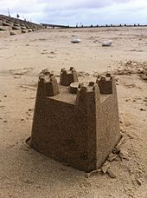[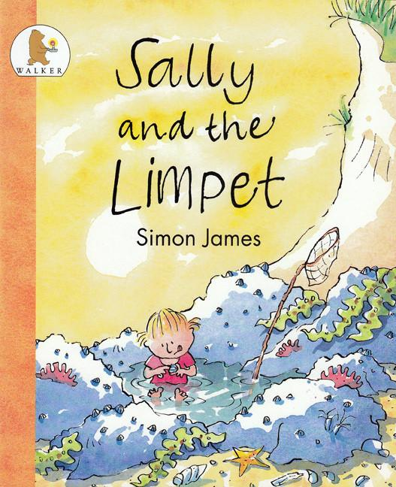](https://www.google.co.uk/url?sa=i&rct=j&q=&esrc=s&source=images&cd=&cad=rja&uact=8&ved=0ahUKEwiq54-dw6vUAhWFbxQKHdfQAY0QjRwIBw&url=https://www.hamiltoneducation.org.uk/collections/books-for-children/products/sally-and-the-limpet&psig=AFQjCNGbrH4tBIEtzW1GRfgHRQQN0x8B7g&ust=1496917724475785)

**ENGLISH**

**Our English work will be based on our seaside topic**

* **Sally and the Limpet by Simon James**
* **The Sand horse by Anne Turnbull**
* **Writing postcards about a trip to the beach.**

**The Seaside IS OUR**

**THEME THIS TERM:**

**Science**: Exploring the weather

and shadows.

**Art/DT:** Seaside sculptures; driftwood boats and rock pool pictures.

**History/Geography**: The history of the seaside; finding clues and comparing past and present.

**Music:** Reflect, rewind and replay: an appraisal of different pieces

**READING & SPELLING**

* Children should **read for a**

**minimum of 15 mins** at home every

day – children should change their

books whenever they need to, on entry or at

the end of the day.

* Reading books and home/school diaries should come into school every day.
* Weekly spellings will be sent home on Fridays

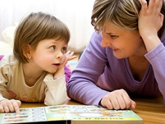

Sports day practice and team games

**Children should have their PE kit in school every day**

**ICT**

We will be making a celebratory card using learn pads.

**RE & PSHCE**

* Celebrations
* Growing and changing
* Looking after ourselves







[](http://www.google.co.uk/url?sa=i&rct=j&q=cartoom+image+counting&source=images&cd=&cad=rja&docid=P5LnG7W1G413sM&tbnid=ElJIdtDFu5cwdM:&ved=0CAUQjRw&url=http://www.clipartreview.com/pages/110824-235560-163009.html&ei=lBKvUpeqKOLA7Ab3s4AY&psig=AFQjCNFWo-dPPyBIaveit4Xqj-O7knGEzQ&ust=1387291653202545)

**MATHS**: In this year group the minimum

expectation is for your child to be able to:

* Read and write numbers from 1 to 100 in

numerals and to 20 in words as well

* Read, write and interpret mathematical statements involving addition (+), subtraction (-) and equals (=) signs
* Solve simple problems, with support, involving multiplication and division using objects or pictures



**HOMEWORK:**

**SET ON FRIDAYS**

**IN ON WEDNESDAYS**



Our **Skill for Success** this term is

**Risk Taking**