
HOW CAN YOU HELP YOUR CHILD?
READ THEIR READING BOOKS WITH THEM EVERY DAY AND RECORD PROGRESS IN YOUR HOME SCHOOL DIARY.
ENJOY STORY TIME TOGETHER
ASSIST WITH HOMEWORK ACTIVITIES.
Science:
- Leaf / seed collecting, bark rubbing and tree identification.
- Seasonal Changes: Autumn into Winter
- Bulb planting
Art/DT: Baking Christmas Cakes, sewing Sir Francis Drake ruffles, Christmas craft
History/Geography: The life of Sir Francis Drake
Music: Firework music, seaside chanties, Christmas songs

LITERACY
- Firework Poetry
- The Emperor’s New Clothes
- Writing Instructions
- The Christmas Story
We will be visiting the Drum Theatre to see The Three Little Pigs.



PE
Dynamic balance to agility
Static balance

KIT SHOULD STAY IN SCHOOL ALL WEEK: BLACK SHORTS, WHITE TEE SHIRT & TRAINERS/PLIMSOLLS.

READING
- Children should read for a
minimum of 15 minutes at home every
night – children should change their
books whenever they need to, on entry or at the end of the day.


ICT

We are TV Chefs
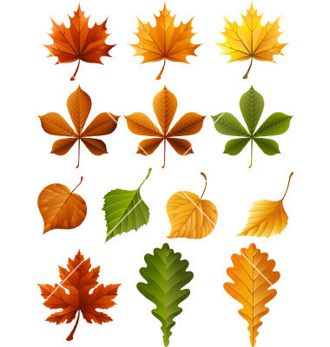
RE & PSHE
What is special to me?


MATHS: In this year group the minimum
expectation is for your child to be able to:
- Read and write numbers from 1 to 100 in
numerals and to 20 in words.
- Read, write and interpret mathematical statements involving addition (+), subtraction (-) and equals (=) signs
- Solve simple problems, with support, involving multiplication and division using objects or pictures

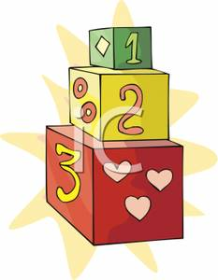
Our whole school focus is on Communication
Our Skill for Success this term is
Self Belief
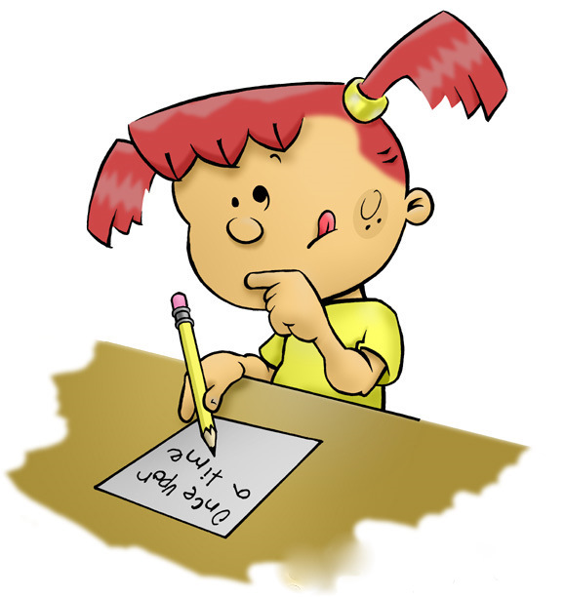
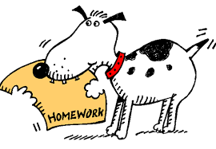
HOMEWORK:
SET ON FRIDAYS
IN ON WEDNESDAYS

