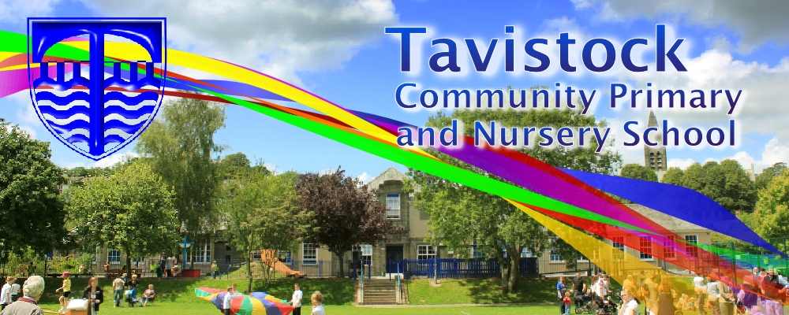 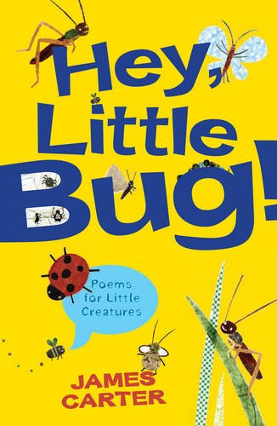 [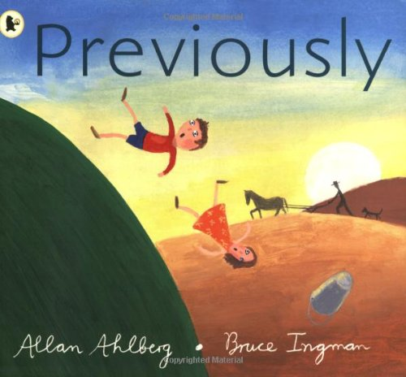](https://www.amazon.co.uk/Previously-Allan-Ahlberg/dp/1406313505)

The Great AAA-OOO!

This is not a fairy tale

There is no dragon in this story

**Check out these books in the library**

**DATES FOR YOUR DIARY**

**14/12 – St Eustachius’ service**

**MATHS**: This term, we will be learning to:

* Identify the properties of 2D and 3D shapes.
* Add and subtract 3 1-digit numbers and 2 2-digit numbers.
* Identify and know the properties of odd and even numbers.
* Count in 2s, 3s, 5s from 0 and in 1s and 10s from any number.
* Find ½ and ¼ of numbers and understand division as sharing and grouping.

1. **ENGLISH :**

**Our work will include:**

* Reading fluently.
* Reading comprehension.
* Developing vocabulary.
* Developing sentence structure

and spelling accurately.

* Writing stories, poetry and performing poetry.

**This term we are going to be exploring:**

**Science**: Uses of everyday materials.

**Art/DT:** Making Christmas cards and calendars. Christmas cooking.

**History/Geography**: How did Christopher Columbus find America?

**Music:** Christmas Music – singing linked to the Christmas story.

**PSHE:** Saying no to bullying.

**ICT:** Creating a program and understanding algorithms (instructions). Games testing.

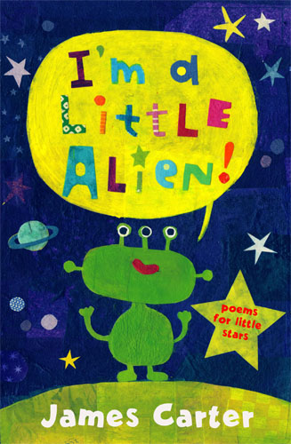

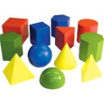

**Science: Uses of Everyday Materials**

* **Explore materials and their purposes.**
* **Investigate how different materials change shape.**
* **Learn how to carry out a fair test.**

**RE**



* Parables
* Jewish beliefs
* The Christmas Story

**REMEMBER**

Please ensure your child brings their reading book and home school diary to school EVERY day.

If you would like to come into class and help – with reading, other activities or general classroom support we would love to welcome you. Please see Mrs Alexander or Mrs Barnes.

[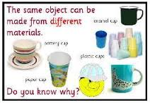](http://www.google.co.uk/url?sa=i&rct=j&q=&esrc=s&source=images&cd=&cad=rja&uact=8&ved=0CAcQjRw&url=http://www.ks1resources.co.uk/page36.html&ei=I6laVOyJCOWp7AaU7oDYAg&bvm=bv.78677474,d.ZGU&psig=AFQjCNGy3aZ1Gq3lZp_6UZf1VOBH9ukZOA&ust=1415314055432946)

**Developing children’s fundamental movement skills as the building blocks for all sport plus balance, coordination and ball skills,**

**PE KIT SHOULD STAY IN SCHOOL ALL WEEK: BLACK SHORTS, WHITE T- SHIRT & TRAINERS.**

Our **Skill for Success** this half term is

**Self Belief – I know I can do it!**

**HOMEWORK: SET ON FRIDAY; IN ON WEDNESDAY**

**SPELLING TEST ON FRIDAY**