

Dates for your diary:

6th and 7th Feb – Parents’ Evenings

Friday 3rd March - Family Assembly

***HOW CAN YOU HELP YOUR CHILD?***

* READ THEIR READING BOOKS WITH THEM EVERY DAY
* READ TOGETHER DAILY AND TALK ABOUT STORIES
* ASSIST WITH HOMEWORK ACTIVITIES AND SUPPORT THEIR LEARNING OF PHONICS SOUNDS.

[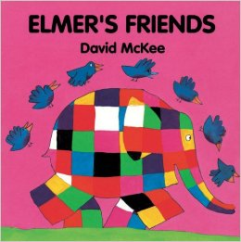](https://www.google.co.uk/url?sa=i&rct=j&q=&esrc=s&source=images&cd=&cad=rja&uact=8&ved=0ahUKEwiWuKrPivfQAhUHthoKHTQ0C_UQjRwIBw&url=https://www.amazon.co.uk/Elmers-Friends-David-McKee/dp/086264495X&psig=AFQjCNH0FhCs3Fhm-hUGsYnYQkgQ6njm9w&ust=1481921684576639)

**ANIMALS IS OUR**

**THEME THIS TERM:**

**Science**: Pets - What do animals

need to be healthy and happy?

**Art/DT:** William Morris inspired

printing, 3D pet sculptures, clay paw

prints, creating a fabric pet blanket**.**

**History/Geography**: Where would make a good home for Percy the penguin? The UK? Africa? Australia? The Poles?

**Music:** Big Bear Funk! Listening,

appraising and playing instruments.

**LITERACY**

**Our literacy work will be based**

**on our animals theme:**

* **Animal Non Fiction Books**
* **Penguin by Polly Dunbar**
* **Polar Bear, Polar Bear What Do You Hear?**
* **Elmer’s Friends**



**READING & SPELLING**

* Children should **read for a**

**minimum of 15 mins** at home every

night – children should change their

books whenever they need to, on entry or at

the end of the day.

* Reading books and home/school diaries should come into school every day.



* Dynamic balance: Exploring movements.
* Static balance: Small base.

**KIT SHOULD STAY IN SCHOOL ALL WEEK: BLACK SHORTS, WHITE TEE SHIRT & TRAINERS/PLIMSOLLS.**

**ICT**

. We are painters – creating electronic artwork to illustrate literacy work.

**RE & PSHE**

* Going for goals
* Healthy Eating
* Drugs Education



[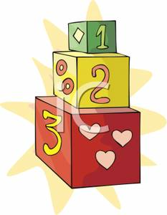](http://www.google.co.uk/url?sa=i&rct=j&q=cartoom+image+counting&source=images&cd=&cad=rja&docid=P5LnG7W1G413sM&tbnid=ElJIdtDFu5cwdM:&ved=0CAUQjRw&url=http://www.clipartreview.com/pages/110824-235560-163009.html&ei=lBKvUpeqKOLA7Ab3s4AY&psig=AFQjCNFWo-dPPyBIaveit4Xqj-O7knGEzQ&ust=1387291653202545)

**MATHS**: In this year group the minimum

expectation is for your child to be able to:

* Read and write numbers from 1 to 100 in

numerals and to 20 in words as well

* Read, write and interpret mathematical statements involving addition (+), subtraction (-) and equals (=) signs
* Solve simple problems, with support, involving multiplication and division using objects or pictures





Our whole school focus is on **Literacy**

Our Skill for Success this term is

**Responsibility**

**HOMEWORK:**

**SET ON FRIDAYS**

**IN ON WEDNESDAYS**