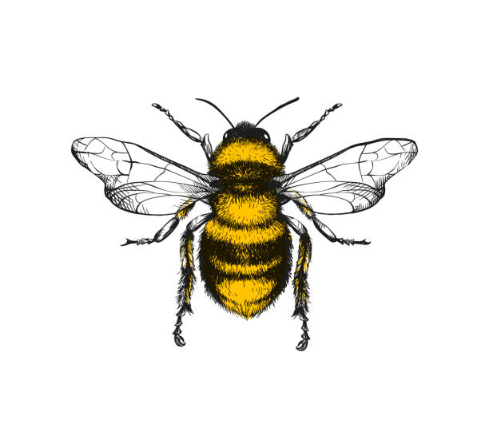

I am beginning to describe a sequence of events, real or fictional, using words such as ‘first’, then’

I can notice and correct an error in a repeating pattern

I can extend and create ABAB Patterns -STICK, LEAF, STICK, LEAF

I can discuss routes and locations, using words like ‘in front of’ and ‘behind’

I can identify patterns around me. For example: stripes on clothes

I know that the last number reached when counting a small set of objects tells you how many there are in total

I can find something that is longer/shorter than a given reference item

I can use my fingers to represent numbers 1-5

**Maths**Every child will see themselves as confident mathematicians. They will be able to use a collection of embedded mathematical knowledge and language naturally in everyday play.

.

I can sing rhymes and songs which require a number to be partitioned e.g. how many are left?

I can join in with rhymes and songs that separate a number e.g. 5 little speckled frogs

I have a deep understanding of the numbers 1, 2 and 3

I am beginning to understand inverse operation e.g. that the 5 little specked frogs will become a group of 5 again if they join back together

I can count forwards and backwards to 5

I can use some number language and number names spontaneously

I can talk about some numbers beyond 10

I am beginning to use Mathematical vocabulary: I know what is ‘one more’ and ‘one less’ than a number using objects to support me up to 5

Say one number for each item in order: 1,2,3,4,5

I can talk about and explore 2D and 3D shapes using informal and mathematical language

I can solve real world mathematical problems with numbers up to 5 (e.g. snack)

I can select shapes appropriately: flat surfaces for building, a triangular prism for a roof

I create and experiment with symbols and marks to represent numbers

I can recite numbers past 5

I can match numerals and quantity: for example, showing the right number of objects to match the numeral, up to 5

I am developing fast recognition of up to 3 objects, without having to count them individually (subitising)

I can attach a number name to a group of objects

I can combine shapes to make new ones- an arch, a bigger triangle etc

I can describe a familiar route e.g. the park, recall the route and the order of things seen on the way

I understand position through words alone-for example: ‘The bag is under the table’ with no pointing

I am aware of day and night

I understand the concept of full and empty

I can compare sizes verbally and begin to use more to use specific terms, such as ‘taller than’/’shorter than’ small, big and medium sized

I can work with an adult to measure ingredients for baking. Using scales

I can role play with money and I am beginning to use the language of money

I show an awareness that a clock tells the time

When modelled I can use ordinary objects to measure using a non standard measure e.g. steps, hands

I compare the weight of different objects in my own play