

***HOW CAN YOU HELP YOUR CHILD?***

* READ with them EVERY night and TALK about the book – thoughts and understanding.
* SUPPORT them with their Maths homework by letting them SHOW YOU methods they have learnt at school.
* PRACTICE spellings daily, putting them into sentences to check understanding.
* **Talk, play and involve them with what you do. Always come and talk if you have any concerns.**

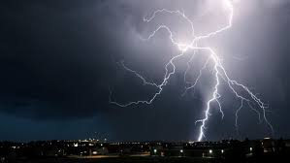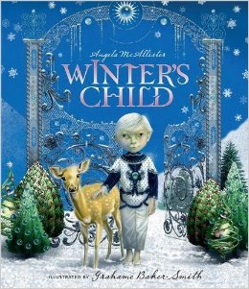

**WEATHER IS OUR THEM**

**THIS TERM:**

**Science**:

Living things. We will be exploring what all living things need and must do and how they are classified.

**Art/DT:**

Designing and creating an air powered car.

**Geography**:

**Why are we so interested in the weather?** During geography we will be exploring weather systems, creating rain gauges, understanding global weather, observing biomes and recording weather data.

**LITERACY**

**Imaginative writing:**

**Winter’s child   
Key learning outcome to** write a   
story based on significant weather   
features, following the structure of   
Winter’s Child.

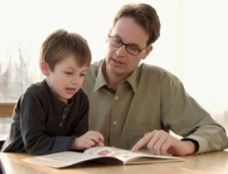

**READING & SPELLING**

* Children should **read for a**

**minimum of 15 minutes** at home every

night – children should change their

books whenever they need to and record their reading in the Home School Diary.

PLEASE DISCUSS WITH YOUR CHILDREN WHAT THEY HAVE READ – ENCOURAGING THEM TO EXPAND ON THEIR THOUGHTS.

* **Spellings** sent home on **Fridays, spelling** **quiz** on **following Friday.** These are linked to our spelling, grammar and handwriting lessons. (Reading books & home/school diaries should come in every day).

**Children will have P.E. twice per week**

**KIT SHOULD STAY IN SCHOOL ALL WEEK: BLACK SHORTS, WHITE T SHIRT & TRAINERS.**

**Outdoor and indoor PE: Orienteering. Children will be developing movement skills and their ability to read maps, to understand that a map is an image.**



**PSHE/RE**

Skills for success – Understanding yourself.

**RE**: Islam- worship/ pilgrimage/ sacred places

**ICT**

Research, collect, collate weather data from two different countries and create a comparative bar chart of the data .



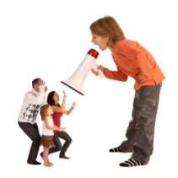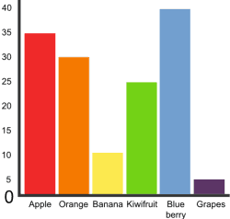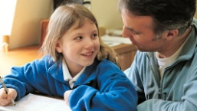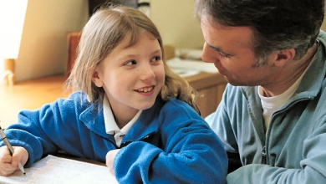

**HOMEWORK**Set on Friday and needs returning by the following Wednesday. Phonics/spelling relationships will be practised in class and consolidated through homework. Reading homework will alternate with literacy homework. There is also a times table /multiplicationchallenge every Friday.

**MATHS:**

* Pupils can explain the relationship   
  between multiplication, division and   
  fractions. They use this understanding   
  to derive facts and solve problems.
* Pupils can explain how to locate points on a grid in the first quadrant and use this knowledge and understanding to solve problems.

Our whole school focus is on **literacy!**

Our **Skill for Success** this term is

Understanding Yourself.