|  |
| --- |
| Our theme this half term is:  **C:\Users\00AKerswill\Pictures\seaside.jpgThe Seaside** |

|  |
| --- |
| Our whole school focus is on **TALK**  C:\Users\00CSmith\AppData\Local\Microsoft\Windows\Temporary Internet Files\Content.IE5\3VOT9909\Talk_WAlk[1].png |

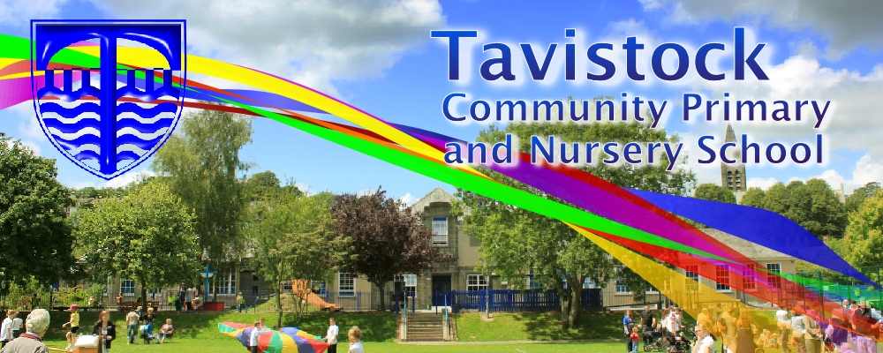

|  |
| --- |
| This half term we plan to have a focus on the following areas:  **Prime Areas of Learning**  **Personal, social and emotional development**  To be able to adjust behaviour to different situations and take changes of routine in my stride.  **Communication and Language**  To follow instructions following several ideas or actions and to develop own narratives and explanations by connecting ideas or events.  **Physical Development**  To understand and talk about ways to stay healthy and safe. To handle tools and equipment safely and successfully.  **Specific Areas**  **Literacy**  Linking sounds to letters (Phase 3 and 4 Letters and Sounds.) Reading Phase 4 tricky words and de-codeable words .(Please see the front of your child’s reading diary for a list of them.) To talk about what has been read, showing understanding and to write simple sentences using basic punctuation.  **Mathematics**  To say which number is one more or one less than a given number. Adding and subtracting two single-digit numbers and counting on or back on a number line to find the answer. Solving problems based around our own interests and linked to our theme.  **Understanding the World**  Developing ICT skills using Learn Pads. To compare environments and make observations and explain why some things happen.  **Expressive Arts and Design**  To use a range of media to create sea themed art work including painting, drawing, printing and collage. And to safely use a range of tools and materials |

|  |
| --- |
| **C:\Users\00AKerswill\Pictures\crab.jpgWe plan to change reading books on Monday and Thursday. You are welcome to change your child’s book more frequently if you want to.** |

|  |
| --- |
| **Skill for Success**  **Our Skill for Success this term is:**  **Risk Taking** |

|  |
| --- |
| **Dates for your diary:**  17/06/16 Trip to Wembury Beach  30/06/16 Sports Day  27/06/16 Moving on up day  01/07/16 Summer Fair |

|  |
| --- |
| **Please feel free to come and talk to your child’s class teacher after school if you have any worries or concerns. We have an open door policy!**  **door.jpg** |