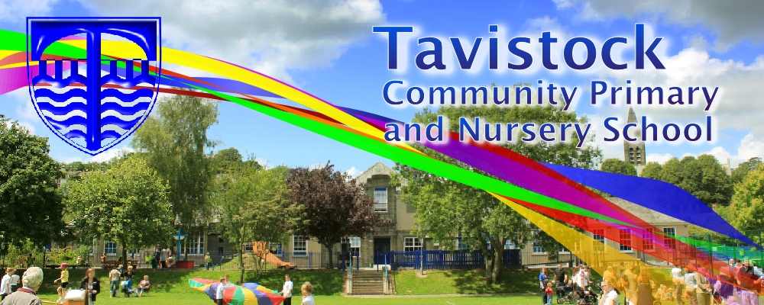

Dates for your Dairy:

28th Feb Y5/6 NSPCC Workshops

10th March Y5 Family Assembly & Curriculum Sharing

30th March End of Term Assembly

**OUR THEME THIS TERM:**

**What happened when the Vikings invaded Britain?**

**Science**: Forces & Materials

**History/Geog**: Vikings & Mapwork

**PE:** Net and Racquet Fundamental Movement Skills / Dance-Westside Story

**MFL:** French

**RE**: Christian beliefs

**MATHS**: In maths we are covering:

Additive Reasoning- Solving addition and subtraction problems using efficient mental and written methods.

Number Sense- Comparing and ordering

Fractions, understand % as parts of 100,

Explore equivalent fractions.

**LITERACY**

**Extreme Animals:**

We exploring this humorous and colourful, Non Fiction Report by Nicola Davies and use it to produce a report in a similar style.

The focae include multi-clause sentences, linking paragraphs and conveying humour.

MC900233964[1]

***HOW CAN YOU HELP YOUR CHILD?***

***Listen to your children read on a regular basis and discuss what has been read.***

***Encourage a wide variety of texts.***

***Practise times tables and spellings.***

**READING**

Every half-term, new copies of recently published books will be available for your children to borrow from the School Library. This half-term, the new books will be as follows. Tell your children to look out for these in the School Library!

* The great Shelby Holmes: girl detective by Elizabeth Eulberg
* The everything machine by Ally Kennen
* Is this a poem? by Roger Stevens



**Art/DT:**

**Perspective drawing and watercolour painting**

**ICT**

Exploring geometric patterning



**KIT SHOULD STAY IN SCHOOL ALL WEEK: BLACK SHORTS, WHITE T-SHIRT & TRAINERS/PLIMSOLLS.**

Our whole school focus is literacy.

Our **Skill for Success** this term is

**Understanding Yourself**

**HOMEWORK:**

**SET ON FRIDAYS**

**IN ON WEDNESDAYS**