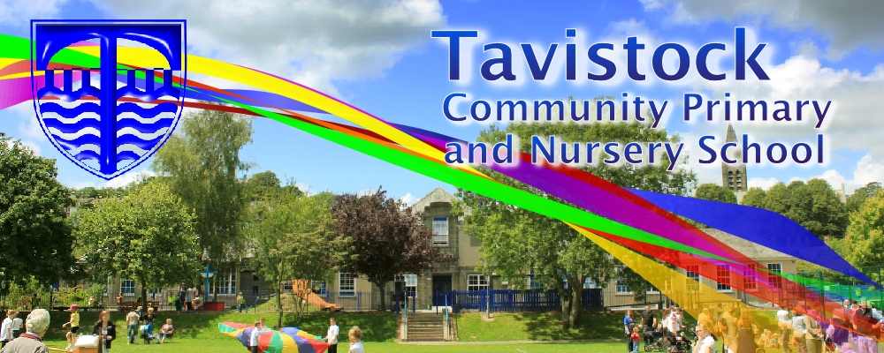

**End of Term – Friday 16th December**

**MATHS**: In maths we are covering:

Multiplicative reasoning and geometric reasoning

Number sense

**LITERACY:**

**Non Fiction**

**A Drove of Bullocks**

**Poetry**

**Personification**

**OUR THEME THIS TERM:**

**Science**: Evolution and inheritance  
**Art/DT:** Gustav Klimt

**History**: A Tardis through Tavistock  
**Geography:** Why is the rest of the world watching China?

**Music:** Christmas songs

**RE:** Moral choices

**MFL:** All about me, families, a school day and a French Christmas

***HOW CAN YOU HELP YOUR CHILD?***

***Fill in the home school diary when you hear your child read.***

***Encourage a wide variety of texts.***

***Practise times tables***

***Learn words from the Year 5 and 6 word list***

[](http://www.google.co.uk/url?sa=i&rct=j&q=CARTOON+IMAGE+OF+CHILD+READING&source=images&cd=&cad=rja&docid=GDIKGDhxjnSlLM&tbnid=28mnPTmCZ2AjFM:&ved=0CAUQjRw&url=http://www.dreamstime.com/stock-image-family-reading-cartoon-image14049521&ei=CmZeUvbNLY6whAfrw4G4Cg&psig=AFQjCNF24QcVcYTwEw65CeNPxQ38MYm6Pw&ust=1382004602345694)

**READING & SPELLING**

* Children should **read for a**
* **minimum of 15 mins** at home

every day.

* Reading books and home school diaries should come in every day.
* Children should know common words and target spellings.



**PE:**

Cognitive skills.  
Reaction and Response.

Game Skills – Ball Handling and Agility

**ICT:**

Spreadsheets

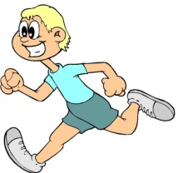

**PLEASE ENSURE THAT YOUR CHILD HAS THEIR PE KIT.**

**KIT SHOULD STAY IN SCHOOL ALL WEEK: BLACK SHORTS, WHITE T-SHIRT & TRAINERS/PLIMSOLLS.**

Our whole school focus is on

**Reading**

Our **Skill for Success** this term is

**Self Belief.**

**HOMEWORK:**

**SET ON FRIDAYS**

**IN ON WEDNESDAYS**