

**Dates for your Diary:**

**TODAY - Incredible Years drop in session.**

**02/03/18 World Book Day.**

**09/03/18 Incredible Years course starts.**

**Library visits –Monday afternoons5/3/18 -21/05/18 plus 24/05/18**

**MATHS**: We will be adding 2 groups of numbers together and recording them using pictures, marks, numbers and mathematical symbols.

We will be using everyday language to talk about size, weight, capacity, position, distance and time.

**OUR THEME THIS TERM**

**Mini-beasts**

[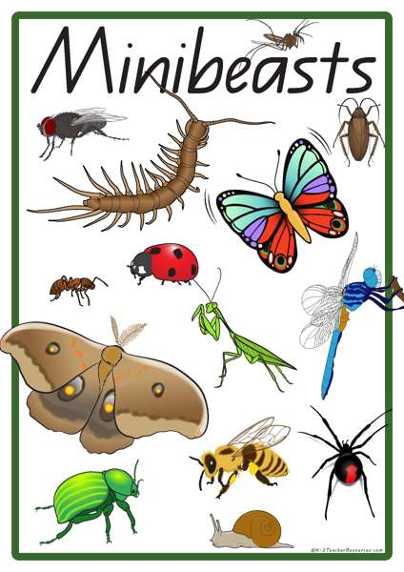](https://www.google.co.uk/url?sa=i&rct=j&q=&esrc=s&source=images&cd=&cad=rja&uact=8&ved=0ahUKEwia1s-x9ZzSAhXENhoKHVLxDTYQjRwIBw&url=https%3A%2F%2Fk-3teacherresources.com%2Fteaching-resource%2Fminibeast-vocabulary-words%2F&psig=AFQjCNG5YbKgP-4IdbXIMVZC_RLA_LoWrQ&ust=1487619690538349)

[](https://www.google.co.uk/url?sa=i&rct=j&q=&esrc=s&source=images&cd=&cad=rja&uact=8&ved=0ahUKEwia1s-x9ZzSAhXENhoKHVLxDTYQjRwIBw&url=https%3A%2F%2Fk-3teacherresources.com%2Fteaching-resource%2Fminibeast-vocabulary-words%2F&psig=AFQjCNG5YbKgP-4IdbXIMVZC_RLA_LoWrQ&ust=1487619690538349)

**LITERACY/COMMUNICATION AND LANGUAGE**

We will be reading, writing and talking about Mini-beasts, using fiction and non-fiction books. Some of the stories we will use are – **the Bad Tempered Ladybird, the Very Hungry Caterpillar, Mad About Mini-beasts, The Very Busy Spider, Super Worm, Norman the Slug with the Silly Shell.**

We will be continuing with Phase 3 phonics and moving on to Phase 4. (See the front of your child’s reading diary)

[](http://www.google.co.uk/url?sa=i&rct=j&q=&esrc=s&source=images&cd=&cad=rja&uact=8&ved=0ahUKEwiRhpX5iJnZAhXEtBQKHUKFABkQjRwIBw&url=http://maryjanesdiary.com/marijuana-weight-grams-quarters-ounces/&psig=AOvVaw3AxF7tyCypQaIijH4XI7QP&ust=1518273821505221)

***HOW CAN YOU HELP YOUR CHILD?***

* ***Read to your child regularly and ask them to re-tell the story and do lots of talking about the vocabulary within the story.***
* ***Support them to blend the letter sounds they know together. Remember buttons and bars for single letter sounds and di/trigraphs.***
* ***Play number games, concentrating on numbers to 10 and 20 and talk about one more/one less than a number to 20***

**Personal, Social and Emotional Development**

We will be working as part of a group and taking turns with others.

We will talk about how we show our feelings and be confident to talk in front of our friends.

**Physical Development** To move confidently in a range of ways and make changes to materials by using tools.

**Understanding the World**

We will be learning about Easter and Mothers Day and Holi.

We will be looking at similarities and differences in relation to living things and make observations of minibeasts.

**Expressive Arts and Design**

We will be singing, dancing and acting to do with our topic.

We will be experimenting with colour, design, texture and form.

[](http://www.google.co.uk/url?sa=i&rct=j&q=&esrc=s&source=images&cd=&cad=rja&uact=8&ved=0ahUKEwj5gJmYrZnZAhUEaxQKHQ3aBLUQjRwIBw&url=http://www.thehotelbalmoral.co.uk/special-offers/dinner-bed-breakfast/easter-breaks-in-torquay/&psig=AOvVaw3cOvB-isR63qVPABFKLb2U&ust=1518283565501320)

Our **Skill for Success** this term is

**Understanding Yourself**

**HOMEWORK: 10-15 minutes of daily reading, including tricky words and letter sounds labelled ‘Phase 2 &3’ in the front of our reading diaries. Use the Phase 2 & 3 letter cards sent home with your child to make words – alien and real and correct formation of cursive letters using the guide sent home.**

**Every half-term, new copies of recently published books will be available for your children to borrow from the School Library. This half-term, the new books will be as follows. My Colourful Chameleon Tell your children to look out for these in the School Library!** *   My colourful chameleon