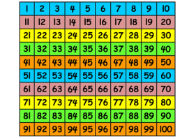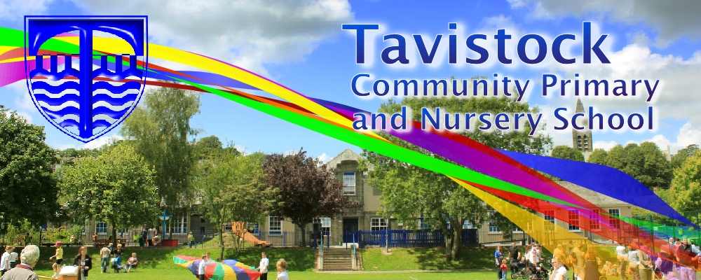 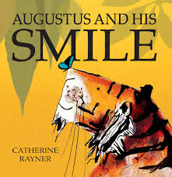

**This term we are going to be exploring:**

**Art/DT:** the artist Lowry and making Victorian toys with moving parts.

**Music:** Singing songs. Listening to classical music, composing, playing instruments and improvising.

**PSHCE:** Living in the world – how to look after the world around me.

**Computing:**  Using classification and design programmes.

**PE:** Sports day team games and

balance and agility.

**MATHS**: This term, we will be learning:

* Using place value to solve problems
* Commutative and inverse relationships of functions
* Counting in 10s from any number
* 2,3, 5 and 10 x tables – use these facts to solve problems
* Fractions – ½ , ¼ , ¾ . Using them in different contexts
* Properties of shapes and symmetry
* Recognising coins and working out change
* Tell the time to o’clock and half past (Y1), to 5 minute intervals (Y2)

**ENGLISH**

**Our English work will include:**

* Augustus and his Smile – power of

3 adjectives

* Performance poetry – The Owl and the Pussycat
* Wanted: The Perfect Pet
* Developing reading comprehension

and inference skills

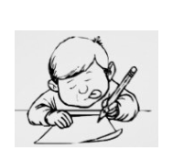

**DATES FOR YOUR DIARY**

* **12th June – KS1 Sports Day**
* **14th June – KS1 Family Assembly**
* **26th June – trip to Morwellham Quay**
* **20th June – Summer Fayre**
* **10th July – ‘Move on up’ day**

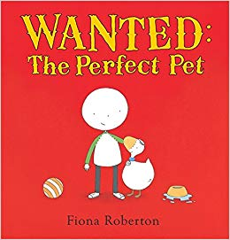 



***Humanities***

* ***Maps and how to read them***
* ***The Victorians***
* ***What life was like for children in Victorian times***
* ***Comparing Victorian and modern day toys***

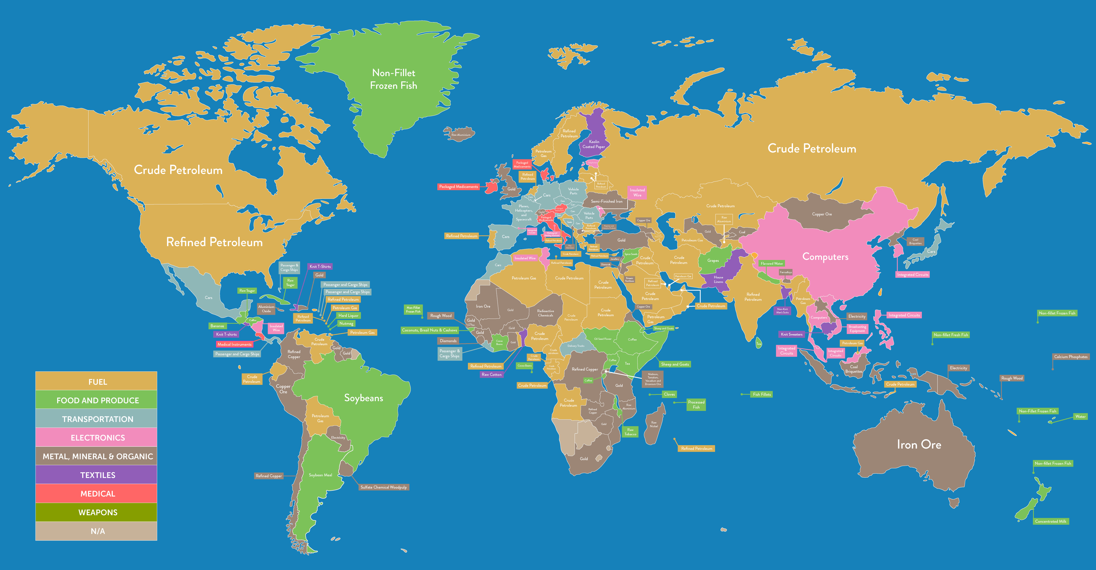

**RE**

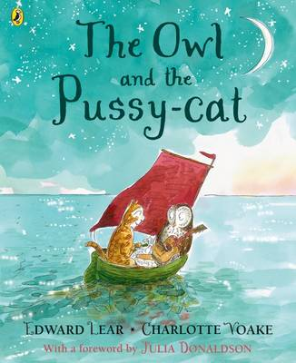

**LOVING READING**

Ask your child:

* to tell you about the book so far – what has happened
* to give alternative meanings for words and phrases
* what the author is telling the reader
* Judaism and a visit to the Synagogue
* Religious symbols and their meanings

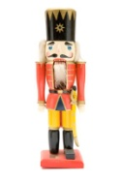

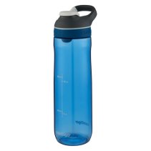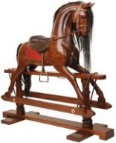

**KIT: BLACK SHORTS, WHITE T-SHIRT & TRAINERS/PLIMSOLLS.**

* **With summer here, it is important your child brings a water bottle to school every day. A hat for playtimes is also a good idea.**

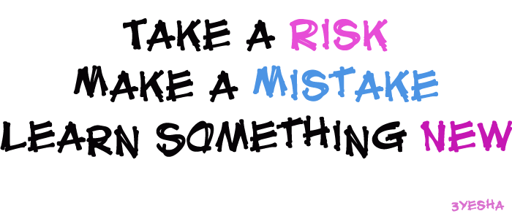

Our **Skill for Success** this half term is

**Risk Taking**

**HOMEWORK:**

**SET ON FRIDAY: IN ON THURSDAY**

**SPELLING TEST ON FRIDAY**