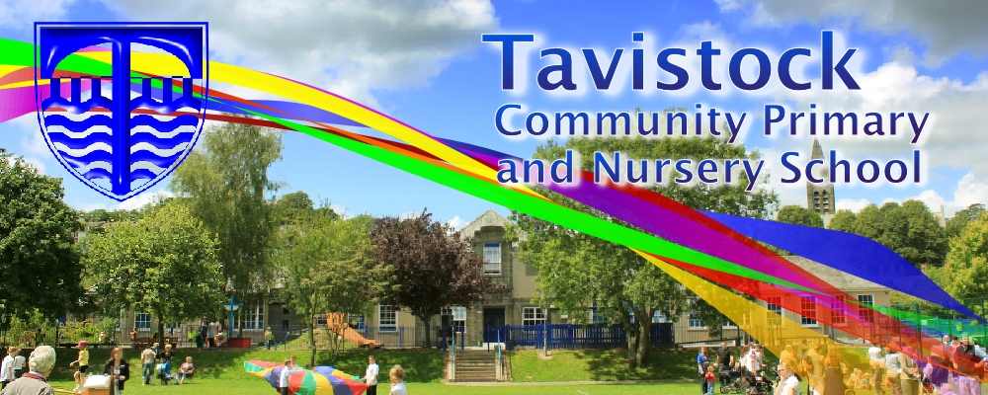

**KS2 Sports day 19th June**

**Summer Fayre 22nd June**

**Tavistock College Parents’ Meeting 3rd July @ 5pm**

**Reports home 5th July**

**Moving up day 11th July**

**End of term Assembly: 23rd July**

**Last day of term: 24th July**

**Maths**

**Number sense –** Demonstrate a clear understanding of when to use counting (including counting below zero), place value and rounding for solving problems.

**Multiplicative reasoning –**Multiply and divide numbers up to four digits; estimate answers and solve problems, including missing number problems, using number facts, place value, and more complex multiplication and division.

**Geometric reasoning** – This sequence of activities develops from creating and using co-ordinates through to exploring translations, reflections and rotations involving all four quadrants.

**English**

**The Shadow Cage**– We will be using the novel ‘The Shadow Cage’ to inspire the children to create suspense in their own stories.

**The Piano**– We are then using the short animation, The Piano to inspire the children to write using flashbacks including ellipsis in their writing.

**Our theme this term:**

**Ancient Civilisations**

**Science**: Survivor investigation unit

**Art/DT:** drawing people in action

**History/Geography**: The Shang Dynasty

**PSHCE:** Healthy living, living in the wider world and relationships

**MFL:** Grammar and word choice

**Music:** Dancing in the street

[](http://www.google.co.uk/url?sa=i&rct=j&q=CARTOON+IMAGE+OF+CHILD+READING&source=images&cd=&cad=rja&docid=GDIKGDhxjnSlLM&tbnid=28mnPTmCZ2AjFM:&ved=0CAUQjRw&url=http%3A%2F%2Fwww.dreamstime.com%2Fstock-image-family-reading-cartoon-image14049521&ei=CmZeUvbNLY6whAfrw4G4Cg&psig=AFQjCNF24QcVcYTwEw65CeNPxQ38MYm6Pw&ust=1382004602345694)

**Reading and Spelling**

* Children should **read for a**
* **minimum of 15 mins** at home

every day.

* Reading books and home school diaries should come in every day.
* Children should know common words and target spellings.

**Tell your children to look out for these newly published books in the School Library:**

**A sheepdog called Sky**

**Bundle with the Britons**

**Letters from the lighthouse**

**PE**

**PE Unit 6:**

Skills with teams and ball games.

**Gymnastics**- High and low level apparatus

**Computing**

‘We are web designers’ using the school’s online web programme.



Please ensure that your child has their PE kit.

Kit should stay in school all week: Black shorts, white t-shirt & trainers.

Our Skill for Success this term is:

Risk Taking

Homework:

Set on Fridays

In on Wednesday